Empirical Formula: the simplest formula that represents the whole number ratio between the elements in a compound.
Molecular formulas and empirical formulas are sometimes the same:
The molecular formula for water is H₂O, a 2 to 1 ratio.
Since the subscripts will not reduce H₂O is also water's empirical formula.

Molecular formulas and empirical formulas are not always the same:
The molecular formula for hydrogen peroxide is H₂O₂, a 1 to 1 ratio.
The formula is correct. Remember that peroxide is a polyatomic ion with a charge of -2.
Reduce the subscripts to the lowest form.
The empirical formula for hydrogen peroxide is HO, a 1 to 1 ratio.

Calculating Empirical Formulas:
Subscripts in a chemical formula are usually thought of as a ratio of atoms.
Subscripts can also be thought of as a ratio of moles.
To determine an empirical formula, one must determine the mole ratio.

Sample Empirical Formula Problem:
Determine the empirical formula of a compound that is composed of 36.5% sodium, 25.4% sulfur, and 38.1% oxygen.

- Find the number of moles of each element present.
Since the amount of each element is given in percentage, you must convert the percentage to a mass. If 100 grams of the sample are assumed, the percentages given are the same as grams.

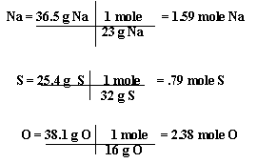

- Determine the whole number mole ratio.
Divide each mole number by the smallest mole number.
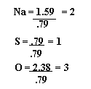
- Use the mole ratio for the subscripts of each element in the formula.
The empirical formula is Na₂SO₃

Molecular formulas from empirical formulas:
The formula mass of the empirical formula above is 126 amu.
If the molecular mass is known to be 378 amu,
what is the molecular formula?
  - Divide the molecular mass by the empirical formula mass to get a whole number.
³⁷⁸/₁₂₆ = 3
  - Multiply each subscript in the empirical formula by this whole number.
  - You now have the molecular formula –
Na₆S₃O₉

