The Expanding Universe Lab

Introduction: The origin of the universe remains one of the greatest questions in science. The "big bang" theory places the origin between 10 and 20 billion years ago, when the universe began in a hot dense state; according to this theory, the universe has been expanding ever since.
The universe has 4 dimensions: height, width, depth, and time. They are bound together as space-time. As the universe expands, the view from any one place in the universe remains the same. It is homogeneous and appears linear in its progression. The Hubble Law states that the recessional velocity of a galaxy is proportional to its distance from us. The velocity of the moving body is measured using the Doppler Effect or spectral line shift. The distance is more difficult to measure. It is measured by its apparent angular size or brightness of objects.

Objective: In this activity, you will use Hubble Space Telescope Images to view how objects in the Universe change and create scientific models of the Universe.
Vocabulary
Doppler Effect
Red Shift
Blue Shift
Materials: metric ruler large paper clips scissors pencil/pen
large balloon for each 2 students 4 strips of paper cut 2 cm X 30 cm
Exploration: Below is a graph that is used by astronomers. Can you figure out what it represents?

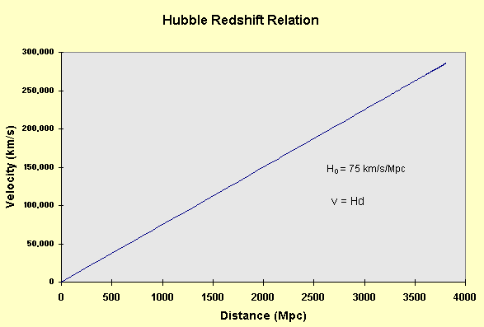
Guided Questions | Answers
1. What do the values on the horizontal axis represent?

2. How might scientists measure this value?

3. What do the values on the vertical axis represent?

4. How might scientists measure this value?

5. Which do you think is harder to measure?
6. What type of relationship is shown by the graph?
7. What are the units of the "slope"?
What could slope represent?

8. What dimension do you get if you take the inverse of the slope?

Procedure:
- Use the markers to make 10-15 dots on the balloon and number 10 of them after the balloon is partially inflated.
- Inflate balloon with 4 medium breaths to about the size of your fist; do not over inflate the balloon!
- Bend the end of the balloon down and paper clip it so that no air escapes.
- Record what happens to the dots in the space provided below. Be very specific; use complete sentences.
- Measure and record the distance between dot number one (your "home" dot) and the next 10 other dots with the METRIC RULERS. Be careful not to indent the balloon by pressing on it.
- Now measure and record the distance between dot number one (your "home" dot) and 10 other dots with the paper strip.
- Double the size of the balloon by inflating it slowly; do not over inflate the balloon! Measure and record the data from the enlarged balloon using both tools.

Data Table:
Partially Expanded | Totally Expanded
  Dot | Initial Distance from Dot #1  using the ruler | Initial Distance from Dot #1  using the paper strip | Difference
  2 | 2 | 2 | 2
  3 | 2 | 2 | 22
  4 | 2 | 2 | 2
  5 | 2 | 2 | 2
  6 | 2 | 2 | 2
  7 | 2 | 2 | 2
  8 | 2 | 2 | 2
  9 | 2 | 2 | 2
  10 | 2 | 2 | 2
  11 | 2 | 2 | 2
  Dot | Final Distance from Dot #1  using the ruler | Final Distance from Dot #1  using the paper strip | Difference | Change from Before to After
  2 | 2 | 2 | 2 | 2
  3 | 2 | 2 | 2 | 2
  4 | 2 | 2 | 2 | 2
  5 | 2 | 2 | 2 | 2
  6 | 2 | 2 | 2 | 2
  7 | 2 | 2 | 2 | 2
  8 | 2 | 2 | 2 | 2
  9 | 22 | 2 | 2 | 2
  10 | 2 | 2 | 2 | 2
  11 | 2 | 2 | 2 | 2
Questions:
1. If the dots represent galaxies, do they get larger as the balloon expands?
Why do you think this is or is not so?
2. What relationship exists between the speed of the galaxies moving apart and their initial distance from one another?
3. Name this Law.
4. Which measuring tool was more accurate? Why?

5. What is harder for the astronomer to measure: A galaxy's redshift (indicating recessional velocity) or its distance from Earth? Why?

Conclusion Questions: Read the passages and answer the questions following them.
Hubble Space Telescope Measures Precise Distance to the Most Remote Galaxy Yet
Abbreviated from: http://hubblesite.org/newscenter/newsdesk/archive/releases/1994/49/text/
In international team of astronomers using NASA's Hubble Space Telescope announced today the most accurate measurement yet of the distance of the remote galaxy M100, located in the Virgo cluster of galaxies.
This measurement will help provide a precise calculation of the expansion rate of the universe, called the Hubble Constant, which is crucial to determining the age and size of the universe.
Cosmic Mileposts
Cepheid variable stars rhythmically change in brightness over intervals of days (the prototype is the fourth brightest star in the circumpolar constellation Cepheus). For more than half a century, from the early work of the renowned astronomers Edwin Hubble, Henrietta Leavitt, Allan Sandage, and Walter Baade, it has been known that there is a direct link between a Cepheid's pulsation rate and its intrinsic brightness. Once a star's true brightness is known, its distance is a relatively straightforward calculation because the apparent intensity of light drops off at a geometrically predictable rate with distance. Although Cepheids are rare, once found, they provide a very reliable "standard candle" for estimating intergalactic distances, according to astronomers.

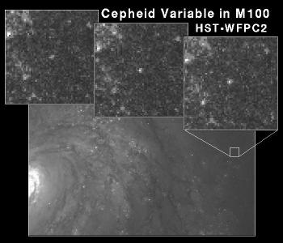
- Astronomers often use Cepheid variables to determine distance. Explain how astronomers use Cepheid variables to determine distance.
********************************************************************
Cosmology is the search for origins. It seems as if everyone wants to know how the Universe began. The Big Bang Theory is the result of several important observations. In 1927, Edwin Hubble observed that galaxies are red shifted, and moving farther and farther away from us. Second, he determined that the farther away a galaxy is from Earth, the faster it is receding. If the universe is expanding, then one can assume that the galaxies that compose our universe were once much closer together than they are now. By simply measuring how far apart galaxies are and how fast they are moving, we determine what cosmologists call the Hubble Constant (estimates range from 50 to 100 km/s per kiloparsec). It is very easy to determine the recessional velocity of galaxies; on the other hand, their current positions are difficult to measure. Distances to galaxies are typically measured by finding Cepheid variable stars or supernovae with known brightness. If we run the expansion process backward, we get two results. The first result is that it probably took approximately 15 billion years for the Universe to grow to its present size. Second, some awesome event must have caused the galaxies to go flying away from one another. Scientists don't know exactly what this phenomenon could have been, but astronomers refer to it as the Big Bang.
There are four fundamental observations and inferences that suggest that a Big Bang of some type did actually occur very long ago.

Observation | Inference
Almost all galaxies are red-shifted. | Almost all galaxies are moving away from the Milky Way.
The most distant galaxies exhibit the greatest red-shift. | The most distant galaxies are moving away the fastest.
The ratio of recessional velocity to distance is between 50 and 100 km/s per kiloparsec and is called the Hubble Constant. | The Universe has been expanding for 8 to 15 billion years.
The Cosmic Background Explorer (COBE) found that the temperature of intergalactic space was not zero. | The universe has not yet cooled from the rapid Big Bang expansion.
2. What are some examples that demonstrate the difference between an observation and an inference?

