
Gotham Equinox
Name____________________

Class __________

NY State / DLESE Collection

Copyright 2005 by S. Kluge

Go to this photo, taken at sunset looking along 34th Street in midtown Manhattan (New York City). Notice that the setting sun is perfectly aligned with the long, straight street.
Now take a look at this map of Manhattan, centered on the spot the photo was taken. (you can click "Satellite" in the upper right hand corner of the map for a zoom-able satellite image, too!)
Notice the orientation of the crosstown streets on the map, and answer the following questions:
What direction was the photographer facing as he took the picture?
Around what date (or dates) could the photograph have been made? EXPLAIN how you know!

Read the paragraph at this Astronomy Picture of the Day, and if you didn't already list and explain 2 possible dates near those mentioned in the article, explain why the sun lines up the way it does in late May and mid-July.

On what day or days of the year does the rising Sun line up with 34th Street?

Some New Yorkers call the 4 days of the year that the rising or setting Sun aligns with the crosstown streets the "Gotham Equinoxes" ("Gotham" is a nickname for New York). Explain why the term Equinox not a good one to describe those dates?

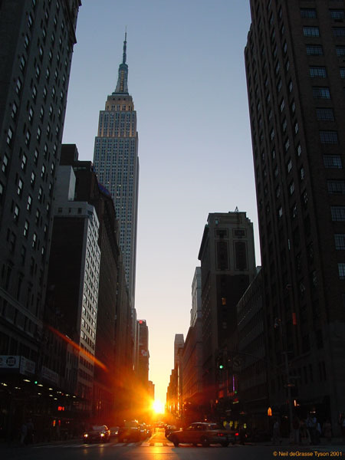

Astronomy Picture of the Day
May 28, 2004

A Manhattan Sunset
Credit & Copyright:
Neil deGrasse Tyson (AMNH)
Explanation: Today, if it is clear, Manhattan will flood dramatically with sunlight just as the Sun sets precisely on the centerline of every street. Usually, the tall buildings that line the gridded streets of New York City's tallest borough will hide the setting Sun. This effect makes Manhattan a type of modern Stonehenge, although only aligned to about 30 degrees east of north. Were Manhattan's road grid perfectly aligned to east and west, today's effect would occur on the Vernal and Autumnal Equinox, March 21 and September 21, the only two days that the Sun rises and sets due east and west. If today's sunset is hidden by clouds do not despair -- the same thing happens every May 28 and July 12. On none of these occasions, however, should you never look directly

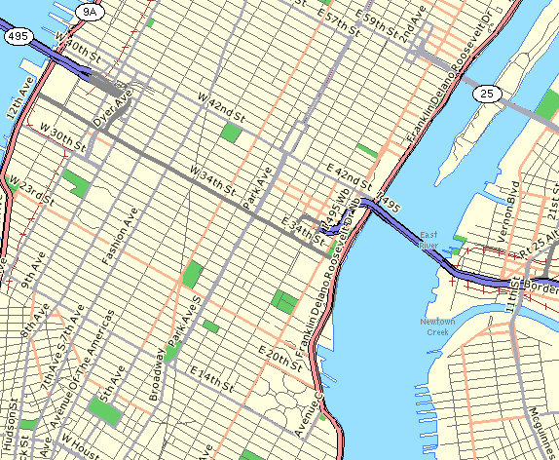
MAP of Midtown Manhattan, NYC, NY. North is up. (Courtesy mapsonus.com)

