3-Dimentional Model of the Human Eye
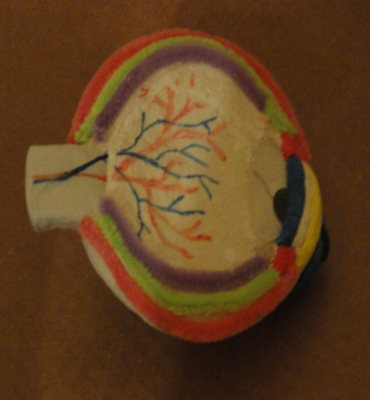
Purpose: To make a 3-dimentional cross-section model of the human eye to be used to teach parts of the eye in a Biology class.
Materials:
- Scissors
- Glue
- Colored Markers
- Modeling Clay
- Pipe Cleaners
- Plastic Spoon
- Clear Plastic Container Top
- Round Metal Mesh Drain Strainer
Procedures:
- Cover the outside of the drain strainer with modeling clay.
- Stuff the inside of the drain strainer with modeling clay to the outside rim.
- Smooth out the clay until shape of the eye is complete.
- Make an iris with modeling clay and glue it onto the outer edge.
- Use a black marker to draw a pupil onto the iris made in 4.above.
- Use colored clay to make a cornea and glue it onto the flat side.
- Use colored clay to make an iris and glue it onto the flat side.
- Use a black marker to draw a pupil onto the flat side.
- Cut an oval shape from a clear container top for lens and glue it over the pupil.
- Use colored clay to make two ciliary muscles and glue them onto the flat side.
- With the spoon, scoop out a small section of clay toward the back of the flat side.
- Use clay to make a rectangular optic nerve and glue it into the scooped out area.
- Measure and cut three pipe cleaners for 3 eye layers and glue around the outer edge.
- Use markers to draw the retinal arteries and veins.

Parts of a Human Eye
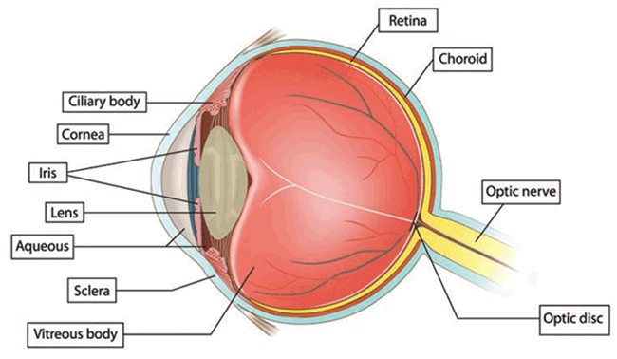

Anterior Cavity - filled with a watery substance called the aqueous fluid
Cornea - the clear bulging eye part that refracts (bends) light to help the eye focus
Ciliary Muscles – the muscles that contract or relax the lens changing its shape to focus on objects near or far
Choroid – the tissue layer between the sclera and the retina that absorbs extra light
Iris – the colored part of the eye that controls the size of the pupil
Lens – bends light coming into the eye and focuses light on the retina by changing shape
Optic Nerve- sends image information from the eye to the brain to interpret
Pupil – hole in the center of the eye where light passes through
Retina – the inner tissue layer of the eye that contains the light-sensitive cells called photoreceptors that allow us to detect movement, shape, and color
Sclera – tough, outer layer of the eyeball that protects the inside structures
Vitreous Humour – jelly-like fluid behind the lens; maintains the shape of the eyeball

3-Dimentional Model of the Human Skin
Purpose: To make a 3-dimentional cross-section model of the human skin to be used to teach parts of the epidermis in a Biology class.
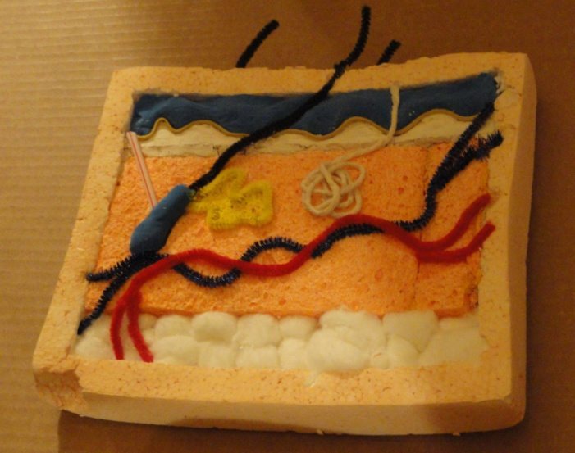
Materials:
- Scissors
- Glue
- Utility Knife
- Paint
- Markers
- One Rectangular-Shaped Styrofoam
- Sponge(s)
- Modeling Clay
- Pipe Cleaners
- Cotton Balls
- Thin Rubber Bands
- Straw
- String
Procedures:
- Hollow out Styrofoam with utility knife.
- Stick a few pipe cleaners up through the top section of the Styrofoam.
- Glue layer of cotton balls in lower part of the Styrofoam.
- Cut sponge to size and glue down in the center of the Styrofoam.
- Use modeling clay to form top layer and glue down in the upper part of the Styrofoam.
- Cut the rubber bands and glue down beneath the clay layer.
- Cut a small hollowed-out section of the sponge.
- Use modeling clay to form an oval follicle shape and glue into the hollowed-out sponge.
- Insert a pipe cleaner out of one end of the oval clay shape and glue down.
- Cut straw to size and stick one end into clay oval and glue down diagonally.
- Shape a pipe cleaner next to the oval clay follicle and glue down. Paint the inside.
- Cut a piece of string; Make a circular shape to bottom end and glue down.
- Glue down red and blue pipe cleaners.
- Paint Styrofoam skin color.

Parts of the Human Skin
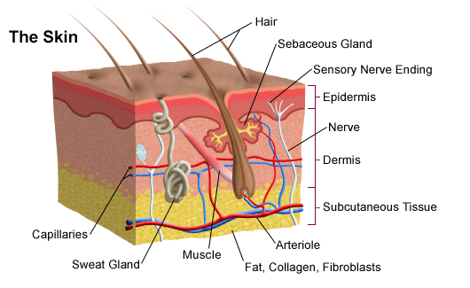

Skin Layers:
Epidermis – the outer layer of skin: prevents foreign substances from entering the body Dermis – under the epidermis: gives strength and flexibility to the skin Subcutaneous tissue - under the dermis: fatty tissue that insulates the body from heat and cold

Blood vessels – tubes that carry blood which supplies the skin with fresh blood
Hair follicle – part that is under the skin; produces the hair and the oil glands
Hair shaft – part of the hair that is above the skin
Hair erector muscle – attached to the hair follicle; when stimulated by the cold, it pulls the hair follicle up causing the hair to stand straight up
Oil (sebaceous) gland – next to hair follicles; releases oils to moisturize the hair and skin
Sweat gland – a coiled structure that produces sweat which evaporates and cools the body

3-Dimentional Model of the Human Brain (Exterior)
Purpose: To make a 3-dimentional model of the human brain to be used to teach parts of the brain in a Biology class.
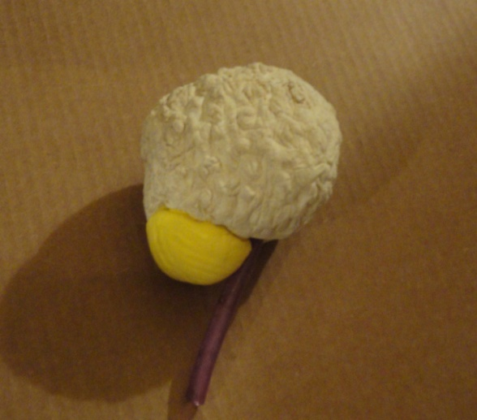
Materials:
- Scissors
- Glue
- Modeling Clay
- Jump rope
- Toothpick

Procedures:
- Use clay to shape the cerebrum.
- Use fingernail to design brain folds.
- Remove some clay down the middle of the cerebrum with a toothpick for hemispheres.
- Use clay to shape cerebellum and glue to the back underside of cerebrum.
- Cut piece of jump rope for the brain stem.
- Stick jump rope through the underside of cerebrum to make a hole.
- Glue jump rope into the hole.

3-Dimentional Model of the Human Brain (Interior)
Purpose: To make a 3-dimentional model of the human brain to be used to teach parts of the brain in a Biology class.
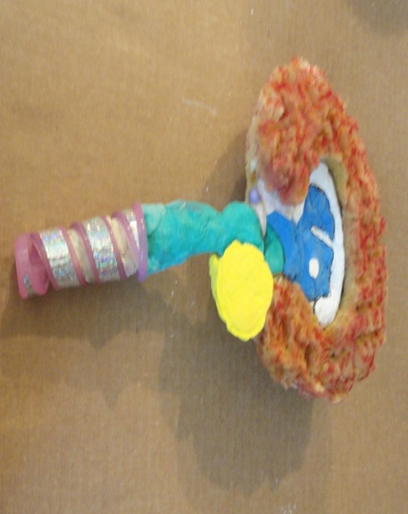
Materials:
- Sponge Roller
- Scissors
- Glue
- Colored Markers
- Modeling Clay
- 2 Loofah Sponges
- Large Plastic Yogurt Container Top
- Large Button
- Spiral Tubing (handle of jump rope)

Procedures:
- Remove sponge from the roller.
- Cut out a section from the plastic yogurt container top.
- Glue the horizontal end of the roller inside the yogurt container top with the vertical part of the roller coming out from the opening that was cut out in 2. above.
- Fill the inside of the yogurt container top with clay and cover over the roller.
- Shape the midbrain, pons, and medulla with clay and glue to the vertical roller handle.
- Use a marker to color the medulla, pons, and midbrain.
- Shape the corpus collosum with clay and glue onto the container top.
- Shape the ventricles/thalamus/hypothalamus with clay and glue onto the container top.
- Cut off the crinkled part of the 1st Loofah sponge and glue it around the container top.
- Cut off crinkled part of 2nd Loofah sponge and glue onto the back of the container top.
- Use a marker to color the front and back of the Loofah sponges.
- Shape cerebellum and glue it onto a large button or other circular object.
- Glue button to handle and lower part of the loofah sponge.
- Shape cerebellum and glue to back of the button and back of the handle.
- Cut off spiral end of jump rope and insert over the end of handle for the spinal cord.
- Shape the pituitary gland and glue on. Use a marker to color the pituitary gland.
Parts of a Human Brain

External View of the Brain Cross Section of the Brain
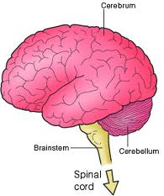
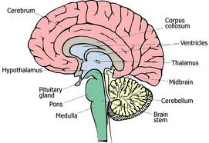

Brainstem – connects the brain’s cerebrum to the spinal cord. The brain stem controls many automatic and motor functions. The brain stem is made of three parts:
- Midbrain- controls visual and auditory reflexes e.g. blinking, eyelid opening
- Medulla- controls automatic functions such as coughing, swallowing, heartbeat, blood pressure, vomiting, breathing
- Pons- connects spinal cord and medulla with the brain; helps regulate respiration
Cerebellum- regulates balance, posture, movement, and muscle coordination
Cerebrum – It is the largest part of the brain. It controls thought, learning, memory, language, vision, hearing, touch, vision, smell, emotions and voluntary movement. It is divided into right and left hemispheres.
Corpus collosum-a bundle of nerve fibers that connects the right and left hemispheres
Thalamus – sends sensory information between the spinal cord and the cerebrum
Hypothalamus-controls body temperature, sleep, hunger and thirst
Pituitary gland-controls the functions of the other hormone-producing glands.
3-Dimentional Model of the Human Heart
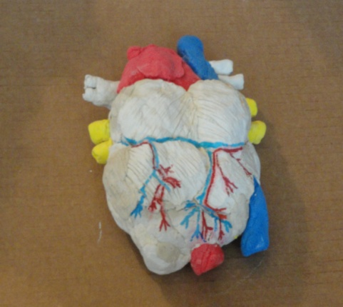
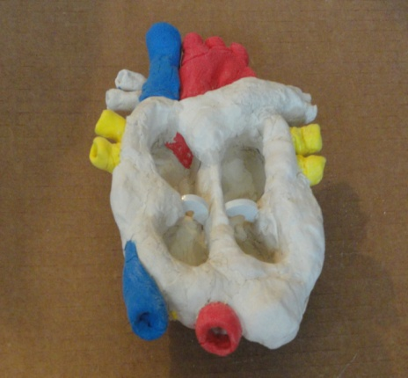
Purpose: To make a 3-dimentional cross-section model of the human heart to be used to teach parts of the heart in a Biology class.
Materials:
- Scissors
- Glue
- Colored Markers
- Modeling Clay
- Butterfly-Shaped Cookie Cutter
- Rounded Eraser (Back of Pencil)
- Toilet Seat Hinge Bolt Washer

Procedures:
- Cover the outside of the butterfly cookie cutter with modeling clay shaping a heart.
- Use clay to make a septum and glue it in the center of the cookie cutter.
- Smooth out the clay until the shape of the heart and the septum is complete.
- Make left pulmonary artery with modeling clay and glue it onto the cookie cutter.
- Use colored clay to make an aorta and glue it onto the top/bottom of the cookie cutter.
- Use colored clay to make a superior vena cava and glue it onto the top of the cutter.
- Use colored clay to make an inferior vena cava and glue it onto the bottom of the cutter.
- Make right pulmonary arteries with modeling clay and glue it onto the cookie cutter.
- Use colored clay to make right/left pulmonary veins and glue them onto sides of cutter.
- With the eraser end of the pencil, stick into ends of all veins/arteries to make openings.
- Cut washer in half. Glue each half to the septum and a side of the cutter.
- Cover the back of the cookie cutter with modeling clay and shape external heart.
- Use pencil point to make cuts on the outside clay to look like heart muscle.
- Use markers to draw the arteries and veins on the back.

Parts of a Human Heart

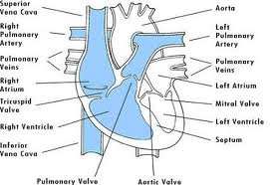

Aorta – artery that carries oxygen-rich blood away from the left ventricle to the body.
Inferior vena cava – a large vein that carries oxygen-poor blood to the right atrium from the lower half of the body.
Left atrium – the left upper chamber of the heart that receives oxygen-rich blood from the lungs by way of the pulmonary vein
Left Ventricle – the left lower chamber of the heart. It pumps blood into the aorta.
Mitral Valve – the valve between the left atrium and left ventricle that prevents blood from flowing back to the left atrium
Pulmonary artery – artery that carries oxygen-poor blood from the right ventricle to the lungs
Pulmonary vein- vein that carries oxygen-rich blood from the lungs to the left atrium
Right atrium – the right upper chamber of the heart. It receives oxygen-poor blood from the superior vena cava and the inferior vena cava.
Right ventricle – the right lower chamber of the heart. It pumps blood into the pulmonary artery
Septum – the muscular wall that separates the right and left sides of the heart
Superior vena cava- a large vein that carries oxygen-poor blood to the right atrium from the upper parts of the body
Tricuspid valve- the valve between the right atrium and the right ventricle that prevents blood frowing back to the right atrium

