Shadows Worksheet

NAME: ___________________________

Base your answers to questions 1 through 5 on the diagram below, which represents a model of the sky above a vertical post in New York State. The diagram shows the position of the Sun at solar noon on September 23 and the position of Polaris above the horizon.

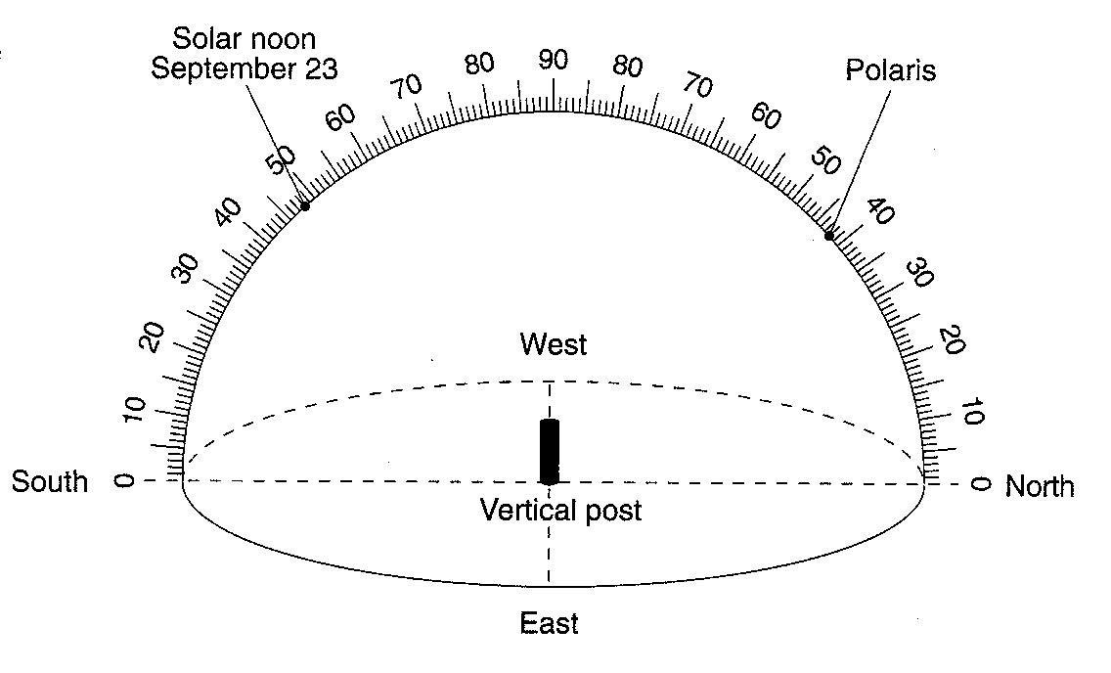
1. On the diagram above, draw the apparent path of the Sun across the sky on September 23 from sunrise to sunset.

2. On the diagram above, draw the shadow of the vertical post as it would appear at solar noon on September 23.

3. Place an X on the diagram above to indicate the altitude of the Sun at solar noon on June 21.

4. How many degrees will the Sun appear to move across the sky from 1 p.m. to 3 p.m. on June 21?

5. At which latitude is this vertical post located? Include the unit and compass direction in your answer.

