Latitude and Longitude Worksheet
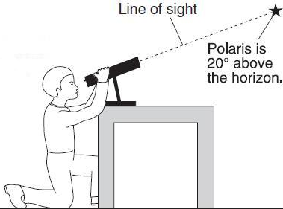
NAME: ___________________________

The diagram to the right shows an observer measuring the altitude of Polaris.

1.______ What is the latitude of the observer?

(1) 20ºN (2) 20ºS (3) 70ºN (4) 70ºS

2.______ What time is it in Greenwich, England (at 0º longitude) when it is noon in Massena, New York?

(1) 7 a.m. (2) noon (3) 5 p.m. (4) 10 p.m.
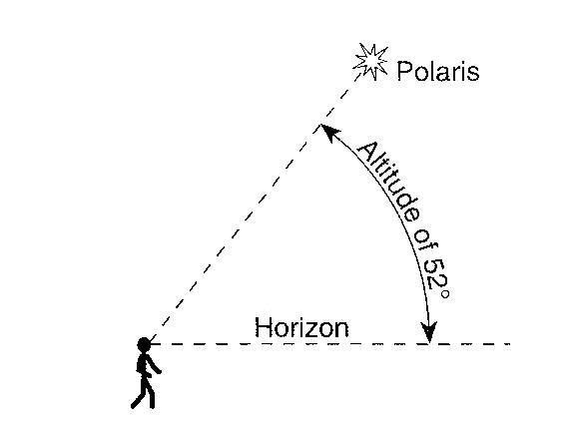
3.______ The diagram to the right shows an observer on Earth viewing the star Polaris. What is this observer’s latitude?

(1) 38ºN (3) 52ºN
(2) 38ºS (4) 52ºS

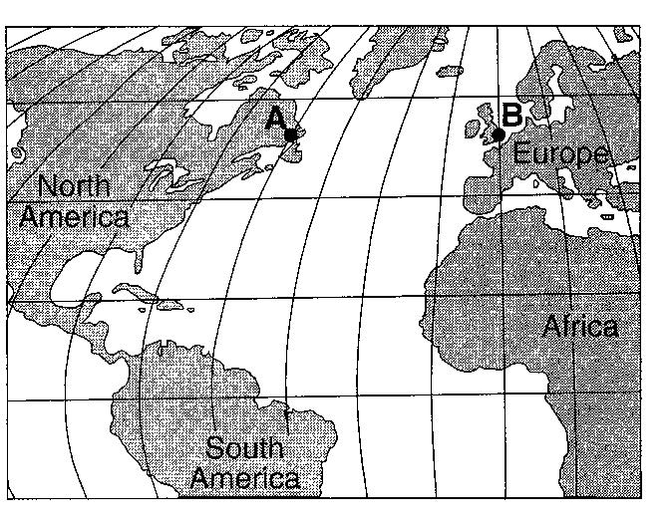
4. On the map to the right, there is a four-hour solar time difference between locations A and B. What is the difference in longitude between locations A and B?

(1) 15º (3) 45º
(2) 23.5º (4) 60º

5. The mineral chrysotile is found with other minerals in New York State mines located near
44º 30’ N, 74º W. In which New York State landscape region are those mines located?

6.______ What is the approximate location of the Canary Islands hot spot?

(1) 32ºS 18ºW (2) 32ºS 18ºE (3) 32ºN 18ºW (4) 32ºN 18ºE

