The Candle Lab

(Created from an activity from the Next Generation Standards Symposium Awareness to Transition Rollout Training in Hayward, California on 9/15/15)

The Basic Investigation: Grades 3-8 – Can be modified for younger students

Student Materials
(Per group of 2 students. “Students” abbreviated hereafter as “Ss”):

- 1 small clear deli-tub or 1 foam plate- like a paper plate, but made from foam (with grooves*)
- one 12 oz. glass jar (like a canning Mason jar) (NOT plastic),
- 2 birthday cake-type candles,
- 1 half-dollar-sized piece of modeling clay (NOT Play-Doh©),
- approx. 100ml blue water (may need more with plates…test it!)
- 1-2 paper towels,
- 2-safety googles,
- lab tub (optional),
- plastic cup for water,
- measuring cup (100ml or greater),
- 1 to 1½ inches of blue tape aka “Painter’s tape”

*with a pen cap or the handle end of a plastic utensil, scratch a series of 5-6 lines horizontally and then a second set vertically into the flat face of the plate. DO NOT PUNCTURE! Cover at least ½ of the space in the middle of the plate face. This will allow water under the jar and keep the suction from securing the plate to the jar during the activity. DO NOT USE PAPER PLATES!!! You can reuse the foam plates for years!

Teacher Materials:
Approximately 4 liters of tap water colored blue (a 2-liter soda bottle works great!), 1 or 2 electronic matches (like an Aim ‘n Flame©)

Getting Ready
Get all materials placed in a lab tub for each group. Provide only 1 candle now and have the others out of site but available for the second go-round.
Please have established the routine or make it implicit prior to Ss entering the lab area or classroom that they do not touch lab materials prior to instruction on their use and the Safety Talk that occurs before every lab.

Students really should somehow measure the water they will use. If you do not have 100ml measuring cups, you could mark the inside of the plastic cup with a sharpie pen at the 100ml line. If the cups are clear or semi-transparent, you can place a piece of blue tape on the cup and have students pour the blue water from the “holder cup” (containing more than the required amount) into the “measuring cup” up to the marked line or the top or bottom of the tape.

Have lab-tubs on tables or over-lapping the partners’ desks when students enter.

Procedure: (60-75 minutes) (Practice 2)

- Ask Ss to write their heading (date and title “The Candle Lab”) into their Science Notebook. Discuss that since the title says “Candle” that it kind of implies that they will be using fire today. And because of this, you have to talk about…”Safety!!”
Have them write the sub-heading “Safety “ on their page as you do on the board.

- Have students discuss candle safety with their partner for 1 minute and then brainstorm 4 or 5 good suggestions of how to be safe around fire. Write them on the board as they add them to their Notebooks. Elicit or add these: sleeves are up above the elbows or remove jackets. NEVER reach across an open flame…reach around with the other hand. Keep each other safe!

During the lab, be sure to check for sleeves coming down and reaching across the flame!

- Transition the discussion to the fire triangle (and have them add it to their Notebooks as you draw it on the board) and the 3 things that fire needs to exist: Oxygen, fuel (in this case the wick and the wax of the candle), & heat (to start the fire). To put out a fire one of those needs to be eliminated. Fire extinguishers usually remove the oxygen by smothering the fire. Ask them to keep this in mind as they do todays’ investigation.

https://en.wikipedia.org/wiki/Fire_triangle

- “So, let’s start our investigation!” First thing is to have the Ss place their clay in the middle of the plate or deli-tub and push it down a little. The jar must fit over the clay completely, so they shouldn’t smoosh it too flat.

- Next have them place the candle in the clay with the point up! (You’d think that this is obvious, I know, but you’d be surprised!)

- Describe how to and then have Ss measure out 100mls of the blue water and pour it in to the deli-tub/plate.

- Tell them that you are going to come around and light all of the candles and that they are going to wait until all have been lit and that the whole class will place their jars up-side-down over the candle/clay carefully and quickly and that all Ss will do this at the same time. Remind Ss not to touch or blow out the flame while they are waiting…just watch it and maybe sing Happy Birthday quietly to themselves while they wait.
🎉

- Show them how to turn and place the jar & maybe even have the jar-flipper-student practice it once or twice. ***Ss often want to be the one who uses the jar, so be sure to tell them that they will be doing this experiment twice and that both will get to be the jar-flipper.

- Tell them that once the jar goes over the candle, things will happen pretty fast and that they are to be observing as much as possible of what transpires. Tell them (especially if the Ss are grades 3 and 4) that here are at least 3 things that they can see happening after the flip. They should NOT TOUCH THE JAR again until asked to and they will watch carefully and then write down their observations.
Making careful observations is A VERY important part of Science!

- Discuss the differences between observations (the “what” of the happening) and opinions or explanations (the “Why”). We only want the “what” right now. Making observations is a lot like putting a video or photo into words…maybe like if you were telling a friend over the phone what is happening on an episode of your favorite show…”Ok, she’s walking across the gym and she goes right up to the door, puts her hand on the door, stops, turns around, smiles at Jimmy and then pushes the door open and walks out!”

Have Ss write the in their Notebook

“Investigation 1: Observations” and number 1, 2, and 3 below, skipping a line between each.

- Go around and light the candles reminding them to wait patiently for everyone’s to be lit. Then…

- Guide them through flipping the jar and lowering it down over the candle maybe counting to 3 when the jar will be set down and released.

- As the activity progresses remind them not to look anywhere but at their own experiment.

- Check to see if any group’s candle is out but no water is rising in the jar. If that is the case, it may be suctioned to the bottom. The Remedy is…. a great song by Jason Mraz. Ha! But in this case it is to ever-so-carefully tip the jar keeping part of the mouth in contact with the base while holding the deli-tub until that suction is broken without tipping the edge of the jar out of the water. Feel free to restart any group’s experiment that has gone astray so that they can still participate.

- When you see that the reaction is over, instruct the Ss to work with their lab partner to write their observations in order of what happened first, second, etc. reminding them to keep the statements factual, not interpretive!

- Discuss what they saw IN THE ORDER of what happened and have Ss add to their observations as they hear interesting, well-said or descriptive phrases. NO erasing! Just add new ideas or details!!

- In addition to writing observations scientists always make drawings to show what happened in an investigation, and so now they will draw this first experimental model. This becomes the visual accompaniment to their observations.
Variations of the model can include modeling the gas (type and amount) in the jar before and after the experiment.

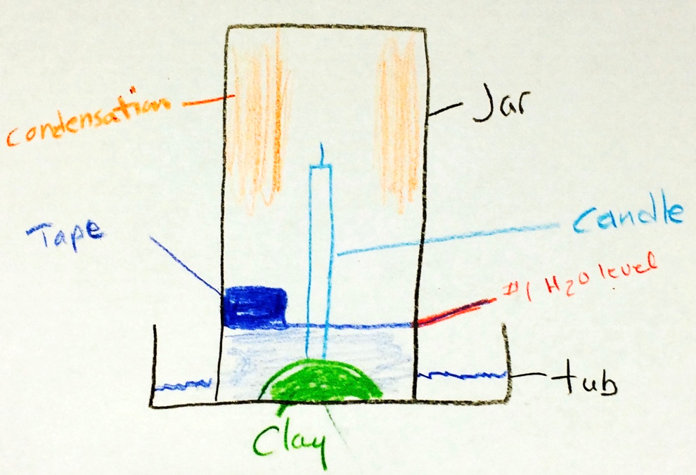
Add measurement indicator of choice after step 20
ALL drawings should be: 1) Large, 2) detailed, 3) accurately-labeled and 4) neatly drawn.
**When working with younger students or near the start of the year you should draw & label this with the students one part at a time.

- Ask “If we were going to do this activity again, what kinds of things could we change to see how it affects or IF it affects the outcome?” Brainstorm on the board & ask Ss to add as many as they like. Remind Ss that you must change and retest only one thing (variable) at a time. Model “I wonder what would happen if we __________?”. Examples from my own student experiences include: using a different liquid, using a larger (smaller) jar, using bigger candles, and using more candles.

- Tell students that you have the supplies to try the last one named above and ask if that would be ok with them. I’ve never had a class decline!

- BEFORE MOVING ANYTHING ask Ss how you will compare the 2 investigations? Elicit ideas: take a picture, measure, mark the jar, etc. Have Ss chose one (either as a class or per group) and make note of the water level before going on to the next step. Blue tape works well. HAVE Ss ADD THE TAPE, etc. TO THEIR DRAWING!!

- To remove the jar without making a mess, hold the deli-tub or plate and tip the jar as in step 13 until it is out of the water and the suction is broken.

- Have Ss place the jar MOUTH UP in the lab-tub so that air can re-enter. Pass out another candle to each group and have them place it in the clay next to the first…close but not touching.

- Put an observation area in their Notebooks as before with the label for “Investigation 2” with 1-3 numbered on every other line. Tell them that this time their observations will be comparative. Share an example of noticing how the speed of the flame fades with 2 candles compared to the 1 candle experiment.

- Remind Ss that the other student may place the jar this time and practice if needed.

- Light the candles as before reminding students of safety practices!

- As before, place the jars over the candles together and observe.

- Repeat writing detailed observations.

- Repeat discussion of observations emphasizing the differences between the 2 investigations and have Ss add to their own observation statements as before.

- Again discuss what they would do next (new or different variable) if you were to continue with this activity. Have Ss add top 3 to their Notebooks under the heading “Further Investigations”.

- Discuss safety and details if they want to do this at home – MUST have an adult present, MUST use glass and not plastic to cover the candle, do not have to have colored water.

Extensions- the BEST PART!!! (Practice 3)

This is an amazing place to let the kids take off and try some of the variables discussed or to come up with new ones to test!!

It is through these extensions that Ss incorporate the NGSS theme of Ss designing and conducting their own experiment. Due to these activities deeper understanding and internalization of concepts occurs.

**Strict rules surrounding approval of each experiment by the instructor prior to testing and the instructor being the only one to light the candle each time must be set up, discussed and observed!

A suggestion would be to have one period where Ss could write up 1-3 investigations (including materials and procedures) and have them approved. Then at the next meeting the investigations would be completed.

If you have any questions or suggestions, please feel free to contact me at ikastelic@smfcsd.net
So, do your Ss want to know why this happens?

It is not a simple explanation and scientists disagree quite a bit as to the primary cause(s). Most do agree that is has to do-at least partially-with the consuming of oxygen, air pressure differences and temperature change.

This is a great discussion to have with your class and to emphasize that even the top scientists don’t really know the answer!

Ah! The beauty and mystery of the unknown!!
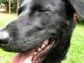

This is a Happy Lab!

