Red Shift Worksheet

NAME: ___________________________
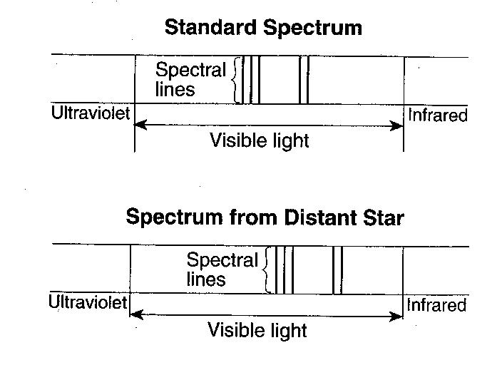
The diagram to the right shows a standard spectrum compared to a spectrum produced from a distant star.

1.______ Which conclusion can be made by comparing the standard spectrum to the spectrum produced from this distant star?

(1) The star’s spectral lines have been shifted toward the ultraviolet end of the spectrum and the star is moving toward Earth.
(2) The star’s spectral lines have been shifted toward the ultraviolet end of the spectrum and the star is moving away from Earth.
(3) The star’s spectral lines have been shifted toward the infrared end of the spectrum and the star is moving toward Earth.
(4) The star’s spectral lines have been shifted toward the infrared end of the spectrum and the star is moving away from Earth.

2.______ Evidence that the universe is expanding is best provide by the

(1) red shift in the light from distant galaxies
(2) change in the swing direction of a Foucault pendulum on Earth
(3) parallelism of Earth’s axis in orbit
(4) spiral shape of the Milky Way galaxy

The diagram to the left shows the spectral lines for an element.
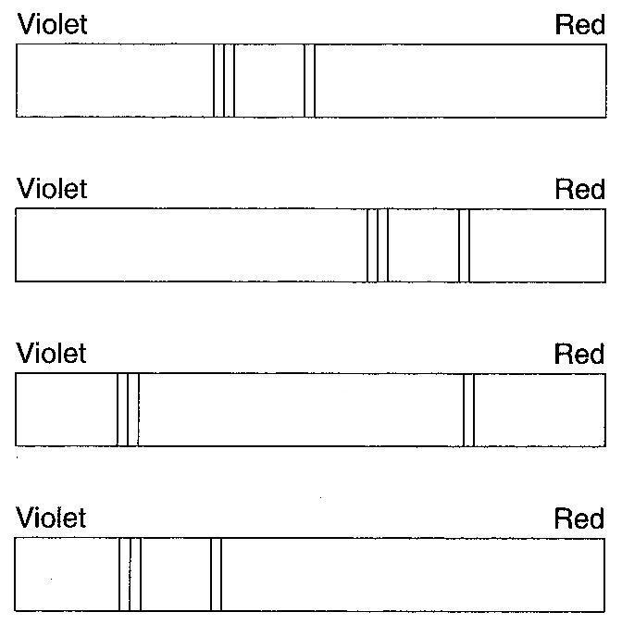
3.______ Which diagram to the right best represents the spectral lines of this element when its light is observed coming from a star that is moving away from Earth?

