Crazy Animal Adaptations

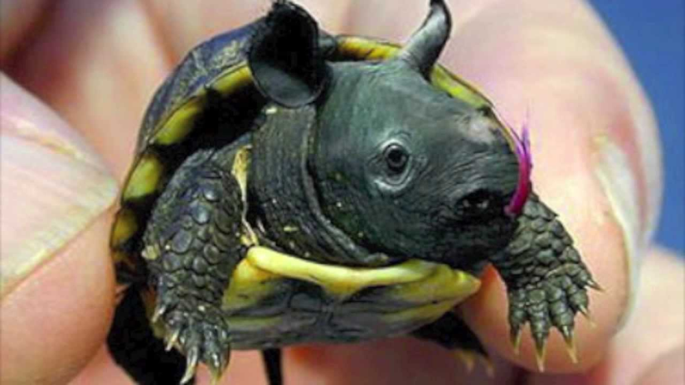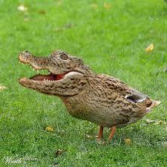
rhinoturtle dalligator
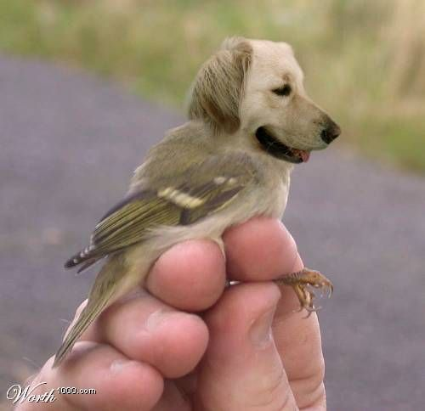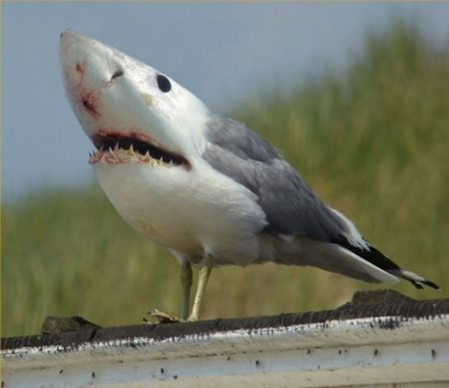
goldenarrow sharkgull

These are some funny combinations. Can you think of one on your own?
You can put together either 2 animals, 3 animals or 4 animals. Draw your animal on white copy paper. Answer these questions on a separate sheet of paper and tape it on the back of your picture.

- You must come up with a name for your animal.
- For each animal you choose, you must name the body part that is represented and how it helps the animal. Example: dog head (golden retriever) - great smell, night vision, excellent hearing. Bird body (sparrow)- can fly and grab its prey in it’s claws to eat.
- Be creative!!!

