Gradients Worksheet

NAME: ______________________________



In the empty space below the diagram, calculate the gradient between points A and B. **Make sure you use and show the 3-step process.**

1. _____ What is the gradient along the straight line between points A and B?

(1) 10 ft/mi (2) 20 ft/mi (3) 25 ft/mi (4) 35 ft/mi

2. What compass direction is the Green River flowing?

In the empty space next to the top the diagram, calculate the gradient between points X and Y. **Make sure you use the 3-step process.**

3. _____ What is the gradient between points X and Y?

(1) 40 m/km (2) 80 m/km

(3) 100 m/km (4) 120m/km



4. Calculate the gradient of the ocean floor between locations A and D and label your answer with the correct units. **Make sure you use and show the 3-step process and circle your final answer with the correct units.**

5. Calculate the gradient of the ocean floor between locations B and C and label your answer with the correct units. **Make sure you use and show the 3-step process and circle your final answer with the correct units.**

6. Which direction is Copper Creek flowing?

7. Is the gradient steeper between B and C or between M and N **and how do you know?**

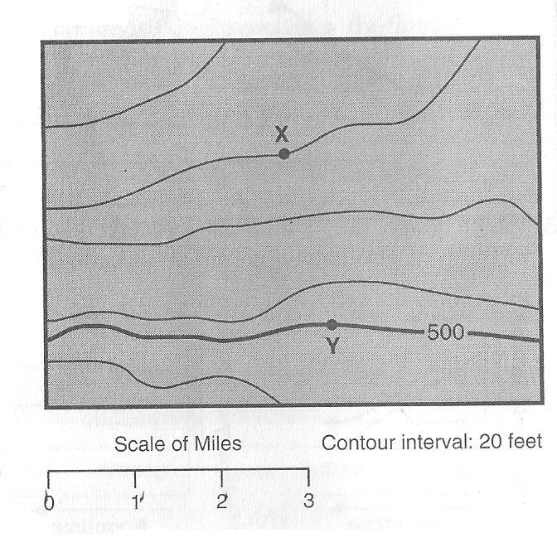8. __________ What is the approximate gradient between X and Y?

(1) 15 ft/mi (2) 20 ft/mi

(3) 30 ft/mi (4) 60 ft/mi

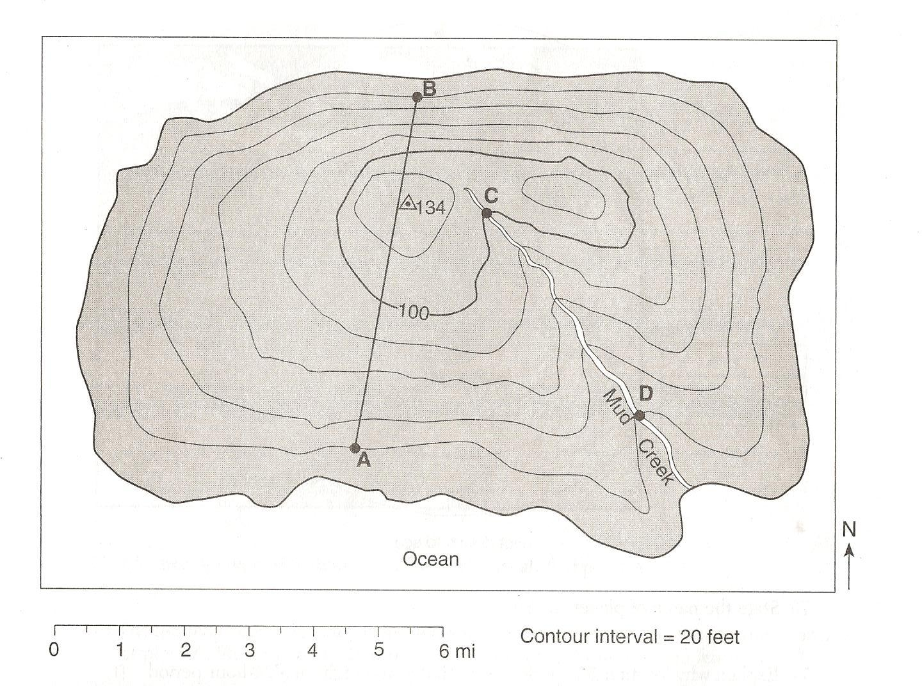

9. What is the gradient between C and D? **Show your work and circle your answer!**

10. What direction is Mud Creek flowing?

11. What side of the hill has the steepest gradient?

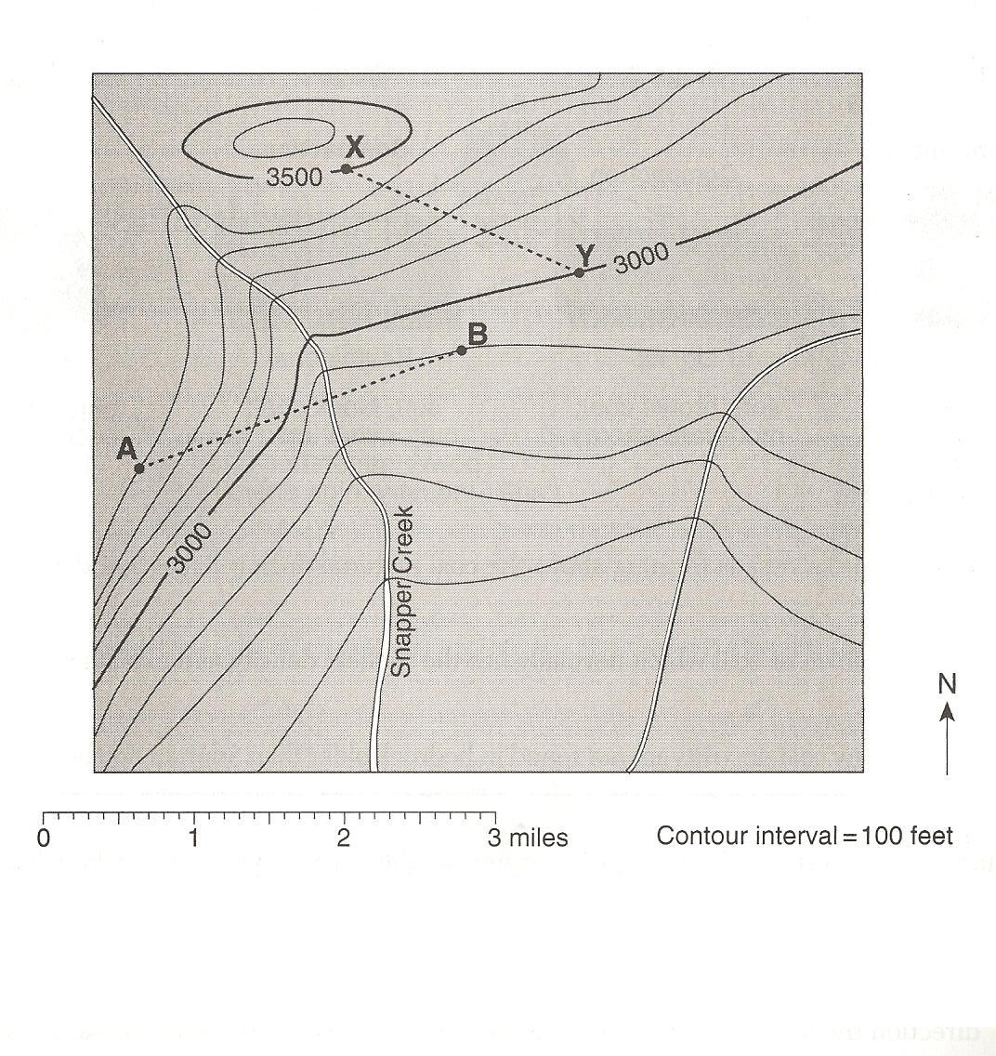12. What is the gradient between points X and Y? **Show your work!**

13. What direction is Snapper Creek flowing?