Landscapes Worksheet

NAME: ___________________________



1.______ Which block diagram to the right represents a portion of a plateau?

2.______ New York State landscape regions are identified and classified primarily by their

(1) surface topography and bedrock structure (3) latitude and longitude

(2) existing vegetation and type of weather (4) nearness to bodies of water

3.______ New York State’s Catskills are classified as which type of landscape region?

(1) mountain (2) plateau (3) lowland (4) plain

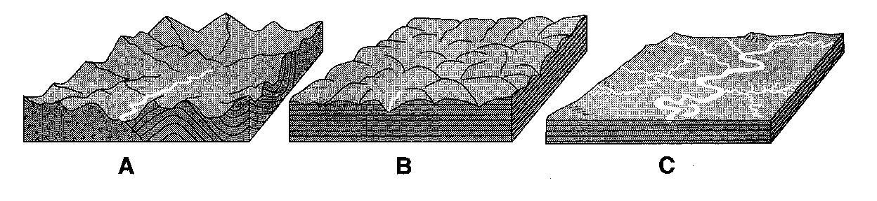The block diagrams to the right, labeled A, B and C, show the relative elevation and rock structure of three different landscape regions.

4.______ Which set correctly identifies the landscape region shown in each block diagram?

(1) A-mountain, B-plateau, C-plain (3) A-plateau, B-mountain, C-plain

(2) A-mountain, B-plain, C-plateau (4) A-plateau, B-plain, C-mountain

5.______ New York State’s generalized landscape regions are identified primarily on the basis of elevation and

(1) bedrock structure (2) climate zones (3) geologic age (4) latitude

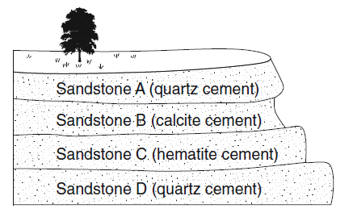The diagram to the right shows an outcrop of different layers of sandstone in a region receiving heavy rainfall.

6.______ Which sandstone layer in the diagram to the right appears to be the *least* resistant to weathering?

7. What characteristic of the sandstone layer you chose would explain it’s being less resistant to weathering?

8.______ The classification of landscape regions is primarily based on which factors?

(1) climate, vegetation, and surface features (3) state boundaries, streams, and rivers

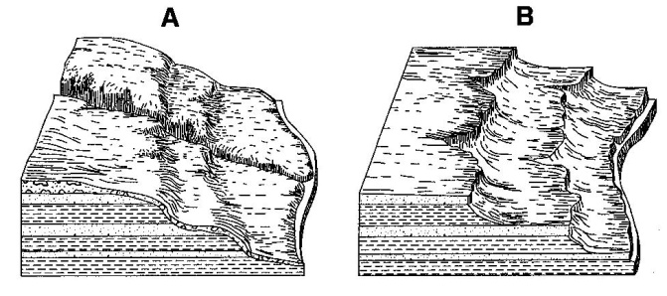(2) bedrock type, structure, and elevation (4) nearness to mountains, lakes, and streams

The block diagrams to the right show landscape regions labeled A and B.

9.______ What is the most probable cause of the difference in surface features between A and B?

(1) A is the result of a humid climate, while B is the result of a dry climate

(2) A is at a high elevation, while B is located at sea level

(3) A is a plateau region, while B is a mountainous region

(4) A is composed of igneous bedrock, while B is composed of sedimentary bedrock

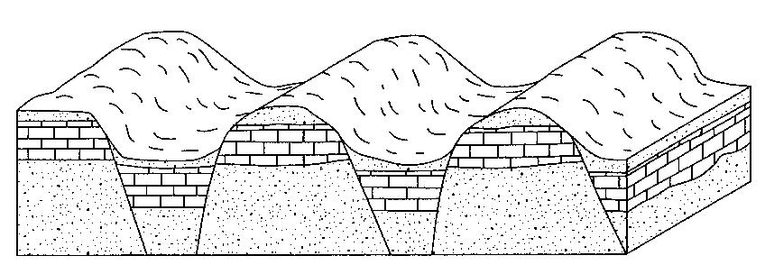The block diagram to the right shows a region that has undergone faulting.

10.______ Which map below shows the stream drainage pattern that would most likely develop on the surface of this region.?

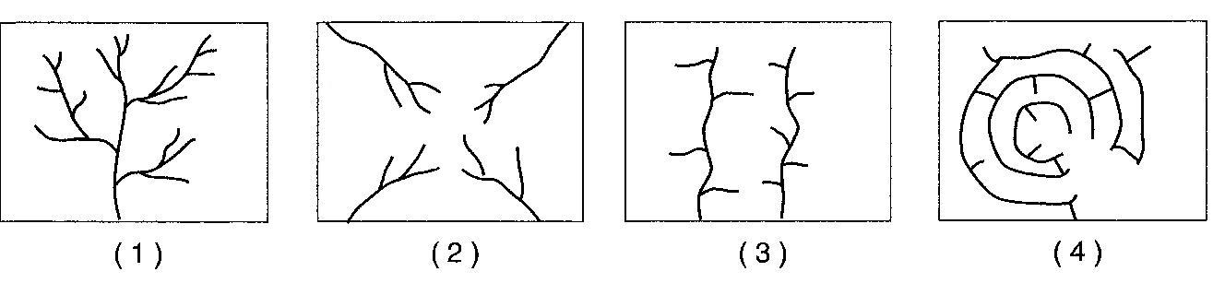

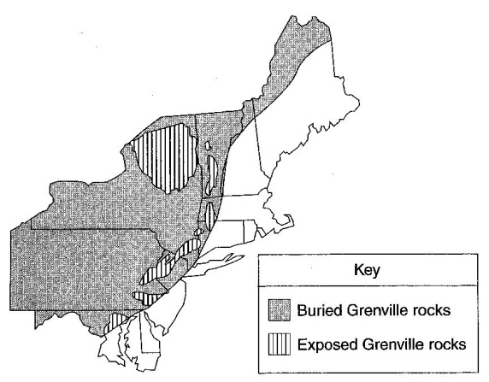The map to the right shows the location of Grenville-age bedrock found in the northeastern United States.

11.______ In which New York State landscapes is Grenville-age bedrock exposed at Earth’s surface?

(1) Erie-Ontario Lowlands and St. Lawrence Lowlands

(2) Catskills and Allegheny Plateau

(3) Tug Hill Plateau and Atlantic Coastal Plain

(4) Hudson Highlands and Adirondack Mountains