Streams Worksheet

NAME: ___________________________
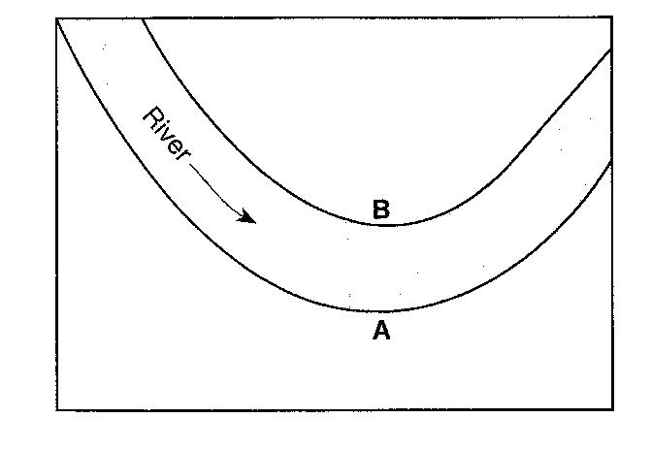
The map to the right shows the path of a river. The arrow shows the direction the river is flowing. Letters A and B identify the banks of the river.

1.______ The water depth is greater near bank A than bank B because the water velocity near bank A is

(1) faster, causing deposition to occur
(2) faster, causing erosion to occur
(3) slower, causing deposition to occur
(4) slower, causing erosion to occur

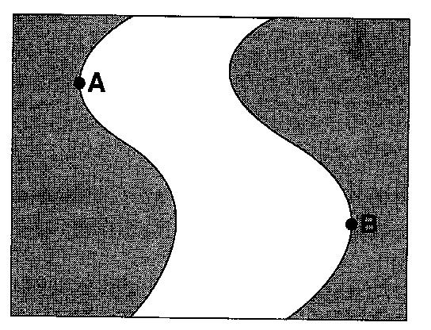
The map to the right shows a meandering river. Points A and B are locations on the bank of the river.

2.______ What are the dominant processes occurring at locations A and B?

(1) deposition at location A; erosion at location B
(2) erosion at location A; deposition at location B
(3) deposition at both locations A and B
(4) erosion at both locations A and B

3.______ Deposition within a meandering stream usually occurs on the inside of the curves because the

(1) water velocity decreases (3) water is deeper
(2) stream gradient decreases (4) stream is narrower

4.______ A meandering stream deposits most of its sediments on the

(1) inside of meanders where the stream flows faster
(2) inside of meanders where the stream flows slower
(3) outside of meanders where the stream flows faster
(4) outside of meanders where the stream flows slower

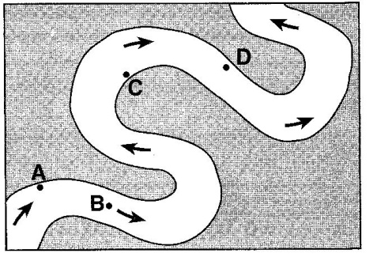
The map to the right shows a meandering stream. Points A, B, C and D represent locations along the stream bottom.

5.______ At which location is the greatest amount of sediment most likely being deposited?

(1) A (2) B (3) C (4) D

6. Describe two surface characteristics that will affect the rate of stream runoff into the ocean.

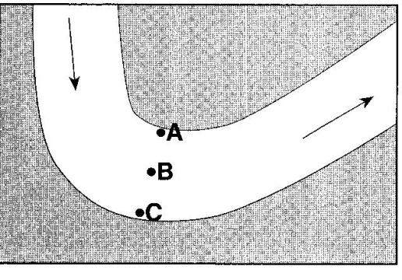
The map to the right shows the bend of a large meandering stream. The arrows show the direction of stream flow. Letters A, B and C are positions on the stream bed where erosion and deposition data were collected.

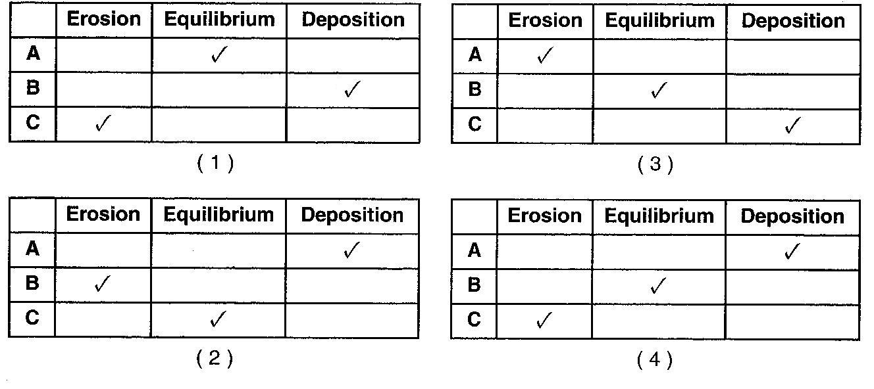
7.______ Which table below best represents the locations where erosion and deposition are dominant and where an equilibrium exists between the two processes? (A check mark represents the dominant process for each lettered location.)

