Name: __________________________________________ Period: _______
Spectroscopy and the Doppler Effect Lab
Spectroscopy is the analysis of light spectra and the way in which light interacts with matter. When light is analyzed it is commonly separated into its component colors. The light source is directed on a slit and the "beam" of light is separated using a prism or grating.  The reason that the images are lines is that the light from the lamp is focused on a narrow slit. The illustration shows the separation of a light beam into its component colors. |  | 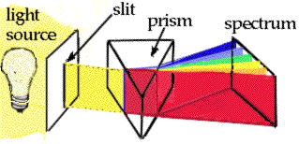
 |  | You can see the specific colors emitted by the light source. A white light (Tungsten lamp or white fluorescent lamps) source will give a spectrum like the one shown above. This is an example of a continuous spectrum, also known as the visible spectrum of colors.
Each color has a characteristic wavelength. The wavelength is the distance between the beginning and end of a complete cycle of the light wave or the distance from one crest to the next. The crest is the tallest part of a wave and the trough is the lowest point of a wave. All colors of light travel at the same speed, 300,000 kilometers/ second. The animation shows how a prism separates photons of red light from photons of blue light. The photons of different colors fall in different positions on the color spectrum. The position is determined by the wavelength.
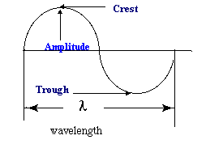
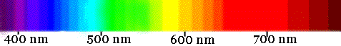
Blue light has shorter wavelength in the range of 400 nm (4000 Ångstrom or 0.00000004 m)

Red light has longer wavelength and is lower in energy than blue light. The wavelength of red light corresponds to the range of 700 to 600 nanometers, (7000 Ångstrom or 0.0000007 meters).

3 Types of Spectra

1. Continuous Spectrum- produced by a glowing solid, liquid, or gas under certain conditions. This spectrum consists of a continuous set of emission lines side by side, with no gaps, and appearing as a smooth transition of all colors from red to violet.
2. Dark-Line Spectrum / Absorption Spectrum- produced when a cooler gas lies between the observer and an object emitting a continuous spectrum. The cooler gas absorbs specific wavelengths of radiation passing through it. This spectrum appears as a continuous spectrum of all colors with a number of gaps or dark lines throughout it.
3. Bright-Line Spectrum / Emission Spectrum- produced by a glowing gas which radiates energy at specific wavelengths characteristic of the element or elements composing the gas. This spectrum consists of a number of bright lines against a dark background. Different elements produce different spectra. These different spectra are called the atomic spectra and are unique enough to be thought of as a finger print of the element.
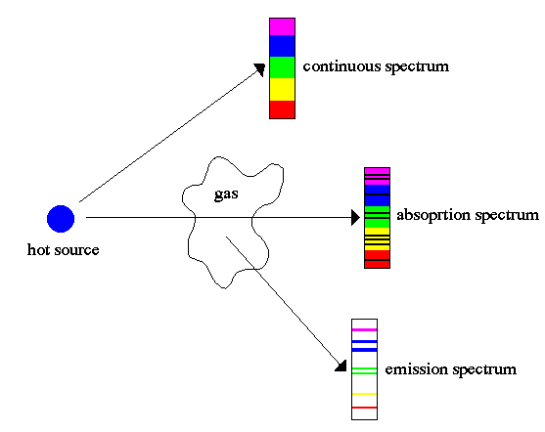
Procedure:
How to use the spectroscope: A spectroscope is similar to a prism in that it can break up light into its component. At one end of the spectroscope is a square film of material that acts like a prism. The film is called a diffraction grating. It is made by putting thousands of grooves on a plastic film. This bends the light coming through it and, in essence, causes the light to spread out into its different wavelengths of light (colors). This is the end of the spectroscope you look through. Look through this end now and aim the wide end at the light source.
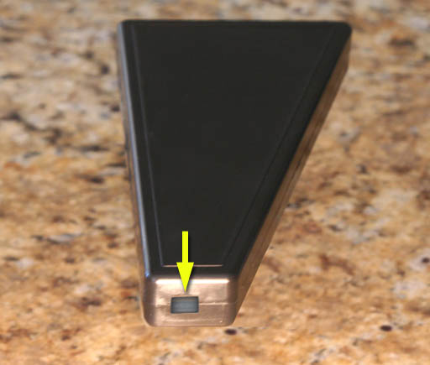
Look to the right in the scope without moving the spectroscope and you will see numbers and colors like this
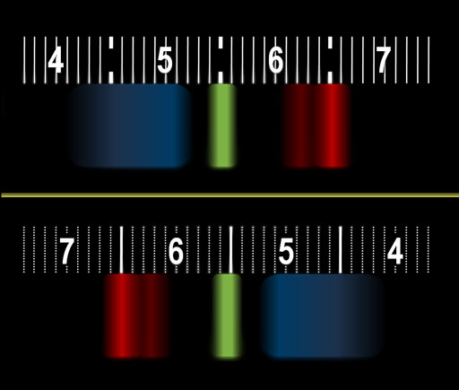

The numbers you see are the wavelengths of the light measured in hundred nanometers. The bright red band has a wavelength of 650 nanometers. The green band is about 550 nanometers. The wide blue band ranges from 450 nanometers (nm) - 520 nm. The spectrum from your monitor might look different but you should see different color bands.

- Look through your spectroscope at the classroom lights and draw what you see below:

- Go to the window and aim your spectroscope outside, draw what you see below:

- Now go to the black boxes in the room and draw what you see in the corresponding boxes:

HYDROGEN

HELIUM

OXYGEN

Questions:

- What is the difference between the continuous (solar) spectrum you drew and the spectra of the elements that you drew?

- What happens to frequencies as wavelengths increase in the electromagnetic spectrum on page 14 in the ESRT?

- How do scientists use spectra of stars to determine the elements of the stars?

DOPPLER EFFECT
One fish, two fish, red shift, blue shift (sorry Dr. Seus)
When a star is moving away from the Earth the wavelength increases and it looks more reddish. This is red shift phenomenon; when a star is moving closer to the Earth it appears slightly blue, and this is blue shift phenomenon.
But how exactly this thing happens? Well, that relates to frequency and wavelength of lights. This is just similar to frequency of sound. For example, When a police car with siren moves towards you, the pitch of the siren sound (which is the frequency of a sound wave) will get higher and higher and reach maximum when it is closest to you, then after it passes you, the sound will get dimmer and dimmer because the frequency of a sound wave is getting lower and lower.
Here is the thing you need to know: blue light has a higher frequency (and lower wave length, but we only need to focus on frequency here) compared to red light. So just replace the police car with a star in the above paragraph, we will get this:
When a star moves towards you or Earth (you are in the Earth, aren't you?), the frequency of light will get higher and higher and reach maximum when it is closest to you (you always see bluish color here), then after it passes you, the frequency will get lower and lower (reddish color). The star may not be necessarily passing the Earth, so we will just say "When a star is moving away from the Earth the wavelength increases and it looks more reddish. This is red shift phenomenon; when a star is moving closer to the Earth it appears slightly blue, and this is blue shift phenomenon".

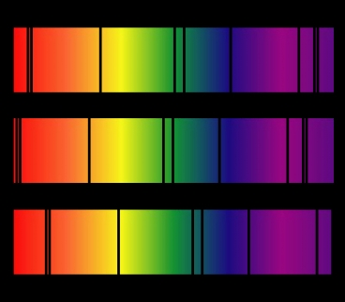

1

2

3

- If spectrum #1 is laboratory spectrum which of the other spectra are showing red-shift and which is showing blue-shift? Explain how you know this?

- Evidence that the universe is expanding is best provided by what phenomena?

Regents questions
1)
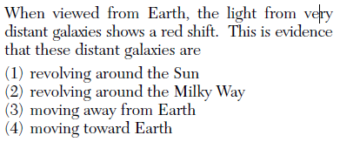

2)
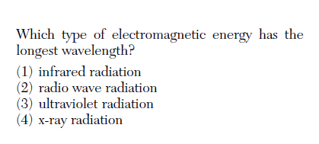
3)
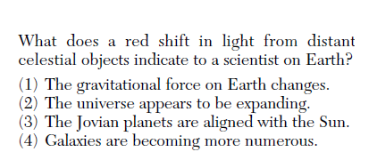
4)
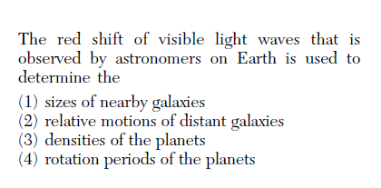
5)
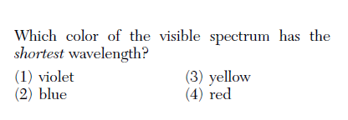

6)
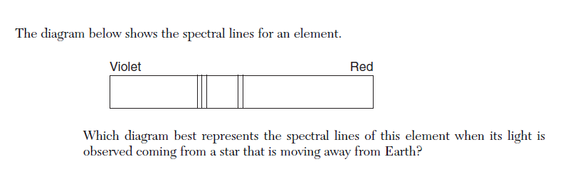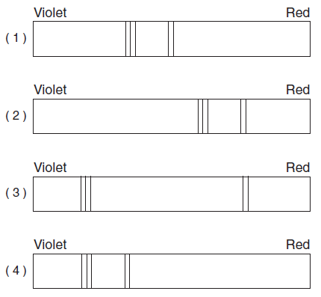

Hydrogen
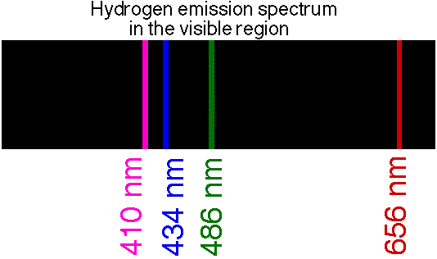

Helium
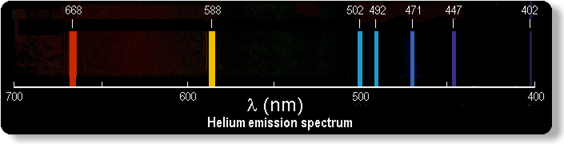

Oxygen

