Geologic History Worksheet

NAME: ___________________________

1.______ Earth’s early atmosphere formed during the Early Archean Era. Which gas was generally absent from the atmosphere at that time?

(1) water vapor (2) carbon dioxide (3) nitrogen (4) oxygen
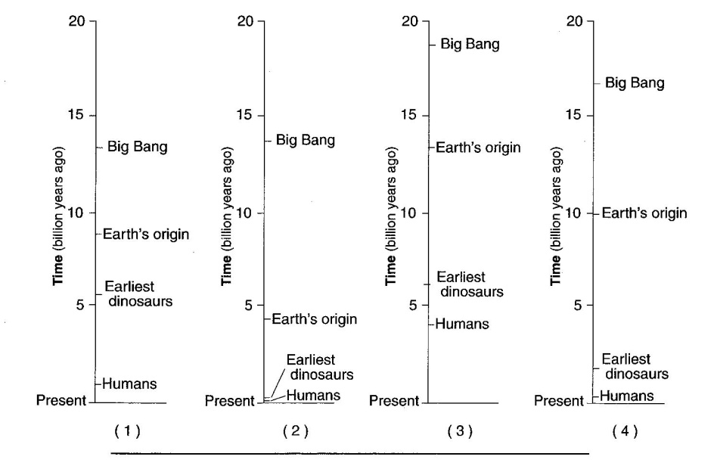

2.______ Which time line to the right most accurately indicates when this sequence of events in Earth’s history occurred?

3.______ Which event in Earth’s history was dependent on the development of a certain type of life-form?

(1) addition of free oxygen to Earth’s atmosphere (3) movement of tectonic plates
(2) formation of clastic sedimentary rocks (4) filling of the oceans by precipitation

4.______ A certain layer of rock formed during the early Devonian period. What type of fossils could possibly be found in this rock layer?

(1) earliest birds (2) earliest reptiles (3) Tetragraptus (4) Ctenocrinus

5.______ Which two landscape regions in New York State have the oldest surface bedrock?

(1) Allegheny Plateau and Newark Lowlands
(2) Tug Hill Plateau and Erie-Ontario Lowlands
(3) Taconic Mountains and the Catskills
(4) Adirondack Mountains and Hudson Highlands

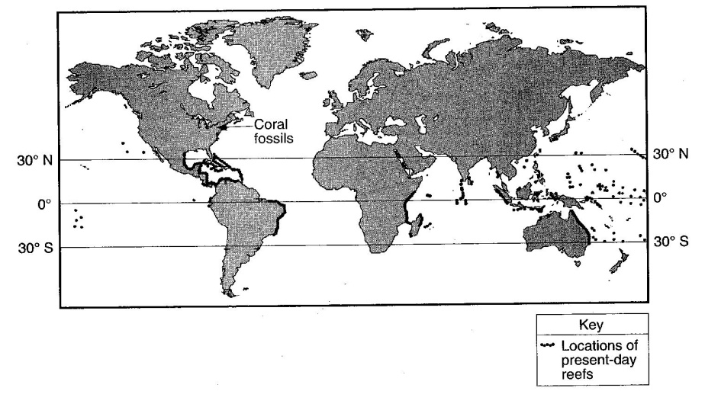
On the map to the right, the darkened areas represent locations where living corals currently exist. The arrow points to a location where coral fossils have been found in Devonian-age bedrock in New York State.

6.______ Devonian-age coral fossils found in some New York State bedrock are not located in the same general region that present-day corals are living because during the Devonian Period

(1) corals migrated to New York State (3) New York State was closer to the equator
(2) corals lived everywhere on Earth (4) New York State had a colder climate
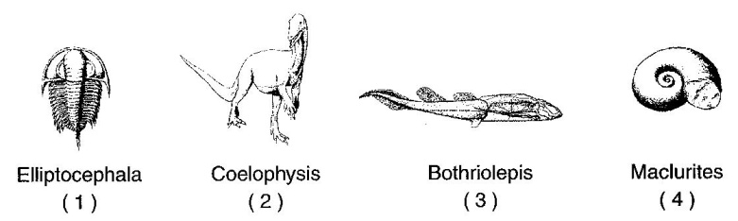

7.______ Which index fossil to the right may be found in the surface bedrock near Ithaca, New York?

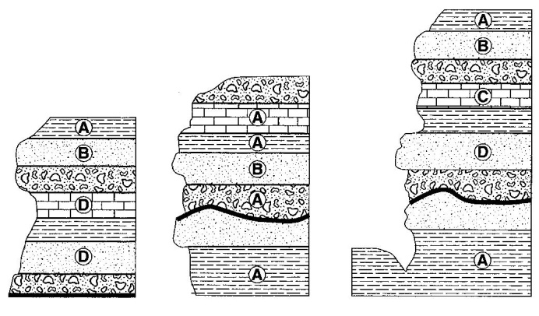
8. The cross sections to the right represent three widely separated outcrops of exposed bedrock. Letters A, B, C and D represent fossils found in the rock layers.

8.______ Which fossil appears to have the best characteristics of an index fossil?

(1) A (2) B (3) C (4) D

9.______ Scientists believe that a large asteroid struck Earth approximately 65 million years ago. It is often theorized that this event contributed to the

(1) end of the last ice age (3) evolution of the first birds
(2) breaking up of the supercontinent Pangaea (4) extinction of the dinosaurs

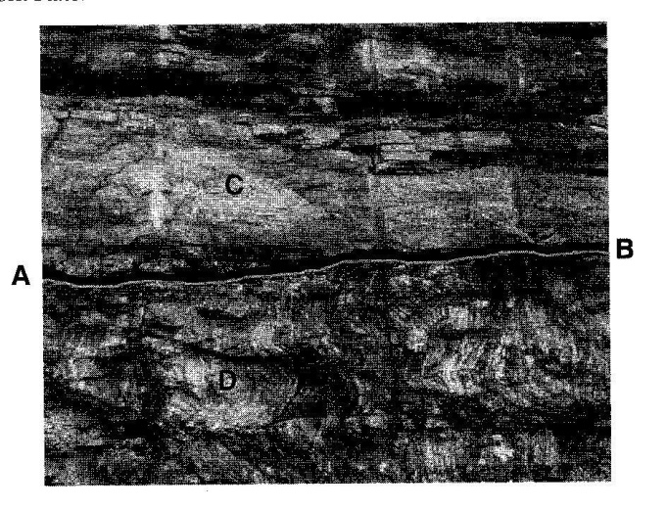
Base your answers to questions 10 and 11 on the photograph to the right, which shows a bedrock outcrop in northeastern New York State. Line AB is an unconformity between sandstone C and metamorphic rock D.

10.______ The lower layers of sediment found in sandstone C were deposited 520 million years ago. During which period of geologic time did this deposition occur?

(1) Cambrian (2) Ordovician (3) Silurian (4) Triassic

11.______ After the metamorphism of rock D, which sequence of events most probably formed unconformity AB?

(1) flooding > deposition > erosion > uplift (3) deposition > flooding > uplift > erosion
(2) uplift > erosion > flooding > deposition (4) erosion > flooding > uplift > deposition
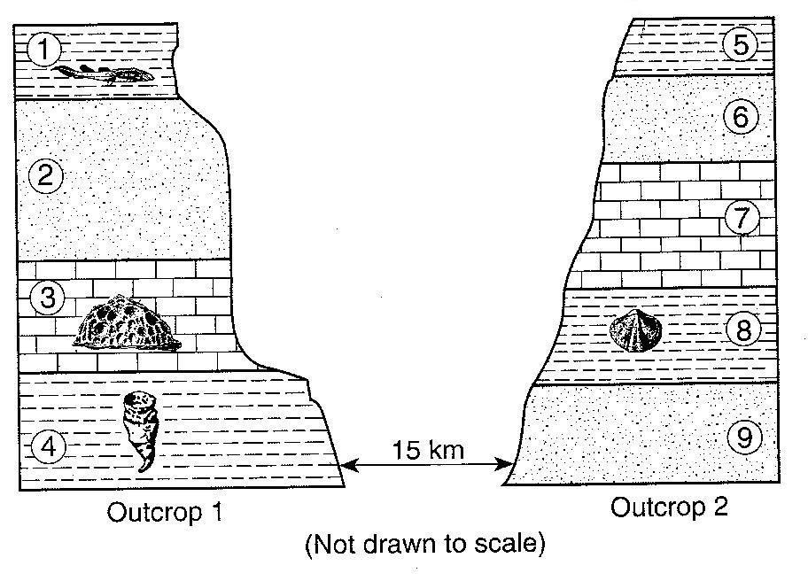
Base your answers to questions 12 through 14 on the cross sections to the right, which represent two bedrock outcrops 15 kilometers apart. The rock layers have been numbered for identification and some contain the index fossil remains shown.

12.______ When these rocks were deposited as sediments, this area was most likely

(1) under the ocean
(2) a desert between high mountains
(3) repeatedly covered by lava flows
(4) glaciated several times

13.______ Both organisms that formed the fossils found in rock layers 3 and 4

(1) lived during the same geologic period (3) are members of the same group of organisms
(2) lived in polar regions (4) are still alive today

14.______ Evidence best indicates that rock layers 4 and 8 were deposited during the same geologic period because both layers

(1) contain the same index fossil (3) contain index fossils of the same age
(2) are composed of glacial sediments (4) are found in the same area

15.______ During which geologic period did a major orogeny form the Taconic Mountains?

(1) Cretaceous (2) Permian (3) Devonian (4) Ordovician

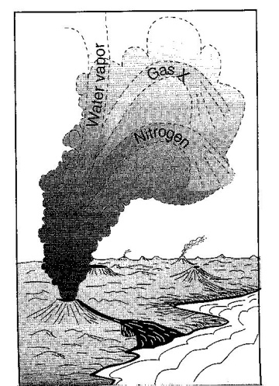
The diagram to the right shows a process thought to have produced Earth’s early atmosphere.

16.______ In the diagram to the right, what major component of Earth’s atmosphere is shown as gas X?

(1) helium (2) ozone (3) carbon dioxide (4) hydrogen

17.______ During which two geologic time periods did most of the surface bedrock of the Taconic Mountains form?

(1) Cambrian and Ordovician (3) Pennsylvanian and Mississippian
(2) Silurian and Devonian (4) Triassic and Jurassic

18.______ Which geologic event occurred in New York State at approximately the same time that eurypterids were becoming extinct?

(1) the opening of the Atlantic Ocean (3) the uplift of the Appalachian Mountains
(2) the formation of the Catskill Delta (4) the intrusion of the Palisades Sill

19.______ One reason Tetragraptus is considered a good index fossil is that Tetragraptus

(1) existed during a large part of the Paleozoic Era
(2) has no living relatives found on Earth today
(3) existed over a wide geographic area
(4) has been found in New York State

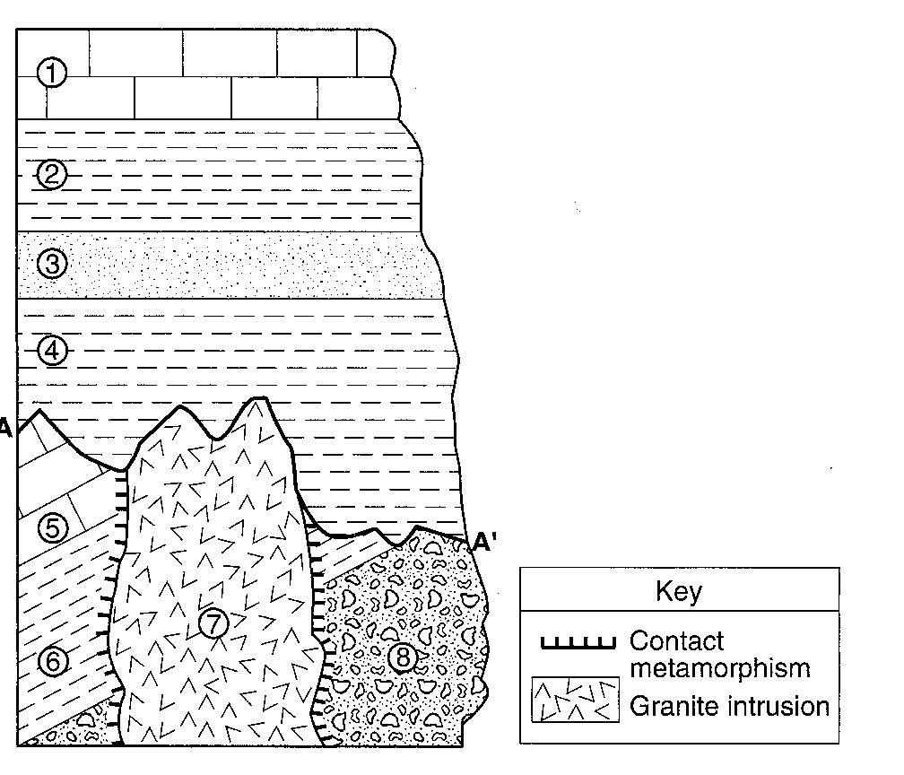
Base you answers to questions 20 through 22 on the cross section to the right. Rock units are labeled 1 through 8. The line between A and A’ indicates an unconformity.

20.______ Which characteristic of the granite intrusion provides the most direct evidence that it solidified deep underground?

(1) very hard (3) light color
(2) coarse texture (4) felsic composition

21.______ Which rock most probably formed in the contact metamorphic zone within rock unit 6?

(1) marble (2) basalt (3) quartzite (4) hornfels

22.______ Which event occurred sometime after the formation of the unconformity?

(1) formation of rock unit 3 (3) deposition of the sediments that formed rock unit 8
(2) tilting of rock unit 5 (4) intrusion of rock unit 7
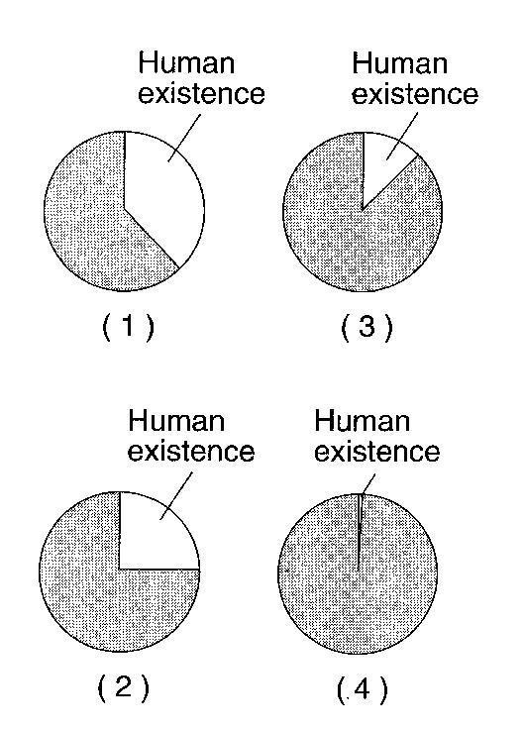

23.______ Which graph to the right best represents human existence on Earth, compared with Earth’s entire history?

24.______ The gases in Earth’s early atmosphere are inferred to have come primarily from

(1) meteor showers (3) volcanic eruptions
(2) melting of glacial ice (4) evaporation of seawater

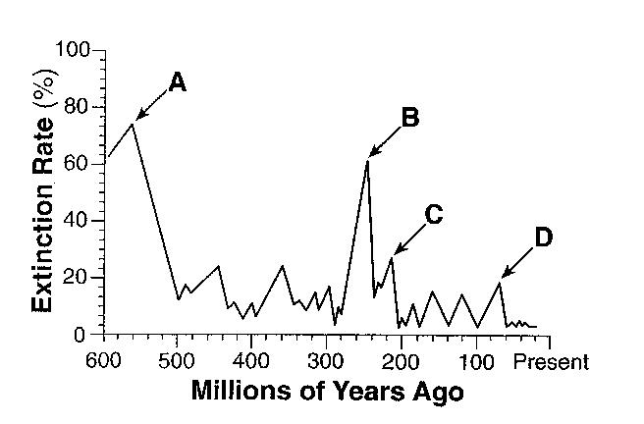
The graph to the right shows the extinction rate of organisms on Earth during the last 600 million years. Letters A through D represent mass extinctions.

25.______ Which letter indicates when dinosaurs became extinct?

(1) A (2) B (3) C (4) D

26.______ Fish known as placoderms lived during which geologic epoch?

(1) Early Mississippian (3) Early Pennsylvanian
(2) Late Mississippian (4) Late Pennsylvanian

27.______ According to the fossil record, which sequence correctly represents the evolution of life on Earth?

(1) fish > amphibians > mammals > soft-bodied organisms
(2) fish > soft-bodied organisms > mammals > amphibians
(3) soft-bodied organisms > amphibians > fish > mammals
(4) soft-bodied organisms > fish > amphibians > mammals

28.______ It is inferred that during the Early Archean Era, the atmosphere of Earth contained water vapor, carbon dioxide, nitrogen, and other gases in small amounts. These gases probably came from

(1) precipitation of groundwater (3) evaporation of Paleozoic oceans
(2) volcanic eruptions (4) convection current in the mantle

29.______ There is evidence that an asteroid or comet crashed into the Gulf of Mexico at the end of the Mesozoic Era. Consequences of this impact event may explain the

(1) extinction of many kinds of marine animals, including trilobites
(2) extinction of ammonoids and dinosaurs
(3) appearance of the earliest birds and mammals
(4) appearance of great coal-forming forests and insects

30.______ Which mountain range resulted from the collision of North America and Africa, as parts of Pangea joined together in the late Pennsylvanian Period?

(1) Appalachian Mountains (3) Taconic Mountains
(2) Acadian Mountains (4) Grenville Mountains

31.______ The feathered dinosaur known as a dromaeosaur is inferred to have lived about 130 million years ago. During which period of geologic time did this animal live?

(1) Cambrian (2) Cretacious (3) Paleogene (4) Permian

32.______ A reason that dromaeosaur is not considered to be a good index fossil is because it

(1) existed too long ago (3) was a land-dwelling animal
\ (2) was preserved in ash (4) was found in only one area

33._____ This feathered dinosaur has been linked to birds, representing an example of the concept of

(1) plate tectonics (2) evolution (3) dynamic equilibrium (4) recycling
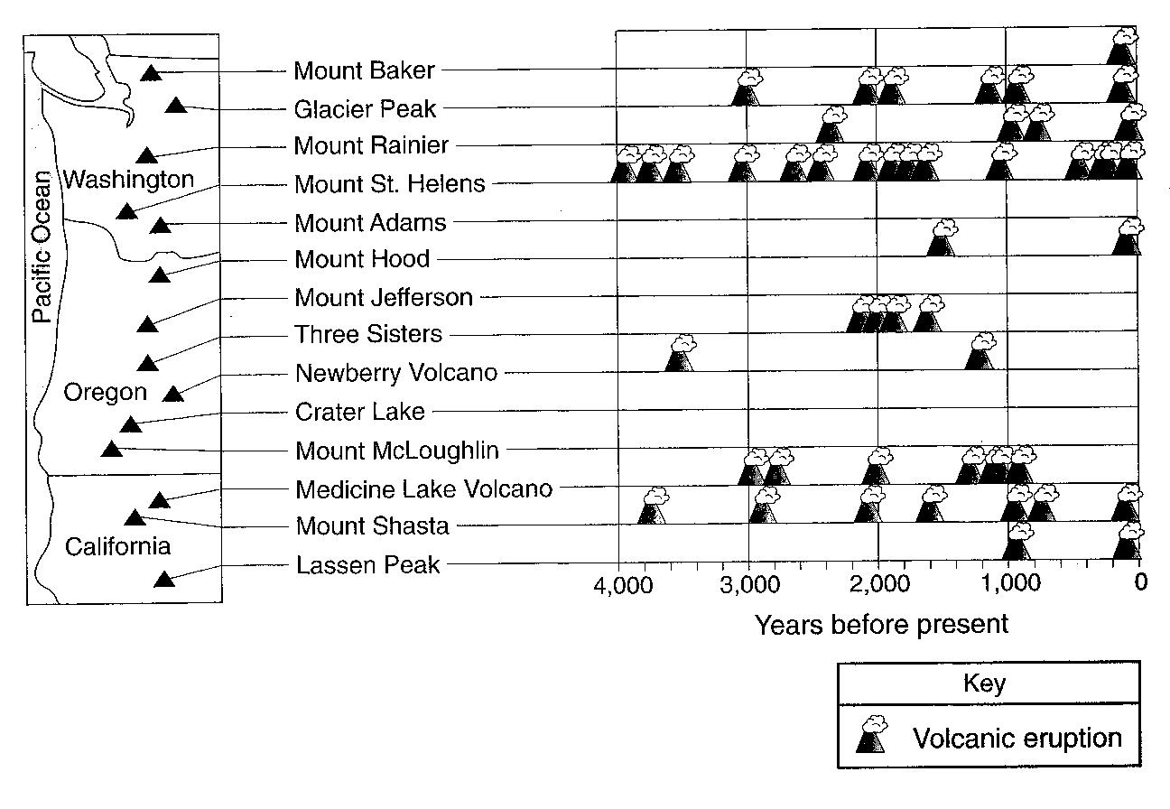

The map to the right shows the name and location of the volcanic peaks in the Cascade Mountain Range of the northwestern United States. The table shows the major eruptions of each peak over the past 4,000 years.

34. During which geologic epic did the volcanic activity shown on the table occur?

