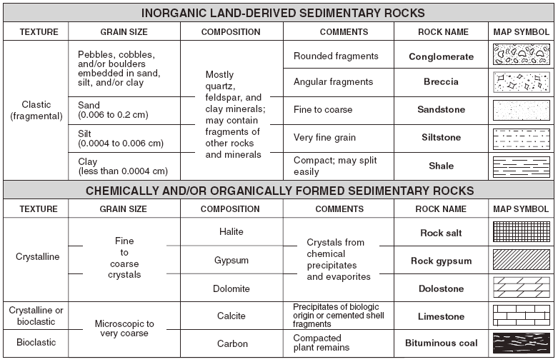

Using the Scheme for Sedimentary Rock Identification above, answer the following questions:
- What are the 3 major texture categories? ______________________________________, ______________________________, ___________________________________
- Are clastic rocks of organic or inorganic origin? ____________________________________
- List the clastic rocks in order from the smallest particles to the biggest: __________________________________, ______________________________________, _________________________________, _________________________________, ____________________________________
- How are crystalline rocks formed?

- How are bioclastic rocks formed?

- What clastic grain size is between 0.0004- 0.0006? ______________________________

- Which sedimentary rock and be either crystalline or bioclastic?

- What mineral makes up limestone? _________________________________

- What are the elements in rock salt? _________________________________

- Which sedimentary rock will bubble with acid only in the powdered form? _____________________________

- What is the difference between conglomerates and breccias?
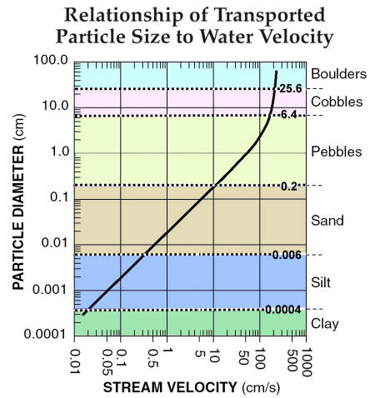
Using the chart about the Relationship of Transported Particles, answer the following questions:
- What is the range of size for sand size particles? _________-__________cm
- What is the range of size for cobble size particles? _________-__________cm
- How fast must a stream be moving to carry a particle with a 0.03cm diameter? ________________________________cm/s
- How fast must a stream be moving to carry a particle with a 10cm diameter? ________________________________cm/s
- What is the minimum stream velocity needed to carry silt size particles? _____________________________________cm/s
- What particle(s) will be carried by a stream moving 5 cm/s? ________________________________________________________________________________
- What particle(s) will be carried by a stream moving 100 cm/s? ________________________________________________________________________________

