It is all Greek to Me!
OK, so you are asking yourself, “When will I ever use trigonometry in my life?” Well, I have an answer for you my friend. With the use of a few simple items and a computer you can calculate the circumference of the Earth. Is this exciting or what?
First a little background information. Many people think Christopher Columbus was the first person to “prove” the world was round. Wrong! Approximately 2000 years earlier a Greek mathematician named Eratosthenes used an ingenious method for determining the circumference.
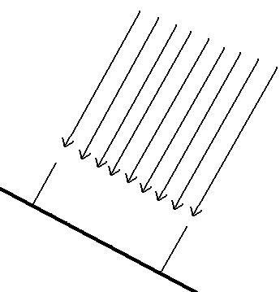
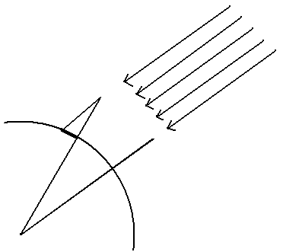
Eratosthenes knew that in the city of Syene, Egypt on noon on a certain day of the year the sun was directly overhead and therefore cast no shadow. He observed on same day of the year, that in his hometown of Alexandria a shadow was cast. How could this be? No shadow in one town and a shadow in the other….hmmm. Let’s look at the first diagram. If the Earth is flat then both cities would not have a shadow. But if the Earth is a sphere, a shadow could be cast in one city and no shadow cast in the second city.

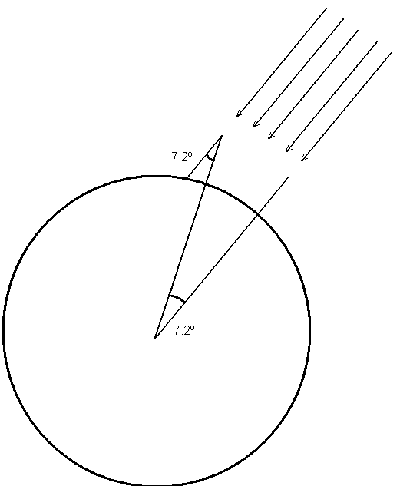
He measured the shadow in Alexandria and determined it to be 7.2º. Then he used the principle of opposite interior angles to reason that 7.2º separated the two cities. Now, a circle is made of 360º. So how many 7.2º pieces of pie will fit in a 360º circle? 360 divided by 7.2 = 50. He needed to know the distance between the two cities. Eratosthenes measured the distance to be 5000 stadia. 5000 stadia is about 500 miles or 800 kilometers. So, he thought to himself, “If the distance between cities is 5000 stadia and there are 50 similar pieces on the Earth, then the distance around the Earth must be 5000 X 50 or 250,000 stadia.” It turns out that he had a less than 2% error! Amazing Indeed!

Let’s Try It!!

We will use Torrington, WY and Carlsbad, NM as our two cities. A 1 meter high stake is virtually driven into the ground at the two cities. First we need to find the shadow length for a certain day. The shadow is at the maximum length on Dec 21st, so let’s use that day. Open the following link:

http://www.findmyshadow.com/index.php

- Under the “Getting Started” portion of the page is the “Sun Position Table and Chart.”
- Press the GO button.
- Use the toggle buttons to locate Torrington, WY. Zoom down to find the intersection of highways 85 and 26.
- Press the “Next” button.
- Set the month as 12 and the day as 21. Set the time as “Mountain Time.”
- Press the “Next” button.
- Locate local time 12:00. Record the shadow length multiplyer. __________________
- Repeat the process for Carlsbad, NM. Shadow length multiplyer. ________________
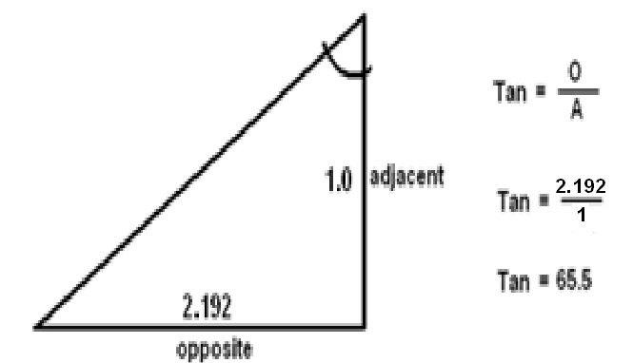
Calculate Shadow Angle
The shadow length multiplyer indicates the length of the opposite side compared to a 1 meter tall stake. So, in the example on the right the multiplyer shows that a shadow of 2.192 meters would be cast by a stake 1 meter tall. These two numbers, opposite and adjacent, can be used to determine the angle at the top of the stake. The tangent function on a math calculator can be used for this purpose. Tangent is a ratio of the opposite length divided by the adjacent length. In the example 2.192 (opposite) is divided by 1.0 (adjacent). The answer is 65.5 degrees. So, let’s figure the shadow angles for Torrington and Carlsbad. Open the link below.

http://web2.0calc.com/

This is a calculator. Make sure the Deg button is on. Press the tan⁻¹. Enter the multipyer from Torrington and divide by 1 which is the adjacent. Close the parenthesis. Press the =. Enter this value in the shadow angle box in the table below.

Location | Date | Shadow Length Multiplyer | Shadow Angle
Torrington | Dec 21
Carlsbad | Dec 21
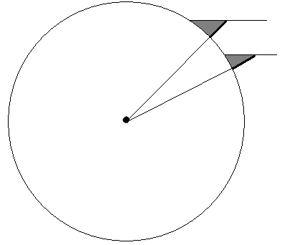
Next, subtract the smaller shadow angle from the larger. This value represents the angular distance between the two cities. Record this value here. ________________

Finding the straight line distance
Now we need to know the straight line distance from Torrington to Carlsbad. Open the link below.
http://www.daftlogic.com/projects-google-maps-distance-calculator.htm
Type Torrington, WY in the search box. A marker will be placed at Torrington. Find Carlsbad, NM on the map. It is directly south of Torrington. You may need to zoom in a few levels to find it. Once you locate Carlsbad, click and a marker will be placed. The total distance is shown under the map. Record the distance here. ________________

Calculating the Polar Circumference of the Earth
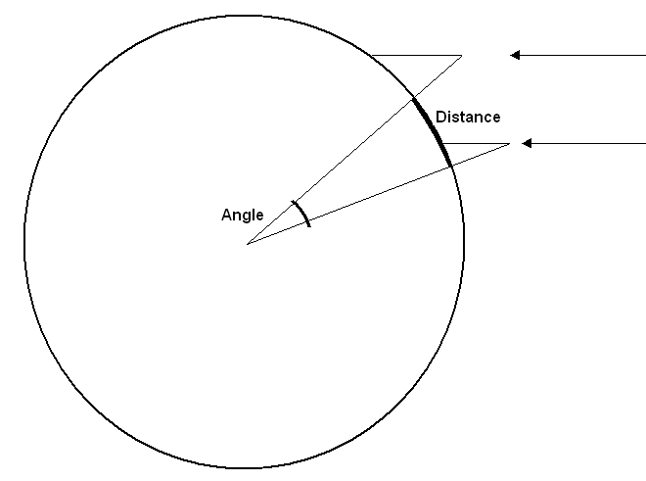
A little review – We have calculated the angle between the cities and the straight line distance between them. We know a circle is composed of 360º. How do we determine the circumference? By using a simple ratio. The angle is to the distance as 360º is to the circumference. The equation is:

Determined Angle ₌ 360º
Distance X

Can be stated as:

X = 360ºx Distance
Angle

Work Area

The actual distance can be found on the following link:
http://www.koordinaten.de/english/informations/earth.shtml

How did your answer compare?

You may want to try this again with two other cities. They can be anywhere in the world as long as they are directly north and south of each other.

