1. The diagram shows the positions of four elements in the Periodic Table. Which element gains electrons to form negatively charged ions?

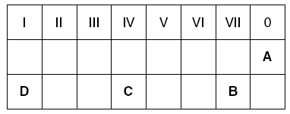

2. The diagram represents an atom of an element.

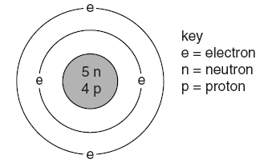

Which symbol gives this information?



3. Which statement about groups in the Periodic Table is correct?

**A** All groups contain both metals and non-metals.

**B** Atoms of elements in the same group have the same total number of electrons.

**C** In Group l, reactivity decreases with increasing proton (atomic) number.

**D** In Group VII, the melting point of the elements increases with proton (atomic) number

4. Element *Q* has a melting point greater than 1000 °C. It has oxidation states (oxidation numbers) of

+2 and +3 in its compounds. These compounds are coloured.

In which position of the Periodic Table shown is *Q* found?

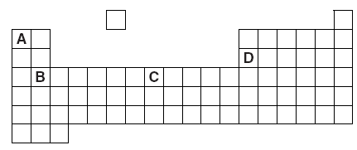

5. The table gives the formulae of the catalysts used in some industrial processes.

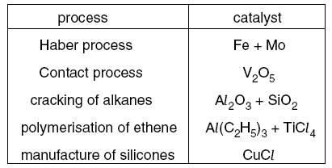

How many different transition metals are included (as elements or as compounds) in the list of

catalysts?

**A** 3 **B** 4 **C** 5 **D** 6

6. Which list contains three elements that all exist as diatomic molecules at room temperature?

**A** hydrogen, fluorine, neon

**B** nitrogen, chlorine, neon

**C** nitrogen, oxygen, fluorine

**D** oxygen, chlorine, helium

7. Which statement shows that iron is a transition metal?

**A** Iron(II) sulphate crystals are green.

**B** Iron(III) oxide is basic.

**C** Iron rusts in moist air.

**D** Iron reacts with dilute hydrochloric acid.

**8.** Astatine (At) is in Group VII of the Periodic Table.Which of the following is a property of astatine?

**A** It forms a basic oxide.

**B** It is a good conductor of electricity.

**C** It is displaced by chlorine from aqueous potassium astatide.

**D** It displaces iodine from aqueous potassium iodide.

9. Which statement is true about the elements in Group I of the Periodic Table?

**A** They are equally reactive.

**B** They become less metallic as the proton (atomic) number increases.

**C** They form chlorides of similar formulae.

**D** The proton (atomic) number of an element is one greater than that of the element above it.

10. Which element is in Group IV, Period 5 of the Periodic Table?

**A** antimony

**B** arsenic

**C** lead

**D** tin

11. Fluorine is the first element in Group VII of the Periodic Table.

Which statement about fluorine is **not** correct?

**A** It is a gas at room temperature and pressure.

**B** Its molecules are monatomic at room temperature.

**C** It is a more powerful oxidising agent than chlorine.

**D** It forms ionic compounds with metals.

12. Which of the following is **not** a use for chlorine?

**A** sterilising water

**B** making domestic bleaches

**C** making table salt

**D** manufacturing plastics

13. Which statement about the alkali metals is true?

**A** they form covalent bonds with Group VII elements

**B** they form oxides on reacting with water

**C** their melting points decrease on descending Group I

**D** their reactivities decrease on descending Group I

14. Two elements are in the same group of the Periodic Table.

Which property will be the same for both elements?

A the charge on their ions

B their electronic structure

C their melting point

D their reactivity with water or acids

15. A lump of element X can be cut by a knife.

During its reaction with water X floats and melts.

What is X?

A calcium

B copper

C magnesium

D potassium

16. ) i) Which halogen is a liquid at room temperature and pressure?

ii) How many electrons does one atom of astatine have in its outer shell?

iii) Predict the atomic radius of astatine

iV) Predict the state and colour of astatine at room temperature and pressure

V) Predict the molecular formula for astatine

17.The diagram shows the nuclei of five different atoms.

**(a)** Which atom has an atomic number of 3? .

**(b)** Which atom has a mass number of 6?

18.



19. The diagram shows part of the Periodic Table.

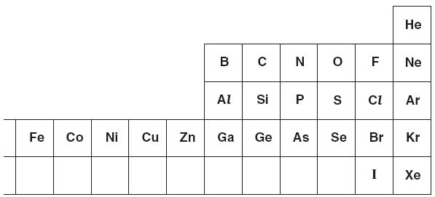

Answer these questions using **only** the elements shown in the diagram.

Each element can be used once, more than once or not at all.

Write the symbol for

**(i)** an element which is in Group 5 and Period 3,

**(ii)** an element which is used as a gas in balloons,

**(iii)** an element which forms ions in aqueous solution which give a white

precipitate on reaction with aqueous silver nitrate

**(iv)** an element which forms an ion of type *X* 3–,

**(v)** an element which is a catalyst for the hydrogenation of alkenes,

**(vi)** two elements which combine to form a compound which

causes acid rain.

20.