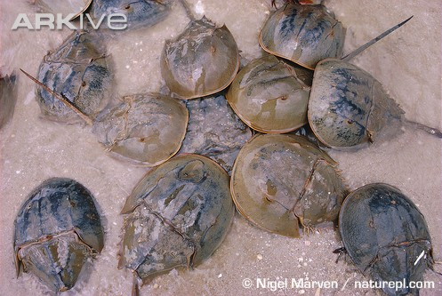
June 10, 2008 Basics
Tallying the Toll on an Elder of the Sea
By NATALIE ANGIER
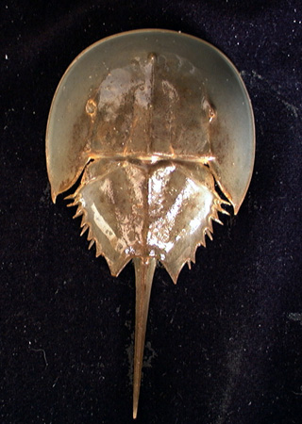
MILFORD, Conn. — Horseshoe crabs may look ancient and alien and battery-operated, they may look like Wilma Flintstone’s idea of a Roomba vacuum cleaner, yet to the sixth-grade students from Columbus School in nearby Bridgeport, the most outrageous thing about the bronze-helmeted creatures crawling clumsily along the beach was not their appearance but their size — or rather sizes. Photo: http://www.arkive.org/species
One boy pointed to a linked pair of horseshoe crabs, a relatively compact specimen maybe seven inches across clinging to the tail end of a much larger companion. A kid crab hitching a ride on its mother? No, explained Jennifer H. Mattei, head of the biology department at Sacred Heart University in Fairfield, who led the expedition. They were both full-grown, a male and a female, and the female was the bruiser out front. Photo: http://www.stat.wisc.edu
Among horseshoe crabs, Dr. Mattei explained, adult females are a good 25 to 30 percent bigger than their mates, a fact that the girls greeted with hoots of triumph, boys of indignation. Why are the females bigger? a boy demanded. It’s supposed to be the other way around!
As it turned out, the answer to that question was closely tied to the reason the students from Cheryl Crevier’s class had ventured out on a flawless June morning to the shores of Long Island Sound. With clipboards purposefully in hand and tape measures jauntily around neck, the 22 children were there to help catch, measure and tag as many specimens as they could find of the American horseshoe crab, or Limulus polyphemus, one of the oldest and most tenacious species on Earth. Fossils found this year in Manitoba reveal that the animal’s architecture has hardly changed in 445 million years. Drawing: http://www.kendall-bioresearch.co.uk
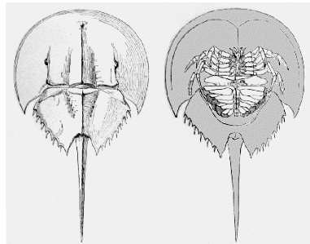
The student project is part of a major effort now under way from Maine to Florida, as researchers and volunteers race to take advantage of the spring spawning season, when the crabs lumber from their wintering seabeds on the continental shelf and head inward to the shoreline to breed, and thus can be readily counted (www.projectlimulus.org). Experts are desperate to know whether their suspicions are correct — that as a result of being harvested en masse for use as fishing bait, horseshoe crab populations are beginning to crash.
The loss of the horseshoe crab would be tragic, researchers said, not only because the creatures are fascinating and cute and predate the dinosaurs by 200 million years, but also because so many contemporary life forms depend on them. Their annual spawns draw hundreds of species of migratory birds, predatory fish, reptiles, amphibians and various other alimentary canals eager to brunch on the freshly deposited Limulus eggs. “Horseshoe crab eggs are like filet mignon around here,” Dr. Mattei said. “They’re a very popular item on the menu.”
A bounteous one, too. “A single female horseshoe crab can put down 80,000 eggs a year, four million in her lifetime,” said John T. Tanacredi, a professor of earth and marine sciences at Dowling College in Oakdale, N.Y.
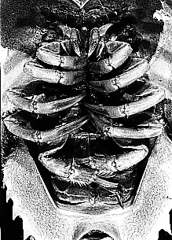
We, too, are multiply tethered to the ancient mariners. From their blood we extract a protein that is exquisitely sensitive to bacterial toxins and is used to test surgical instruments and intravenous drugs to ensure they are safe. The relatively simple visual circuitry of the horseshoe crab has proved an ideal model system for decoding the basis of sight. “Only with the horseshoe crab eye is it possible to predict what each nerve fiber in the retina will send to the brain as it sees,” said Robert B. Barlow, a professor of ophthalmology at the State University of New York Upstate Medical University. The Columbus School students, after being assured that the crab was harmless and surmounting their squeamishness at holding something that, when turned over, looks very much like a large version of the scorpions and spiders to which the horseshoe crab is more closely related than it is to standard crabs like the Dungeness, took to their task with gusto.
They scooped the crabs out of the water carefully and held them, as instructed, like bowls of soup. They punctured small holes in the hard, chitinous shell with special tools designed by Dr. Mattei and her colleagues Mark Beekey and Barbara Pierce. And before a crab could ooze more than a spot of its distinctive blue blood — the color the result of the crab’s blood using copper as an oxygen ferrier rather than iron, as we do — they inserted the white numbered tag. Photo: http://www.ucmp.berkeley.edu
While they worked, the students learned about the horseshoe crab, how it uses its ice-pick-like tail, or telson, to steer in the water and to right itself should it be overturned in the sand, how the crab is a generalist willing to feed on plankton, bits of fish and worms, and how it lacks jaws for chewing and so grinds up its food with the help of bristles on its legs and an internal gizzard that contains bits of sand and gravel.
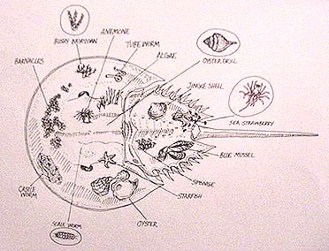
Dr. Mattei explained that in the ever-shifting tidal environment, the solid crabs are coveted real estate. “Over 20 species of organisms can be found living on their shells,” she said, including barnacles, slipper shells, blue mussels, sponges, flatworms and leeches, a baggage sum that, if not helpful to the crabs, doesn’t usually hurt them either. ←Drawing: http://ux.brookdalecc.edu/staff/sandyhook/dgrant/field/limulus.htm

She described the crab’s life cycle, how the animals shed their shells some 17 times before reaching adult size at around nine years of age. The males emerge from that final shell-shucking with a distinguishing pair of “boxing gloves” on their front claws, which they use for the all-important task of clinging to the back of a female for months at a time. While conjoined, the couple doesn’t have sex. But whenever the female lays a clutch of eggs, the male is well positioned to fertilize them by releasing a spermic plume. Illustration:.http://www.ocean.udel.edu/horseshoecrab
“Females are bigger just for the physics of carrying all those eggs,” Dr. Mattei said. Sperm, by contrast, is gossamer, and male-male combat rare. “It’s whoever gets there first,” Dr. Mattei said, a reproductive strategy that may, in fact, reward the petite.
Alas, sometimes the first comer is a large warm-blooded crab with opposable thumbs. In the last few years, the Asian market for North American eel and conch meat has soared, and it seems that gravid female horseshoe crabs make the best bait. Even the stalwart Limulus can’t last if all its eggs end up in one basket — shaped like a fisherman’s boat. [also see: http://www.horseshoecrab.org/]
Activities:
- Define & explain the boldface terms & concepts to fit their usage in this article.
- Prepare a visual display, brochure or PowerPoint which could be made available at horseshoe crab sites, seashore parks, and/or schools which details the contributions of Limulus polyphemus to seashore ecology, biomedical research and the like. Each of the photo credits above is a link to a useful site.
- Write a letter to the U. Delaware site advocating the inclusion of Dr. Mattei’s work in their reference section.
- View the PBS program “Crash” & its site, links & resources: http://www.pbs.org/wnet/nature/crash/. Prepare visuals & activities for a junior high/middle school classroom. Include skits, models, word searches, crosswords, etc.

