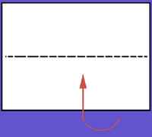
Ellipse Lab
The Ellipse Lab
Marrazzo

Name
Period

The ellipse is the geometric shape of most orbits. In this lab, you'll construct 3 ellipses, examine and measure them to determine some of the fundamental properties of ellipses.
Follow the directions below, making sure you draw and measure carefully along the way. When you have completed the construction and measurement of your ellipses, carefully and thoughtfully answer the questions posted at the end of this lab using your ESRT.

- Gather up the materials you need to complete this lab (See Fig. 1):
- A piece of cardboard
- 1 sheet of white paper
- 2 push pins
- A string loop
- Ruler
- ESRT
- A pen or sharp pencil
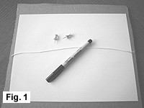
1.5. Fold your paper in ½ lengthwise (hotdog fold). Label the fold "major axis"
Major Axis

- Place the sheet of paper on the cardboard, and draw 2 dots in the center of the page 3cm apart. Place the 2 push pins into the dots as shown
in Fig. 2.
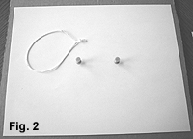

- After you've drawn your ellipse, remove the push pins. The 2 pinholes are called the foci of the ellipse (each one is called a focus). Label the 2 foci F₁ and F₂ as indicated below.

Label this ellipse 1
F1
F2
1

3. Place your loop of string around the 2 push pins, and, keeping the string tight, use the string as a guide to carefully draw an ellipse around the push pins. (See Fig 3.) Be patient - you may have to try it a few times before you get the hang of it!

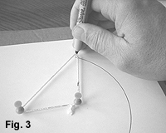

- Ellipse 1
- Measure the distance between foci 1&2 "d".
- Measure the length of the major access of ellipse 1 “L”
- Calculate the eccentricity “e” (FORMULA IN YOUR ESRT)
d-________________ Calculations
L-________________
e1-________________

- Ellipse 2 - Move EACH pin out 1 cm and draw a new ellipse. Label the foci F3 & F4. Label the ellipse 2.
F1
F2
1
2

F3
F4

- Measure the distance between foci 3&4 "d".
- Measure the length of the major access of ellipse 2 “L”
- Calculate the eccentricity “e”.
d-________________ Calculations
L-________________
e2-________________

- Ellipse 3 - Move EACH pin out 1 cm and draw a new ellipse. Label the foci Sun & F6. Label the ellipse 3.
3
F1
F2
1
2

Sun
F3
F4
F6

- Measure the distance between the focus sun & F6 "d".
- Measure the length of the major access ellipse 3 “L”
- Calculate the eccentricity “e”
d-________________ Calculations
L-________________
e3-________________

- Write the word FAST on ellipse 3 where the planet would have the most speed!

Discussion Questions

- What changes do you see in the eccentricity (e) of your ellipses as you INCREASE the distance between the foci (pins).
2. Out of the 3 ellipses you drew, which has the most eccentric?
3. Out of the 3 ellipses you drew, which has the least eccentric?
- How does the numerical value of "e" change as the ellipse approaches a straight line?
5. What was the eccentricity you calculated for Ellipse #1?
6. Which is less eccentric, the orbit of the Earth or Ellipse #1?
7. Which planet has the most eccentric orbit?
CONCLUSION: Describe the true shape of the Earth's Orbit.

