Force may be a simple push or pull. The unit for force is Newton (N) A spring balance measures force.

What Force can do
- Change an object’s position
- Change an object’s size and shape
- Stop a moving object
- Change an object’s direction
- Cancel another force

Resultant Force (Net Force)- a single force resulting from two unbalanced forces.

The diagram below shows how to get the resultant force between two forces pulling in opposite directions.
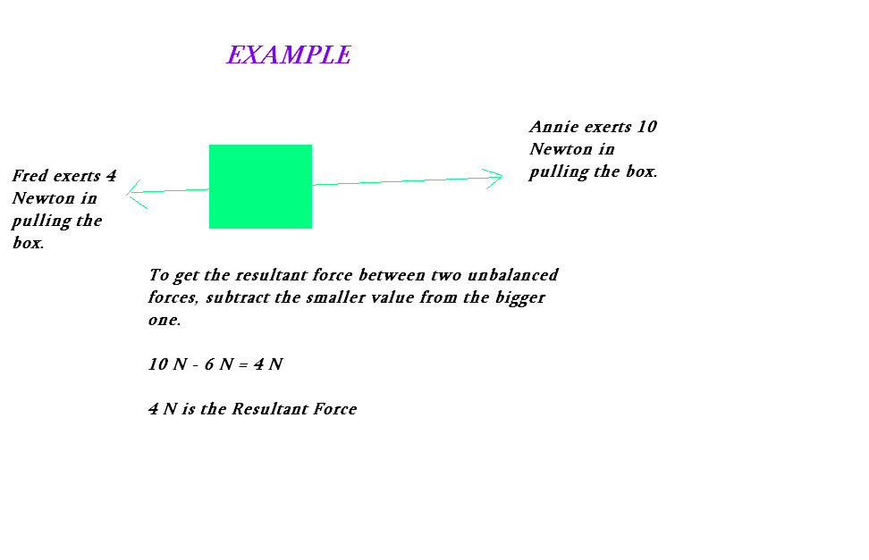
The diagram below shows how to get the resultant force between two forces pulling in the same direction.
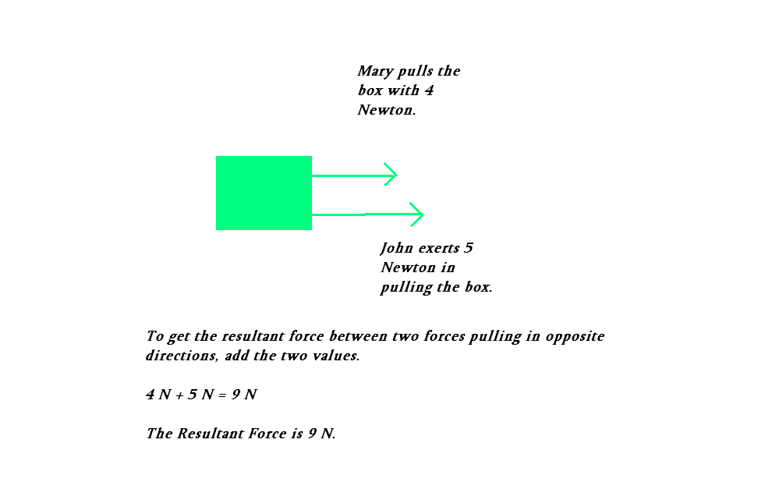

Contact Forces are forces that occur when an object is in direct contact with another object.

Friction is a contact force that opposes another force.

How to reduce Friction?
- Use a lubricant (e.g. oil, grease)
- Use wheels
- Polish the surface

How to increase Friction?
- Use Coke
- Use Spikes
- Use Sandpaper

Normal Force is another contact force. It is the force acting on an object to prevent it from penetrating another object.

Non Contact Forces or Forces Acting at a Distance are applied to objects not in direct contact with it.
Gravitational Force is the force of attraction in which each object in the universe attracts another object. High Tides and Low Tides are the result of the gravity from the moon. Gravity is also the reason everything that goes up comes down eventually.
Magnetic Force is another force that acts from a distance. A magnetic field is the field that exists around a magnet.
Electrical Force may be attractive or repulsive. Have you tried rubbing a balloon with your hair and watching some strands of hair sticking to it? That is the result of Electrical Force. Some electrons from your hair get transferred to the balloon, so the balloon becomes negatively charged and your hair becomes positively charged. And we both know, that unlike charges attract.
Nuclear Force- is the force exerted by the nucleus o an atom. It is a very strong force that is usually used for making bombs.

