Apparent Temperature (Heat Index) Worksheet
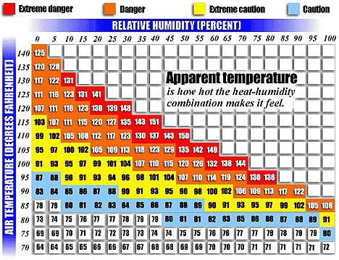

How Forecasters Decide Whether to Issue Excessive Heat Warnings
NOAA's heat alert procedures are based mainly on Heat Index Values. The Heat Index, sometimes referred to as the apparent temperature is given in degrees Fahrenheit. The Heat Index is a measure of how hot it really feels when relative humidity is factored with the actual air temperature.
To find the Heat Index temperature, look at the Heat Index chart below. As an example, if the air temperature is 96°F and the relative humidity is 65%, the heat index--how hot it feels--is 121°F. The Weather Service will initiate alert procedures when the Heat Index is expected to exceed 105°-110°F (depending on local climate) for at least 2 consecutive days.
Use the chart above to answer the following questions:
1. If the temperature is 90° F and the relative humidity is 70% what would the real apparent (feel) temperature be? What zone of health would you be in?
3. Some people say that heat is relative based on the relative humidity. Living in Arizona the daily high temperature can rise to 120° F. What would the minimum relative humidity percentage have to be that would put your health in the extreme danger zone?
4. At what temperatures will the National Weather Service (NWS) initiate alert procedures?
5. For how many consecutive days would the temperatures have to be at that level before the NWS initiate the alert procedures?
6. Even at temperatures as low as 75° F conditions can reach cautionary levels after two consecutive days. What relative humidity level must be reached for a 75° F day to reach the caution zone?
7. What does apparent temperature mean?
8. Some people are more affected by high apparent temperatures based on the level of the air’s temperature and relative humidity. What people might have concerns about going outside when there is a high apparent temperature (high heat index)?
9. What kinds of workers may be affected by high apparent temperatures? What are some precautionary mesure these workers must take to stay safe?
10. The highest temperature in the middle of summer around here can be 95° F. What would the relative humidity reading have to reach before reaching extremely dangerous health conditions?

