Climate Worksheet

NAME: ___________________________

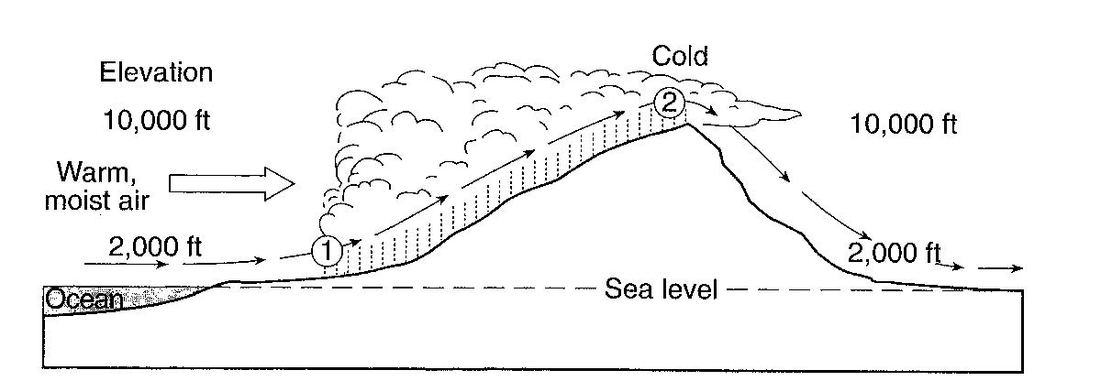
Use the diagram below to answer questions 1 and 2. This diagram shows warm, moist air moving off the ocean and over a mountain, causing precipitation between points 1 and 2.
3
1. Describe two changes that occur to the warm, moist air between points 1 and 2 that would cause cloud formation.

2. In terms of moisture and temperature, how would the air be different at position 3 as compared to position 1?

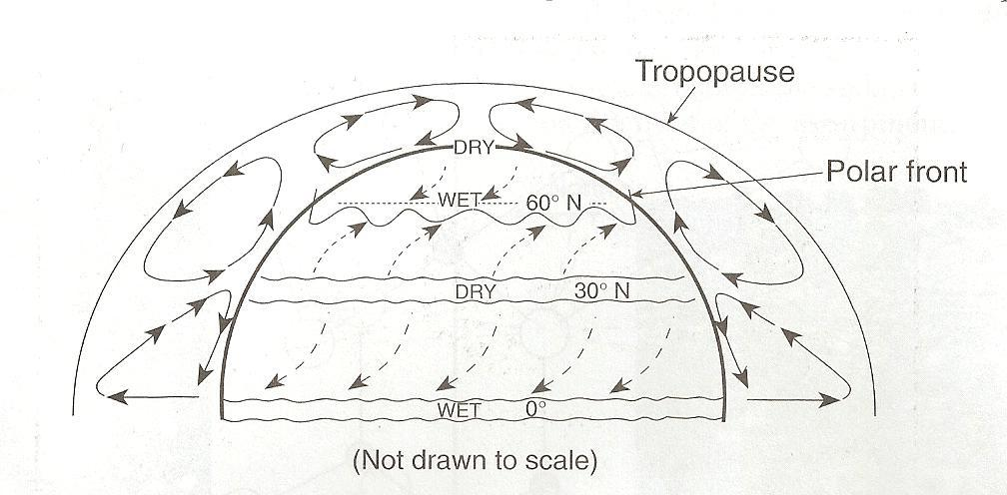

3.______ The climate at 90o north latitude is dry because the air at that location is usually

(1) warm and rising
(2) warm and sinking
(3) cool and rising
(4) cool and sinking

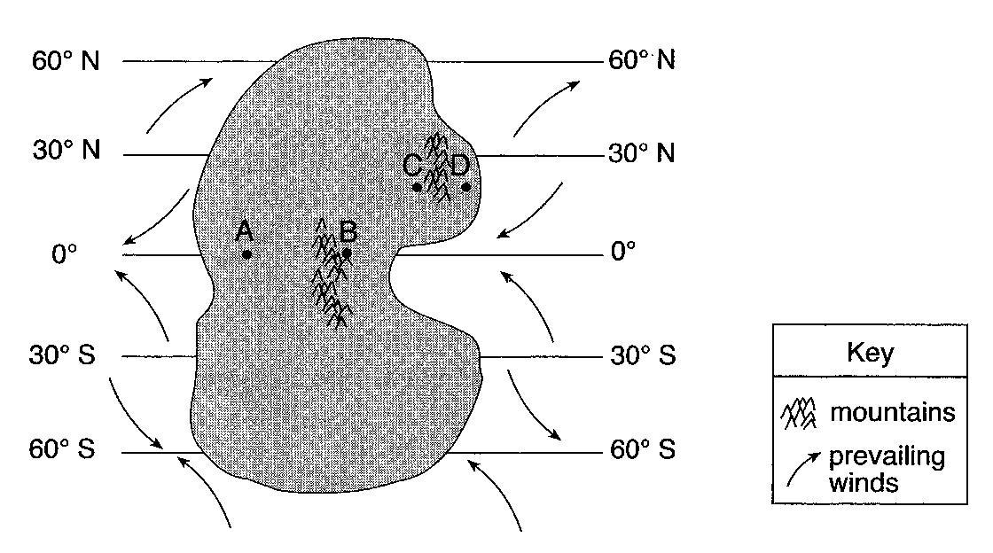
Base your answers to questions 4 through 6 on the map to the right, which shows an imaginary continent on a planet that has climate conditions similar to Earth. The continent is surrounded by oceans. Two mountain ranges are shown. Points A through D represent locations on the continent.

4. Identify one labeled latitude on this continent where a high-pressure zone exists and dry air is sinking to the surface. Include both the unit and compass direction in your answer.

5. Identify one factor that causes a colder climate at location B than at location A.

6. Explain why location C has a warmer and drier climate than location D.

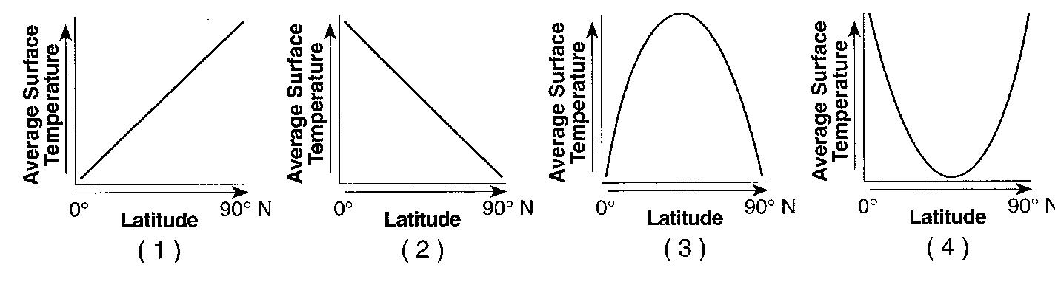
7.______ Which graph to the right best represents the general relationship between latitude and average surface temperature?
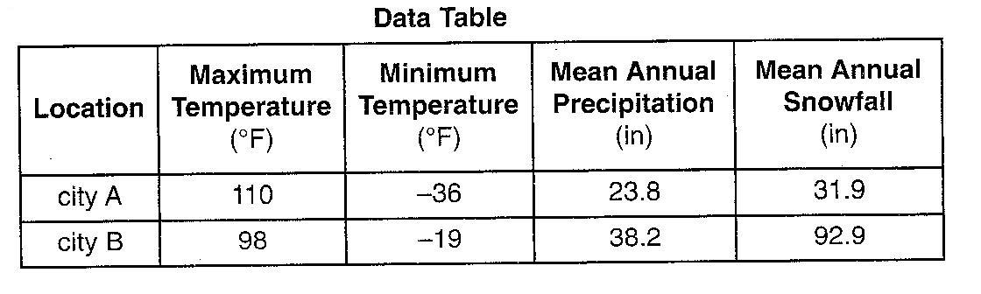
The data table to the right compares the climate of two United States cities located at approximately 43º north latitude.

8.______ Which statement best explains the climate variation between these two cities?

(1) City A and City B are located at the same latitude.
(2) City A is located a high elevation, and City B is located at sea level.
(3) City A is located far inland, and City B is located near a large body of water.
(4) City A is located on the east coast, and City B is located on the west coast.

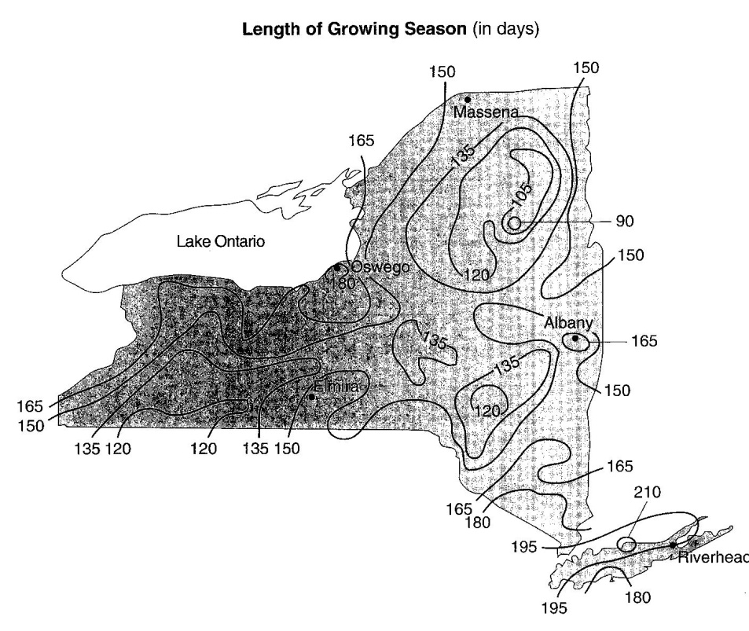
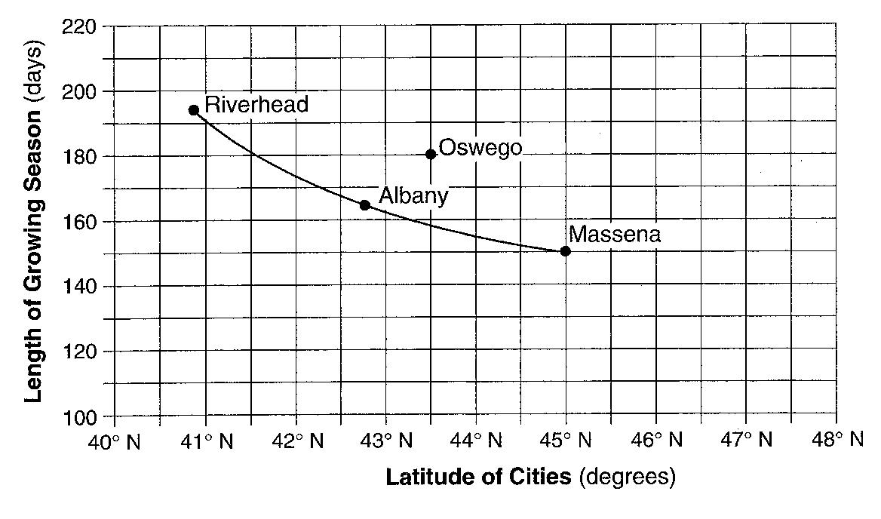
Base your answers to questions 9 through 11 on the map to the right, the graph below, and your knowledge of Earth science. The map shows the length of the growing season in New York State, expressed in days. The growing season is the average numbers of days between the last frost in spring and the first frost in fall. The graph line shows the relationship between the latitudes of Riverhead, New York; Albany, New York; and Massena, New York; and the length of the growing season at these three locations.

9. For Riverhead, Albany, and Massena state the relationship between latitude and the length of the growing season shown by the graph.

10. The data for Oswego, New York, have been plotted separately on the graph. Explain why the location of Oswego causes it to have a growing season longer than the other cities at the same latitude.

11. Compare the length of the growing season in a lowland region with the length of the growing season in a mountain region at approximately the same latitude.

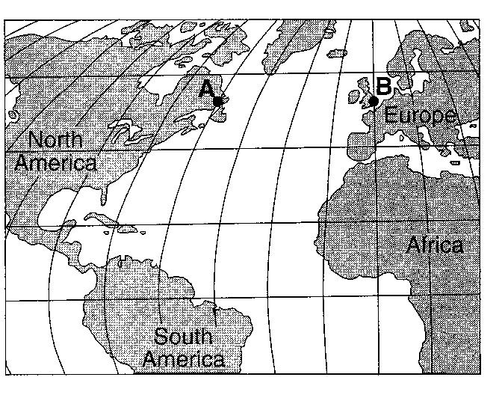
The map to the right shows locations A and B on Earth’s surface at the same distance from the ocean, at the same elevation above sea level, and at the same latitude.

12.______ Which statement best explains why location A has a cooler climate than location B?

(1) Location B is farther from the equator.
(2) Location A has a longer duration of insolation each day.
(3) Location A is influenced by a cold ocean current.
(4) Location B has less intense insolation each day.

13.______ Very cold climates occur at Earth’s North and South Poles because the polar regions

(1) are usually farthest from the Sun (3) receive the most hours of daylight
(2) absorb the greatest amount of insolation (4) receive low-angle insolation

14.______ Mt. Marcy often has the coldest nighttime temperatures in New York State because of its

(1) latitude and planetary winds (3) longitude and planetary winds
(2) latitude and elevation (4) longitude and elevation
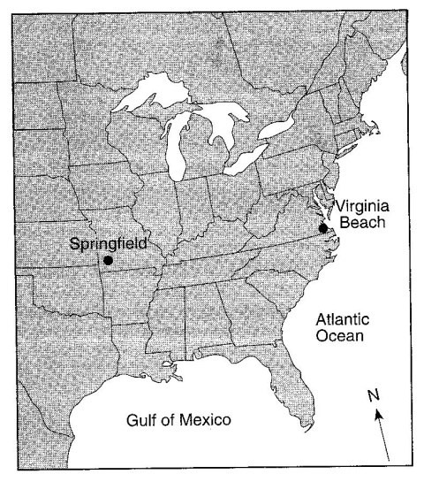

The map to the right shows the locations of Virginia Beach, Virginia and Springfield, Missouri.

15.______ Virginia Beach experiences cooler summers and warmer winters than Springfield because Virginia Beach

(1) is located closer to the Atlantic Ocean
(2) is located closer to the equator
(3) has a greater average yearly duration of insolation
(4) has a greater average yearly intensity of insolation

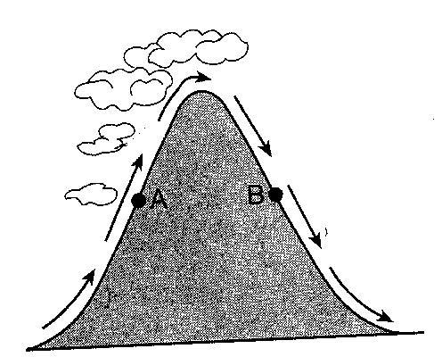
The cross section to the right shows the direction of air flowing over a mountain. Points A and B are at the same elevation on opposite sides of the mountain.

16.______ Compared to the air temperature and humidity at point A, the air temperature and humidity at point B are usually

(1) cooler and drier (3) warmer and drier
(2) cooler and wetter (4) warmer and wetter

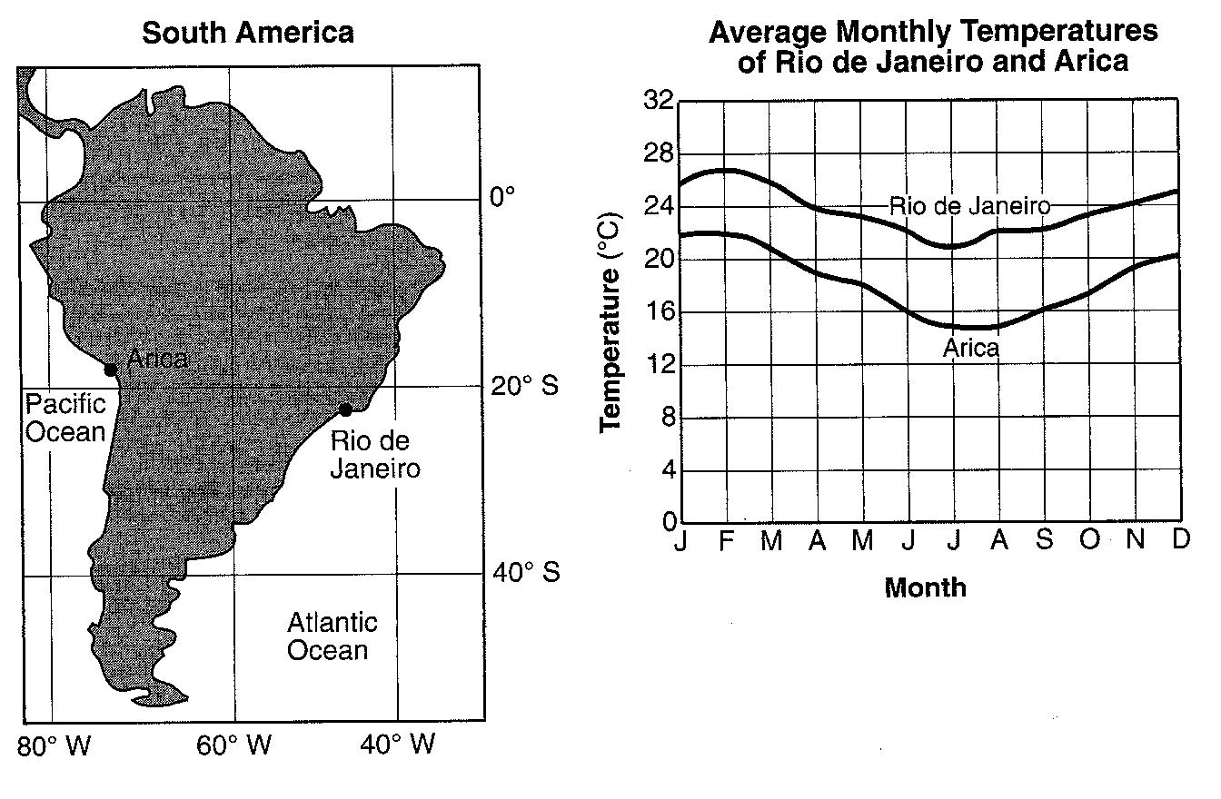
Base your answers to questions 17 and 18 on the map and table to the right. The map shows two cities, Arica and Rio de Janeiro, located on opposite coasts of South America. Both cities are near sea level. The graph shows the average monthly temperatures for the cities.

17.______ Why does Arica have cooler average monthly temperatures than Rio de Janeiro?

(1) Rio de Janeiro receives insolation at a higher angle than Arica.
(2) Rio de Janeiro is influenced by a warmer ocean current than Arica.
(3) Arica is father north than Rio de Janeiro.
(4) Arica receives yearly insolation that is less intense than Rio de Janeiro.

18.______ The summer season at Arica and Rio de Janeiro occurs from approximately

(1) March 21 through June 20 (3) September 23 through December 20
(2) June 21 through September 22 (4) December 21 through March 20

19.______ During some winters in the Finger Lakes region of New York State, the lake water remains unfrozen even though the land around the lakes is frozen and covered with snow. The primary cause of this difference is that water

(1) gains heat during evaporation (3) has a higher specific heat
(2) is at a lower elevation (4) reflects more radiation

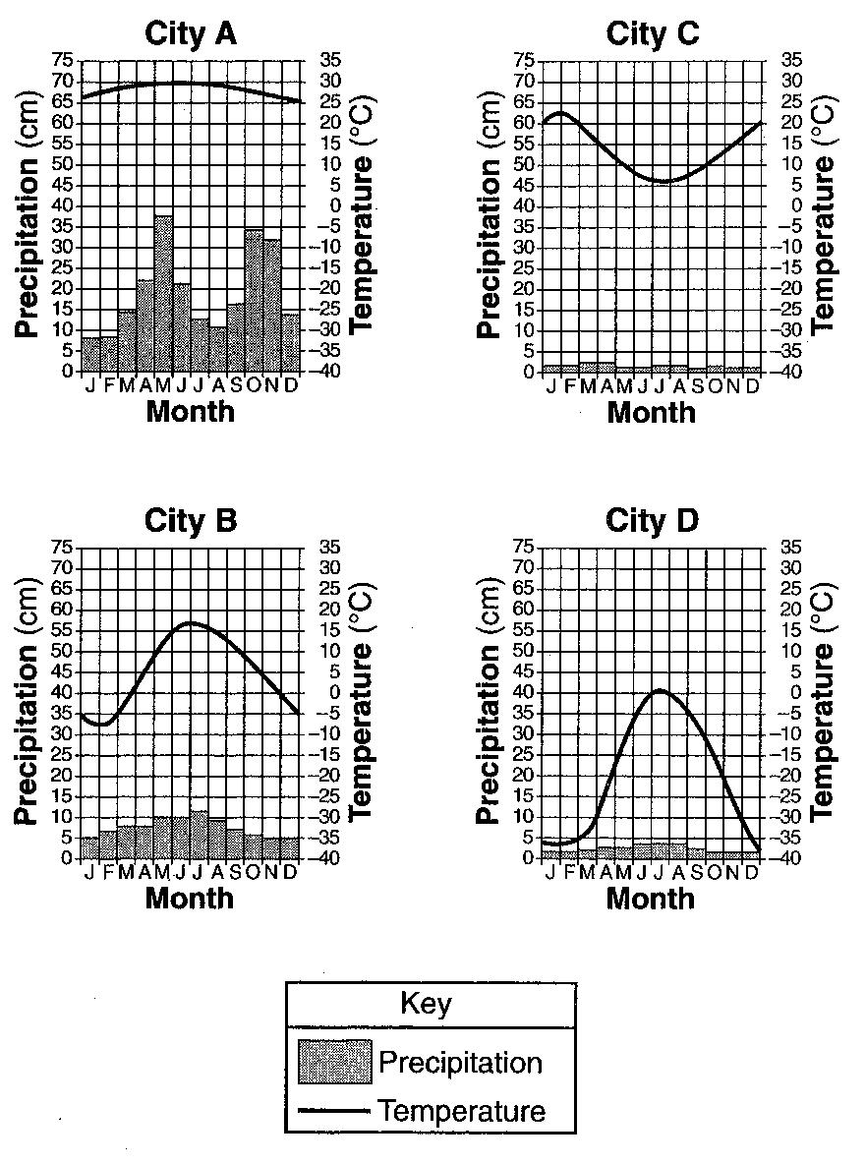
Base your answers to questions 20 through 23 on the climate graphs to the right, which show average monthly precipitation and temperatures at four cities, A, B, C, and D.

20.______ City A has little variation in temperature during the year because city A is located

(1) on the dry side of a mountain
(2) on the wet side of a mountain
(3) near the center of a large landmass
(4) near the equator

21.______ During which season does city B usually experience the month with the highest average precipitation?

(1) spring (2) summer (3) fall (4) winter

22.______ It can be concluded that city C is located in the southern hemisphere because city C has

(1) small amounts of precipitation throughout the year
(2) large amounts of precipitation throughout the year
(3) its warmest temperatures in January and February
(4) its warmest temperatures in July and August

23.______ Very little water will infiltrate the soil around city D because the region usually has

(1) a frozen surface (3) a small amount of runoff
(2) nearly flat surfaces (4) permeable soil

