Earth Interior Worksheet

NAME: ___________________________

1.______ Earth’s inner core is inferred to be solid based on the analysis of:

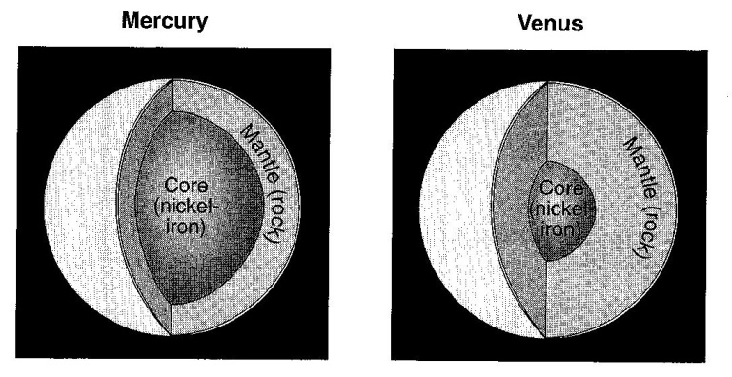
(1) seismic waves (2) crustal rocks (3) radioactive decay rates (4) magnetic pole reversals

The diagram to the right shows cutaway views of the inferred interior layers of the planets Mercury and Venus.

2.______ What is the reason for the development of the interior layers of these two planets?

(1) Impact events added to the mantle rock above the cores
(2) Heat from the Sun melted the surface rocks to form the mantles above the cores.
(3) Gravity separated the cores and mantles due to their density differences.
(4) Rapid heat loss caused the cores to solidify before the mantles.
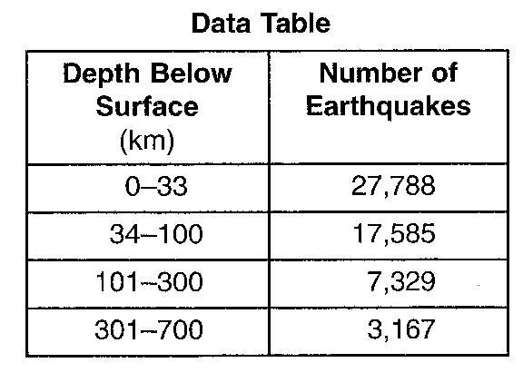
The data table to the right shows the origin depths of all large-magnitude earthquakes over a 20-year period.

3.______ According to these data, most of these earthquakes occurred within Earth’s

(1) lithosphere (3) stiffer mantle
(2) asthenosphere (4) outer core

4.______ Which combination of pressure and temperature is inferred to occur with Earth’s stiffer mantle?

(1) 3500ºC and 0.4 million atmospheres (3) 5500ºC and 0.4 million atmospheres
(2) 3500ºC and 2.0 million atmospheres (4) 5500ºC and 2.0 million atmospheres

5.______ What happens to the density and temperature of rock within Earth’s interior as depth increases?

(1) density decreases and temperature decreases
(2) density decreases and temperature increases
(3) density increases and temperature increases
(4) density increases and temperature decreases
6.______ Which part of Earth’s interior is inferred to have convection currents that cause tectonic plates to move?

(1) rigid mantle (2) asthenosphere (3) outer core (4) inner core

7.______ Compared to the continental crust, the oceanic crust is

(1) less dense and less felsic (3) more dense and more felsic
(2) less dense and more mafic (4) more dense and more mafic

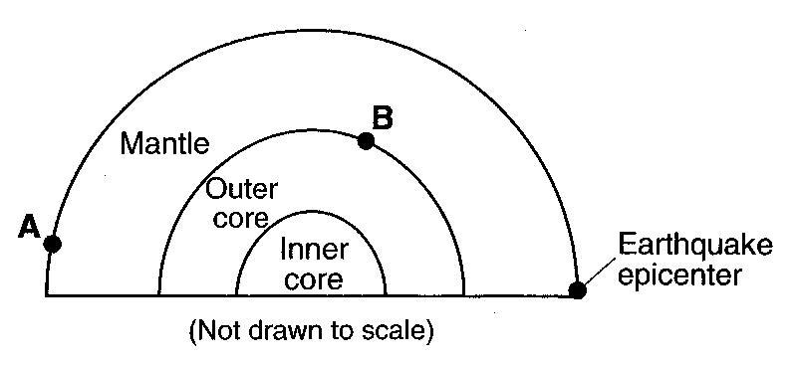
8. Referring to the cross section to the right, what is the approximate depth at location B?

9. Which layer of Earth is composed of both the crust and the rigid mantle?

