Global Warming, Ozone, Insolation and Heat Worksheet

NAME: ___________________________

1.______ Which two gases have been added to Earth’s atmosphere in large amounts and are believed to have increased global warming by absorbing infrared radiation?

(1) neon and argon (3) hydrogen and helium
(2) chlorine and nitrogen (4) methane and carbon dioxide

2.______ Increasing the amount of carbon dioxide in Earth’s atmosphere increases atmospheric temperature because the carbon dioxide absorbs

(1) incoming solar mamma ray radiation (3) outgoing terrestrial ultraviolet radiation
(2) incoming solar visible light radiation (4) outgoing terrestrial infrared radiation

3.______ Scientists are concerned about the decrease in ozone in the upper atmosphere primarily because ozone protects life on Earth by absorbing certain wavelengths of

(1) x-ray radiation (2) ultraviolet radiation (3) infrared radiation (4) microwave radiation

4.______ Which type of land surface would most probably reflect the most incoming solar radiation?

(1) light colored and smooth (3) dark colored and smooth
(2) light colored and rough (4) dark colored and rough

5.______ The tropopause is approximately how far above sea level?

(1) 12 mi (2) 12 km (3) 60 mi (4) 60 km

6.______ In New York State, summer is warmer than winter because in summer New York State has
(1) fewer hours of daylight and receives low-angle insolation
(2) fewer hours of daylight and receives high-angle insolation
(3) more hours of daylight and receives low-angle insolation
(4) more hours of daylight and receives high-angle insolation

7.______ Most insolation striking a smooth, light-colored, solid surface is

(1) refracted (2) transmitted (3) reflected (4) absorbed

8.______ Which process requires water to gain heat energy from the environment?

(1) evaporation (2) condensation (3) infiltration (4) precipitation
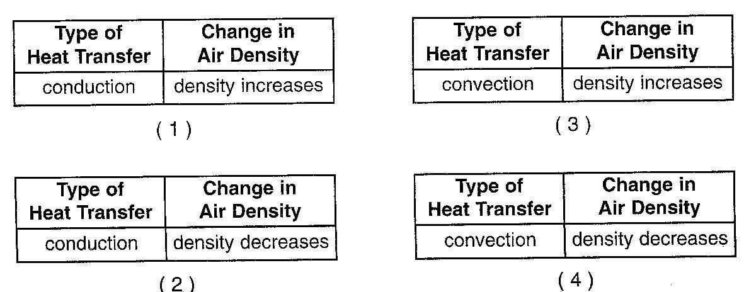
9.______ The air above a burning candle is heated and rises. Which table to the right correctly identifies the type of heat transfer within the rising air and the change in air density above the burning candle?

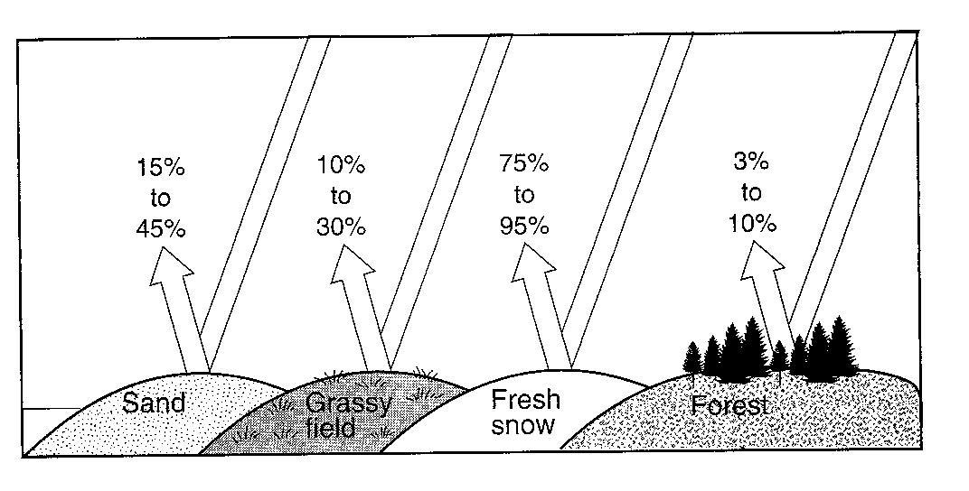
The diagram to the right indicates the amount of solar radiation that is reflected by equal areas of various materials on Earth’s surface.

10.______ Which material absorbs the most solar radiation?

(1) grassy field (3) sand
(2) fresh snow (4) forest
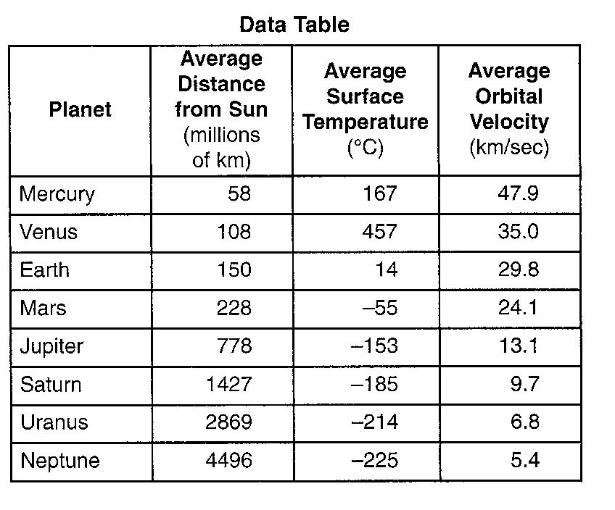

The map to the right shows, among other information, the average surface temperature of eight planets.

11. Venus has an atmosphere composed mostly of carbon dioxide. Mercury has almost no atmosphere. Explain how the presence of the carbon dioxide in Venus’ atmosphere causes the average surface temperature on Venus to be higher than the average surface temperature on Mercury even though Mercury is closer to the Sun.

12.______ When Earth cools, most of the energy transferred from Earth’s surface to space is transferred by the process of

(1) conduction (2) reflection (3) refraction (4) radiation

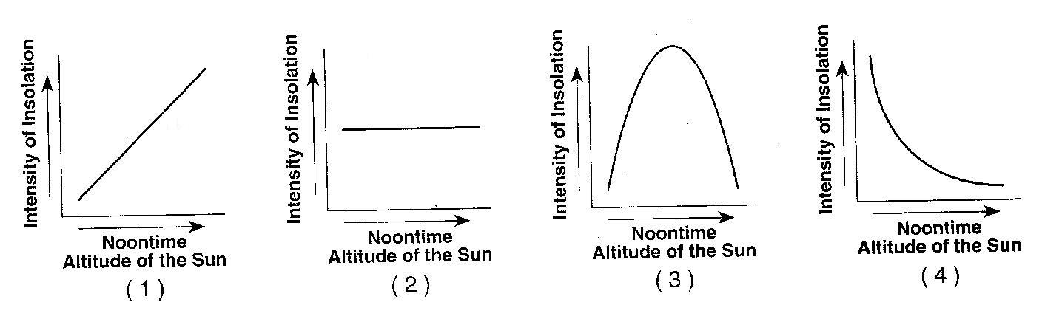
13.______ Which graph to the right best shows the general relationship between the altitude of the noontime Sun and the intensity of insolation received at a location?

14.______ Equal areas of which surface would most likely absorb the most insolation?

(1) smooth, white surface (3) smooth, black surface
(2) rough, white surface (4) rough, black surface

