HR Diagram Worksheet

NAME: ___________________________
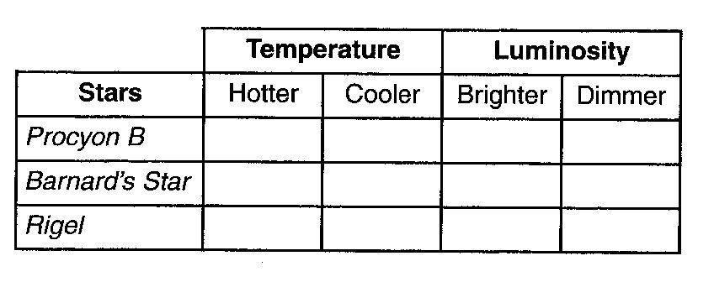

1. Complete the table to the right by placing an X in the boxes that indicate the temperature and luminosity of each star compared to our Sun.

2. The star Betelgeuse is farther from Earth than the star Aldebaran. explain why Betelgeuse appears brighter or more luminous than Aldebaran.

3.______ Which star’s surface temperature is closest to the temperature at the boundary between Earth’s mantle and core?

(1) Sirius (2) Rigel (3) the Sun (4) Betelgeuse

Base your answers to questions 4 and 5 on the Luminosity and Temperature of Stars graph in the Earth Science Reference Tables.

4. Describe the relationship between temperature and luminosity of main sequence stars.

5. In which group of stars would a star with a temperature of 5000ºC and a luminosity of approximately 100 times that of the Sun be classified?

6.______ Which statement best describes the general relationship between the temperature and luminosity of main sequence stars?

(1) As temperature decreases, luminosity increases.
(2) As temperature decreases, luminosity remains the same.
(3) As temperature increases, luminosity increases.
(4) As temperature increases, luminosity remains the same.

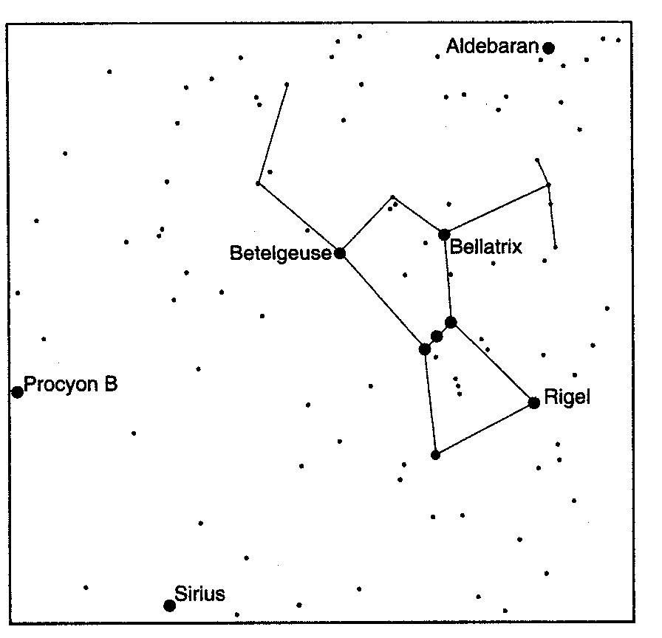
Base your answers to questions 7 and 8 on the star chart to the right, which shows part of the winter sky visible from New York State. Some of the brighter stars are labeled and the constellation Orion is outlined.

7. Identify the color of the star Bellatrix, which has a surface temperature of approximately 21,000ºC.

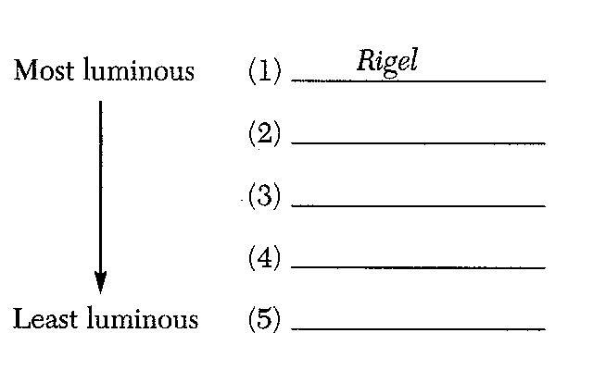

8. In the space provided to the right, list the stars, other than Bellatrix, found on the chart in order of decreasing luminosity. Rigel, the most luminous star, has been listed.

9. The star Algol is estimated to have approximately the same luminosity as the star Aldebaran and approximately the same temperature as the star Rigel. Algol is best classified as a

(1) main sequence star (2) red giant star (3) white dwarf star (4) red dwarf star

