Permeability, Porosity and Capillarity Worksheet

NAME: ______________________________

1.__________A soil sample with a large amount of space between the particles will have a:
(1) low permeability rate (3) high porosity
(2) low infiltration rate (4) high capillarity
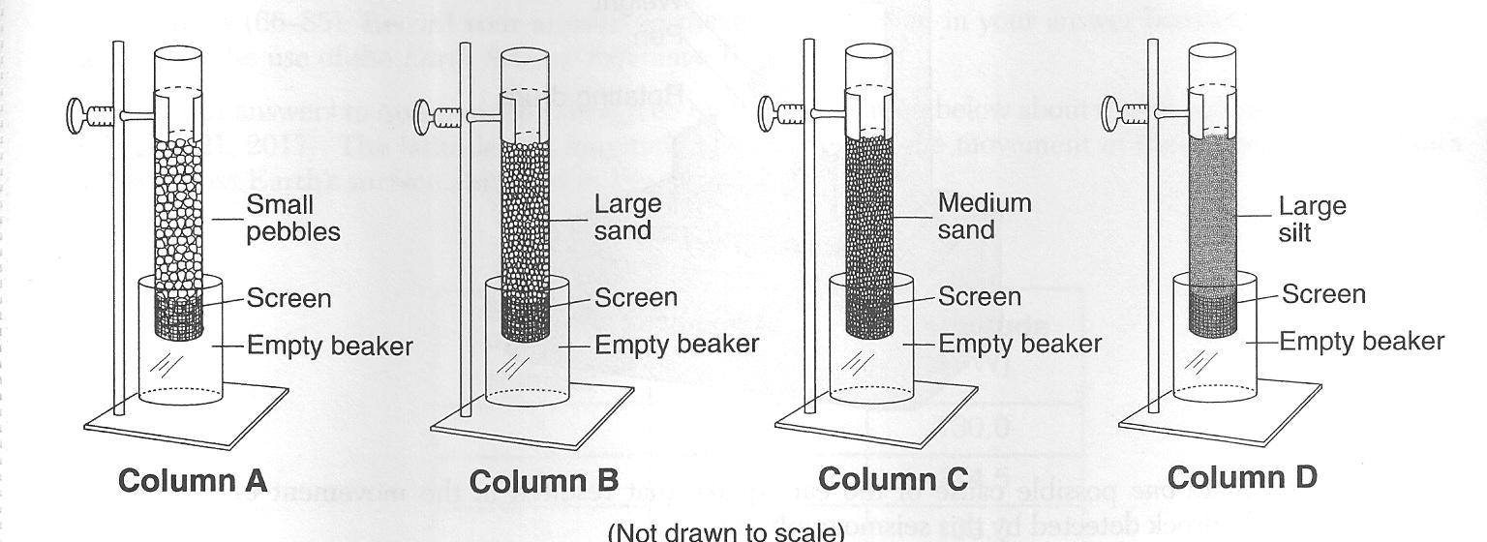
2.__________Which column above contains particles with a diameter of 0.4 cm?

3. Describe the relationship between the sediment size and the permeability that will be observed when water is poured through the sediments in the columns above.

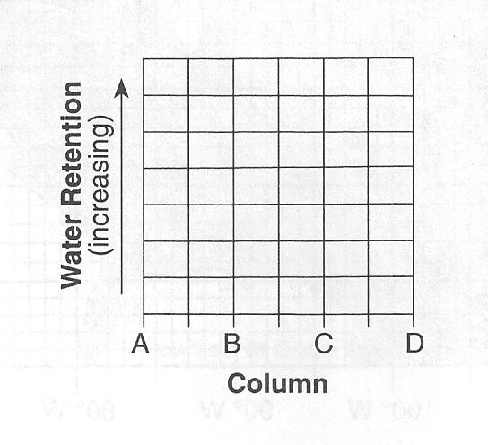

4. An equal amount of water is poured through each column above. On the grid to the right, draw a line to show the relative amount of water retained in the sediment after the water flows through each column.

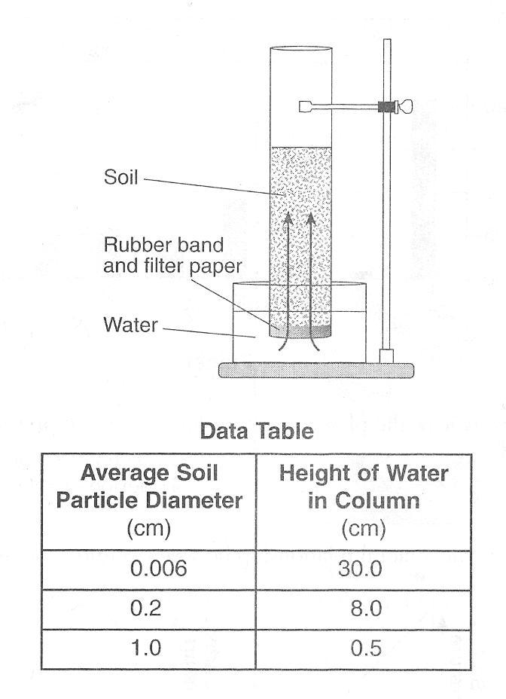
The diagram to the right shows a laboratory setup. The rubber band holds the filter paper across the base of the open tube to hold the soil sample. The tube was placed in the water as shown. The upward movement of water is represented by arrows. The height of the water that moved upward within the soil was measured. Students repeated this procedure using soils with different particle sizes. Results of the experiment are shown in the data table.

5.__________Results of this experiment lead to the conclusion that:

(1) capillarity is greater in soils with larger particles
(2) capillarity is greater in soils with smaller particles
(3) permeability is greater in soils with smaller particles
(4) porosity is greater in soils with smaller particles

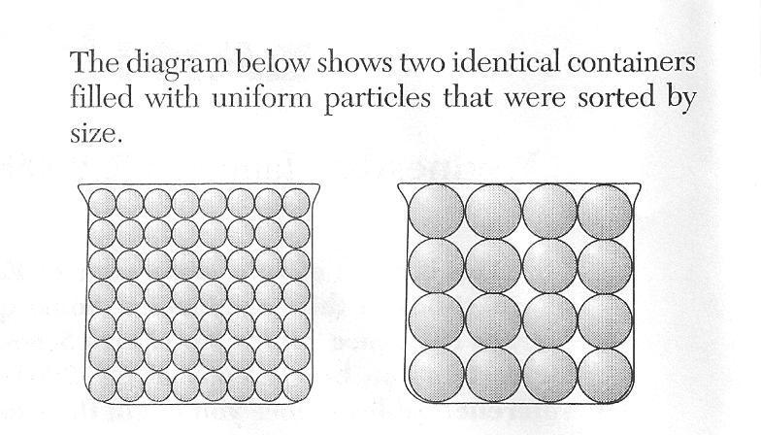

6.__________Refer to the diagram to the right to answer this question. Which characteristic is most likely the same for these particle-filled containers?

(1) infiltration rate (3) capillarity
(2) permeability (4) porosity

7.______ Which graph below best represents the relationship between soil particle size and the soil’s permeability rate?
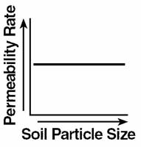
(1) (2) (3) (4)
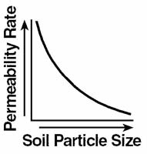
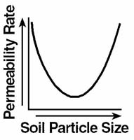
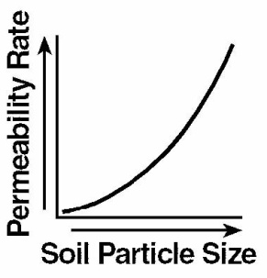

8.______ Which soil conditions normally result in the greatest amount of runoff?
(1) low permeability and gentle slope (3) high permeability and gentle slope
(2) low permeability and steep slope (4) high permeability and steep slope

9.______ A soil sample with a large amount of space between the particles will have a

(1) low permeability rate (2) low infiltration rate (3) high porosity (4) high capillarity
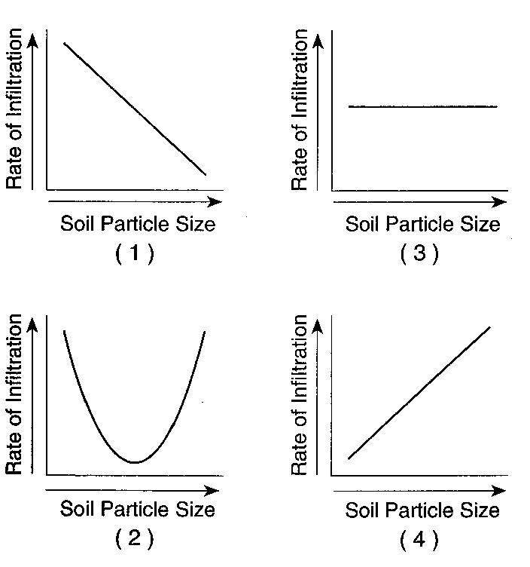
10.______ Which graph to the right best represents the relationship between soil particle size and the rate at which water infiltrates permeable soil?

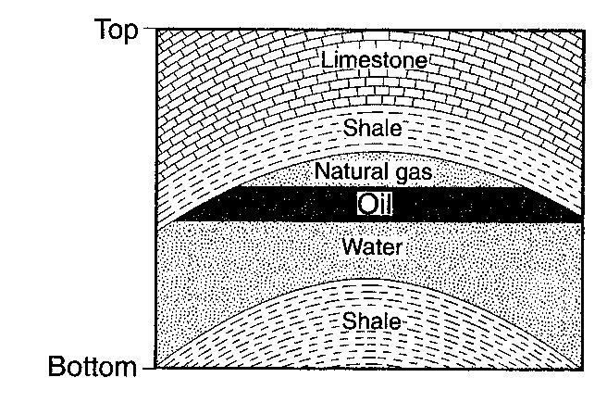
Base your answers to questions 11 and 12 on the bedrock cross section to the right. The cross section represents part of Earth’s crust where natural gas, oil, and water have moved upward through a layer of folded sandstone and filled the pore spaces at the top of the sandstone layer.

11.______ The final arrangement of the natural gas, oil, and water within the sandstone was caused by differences in their

(1) density (2) specific heat (3) relative age (4) radioactive half-life

12.______ The natural gas, oil, and water are trapped within the layer of sandstone and do not move upward through the shale because, compared to the sandstone, the shale has

(1) lower permeability (2) less foliation (3) larger pore spaces (4) larger particles

