Plate Tectonics Worksheet

NAME: ___________________________

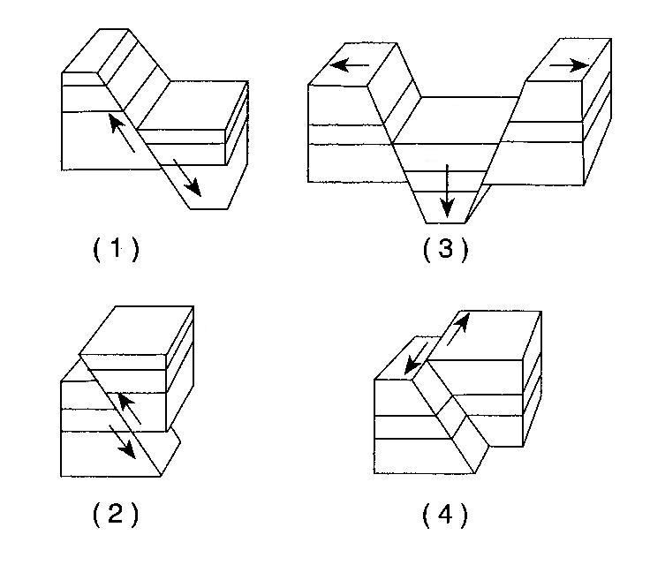

1.______ Which block diagram to the right best shows a transform fault?

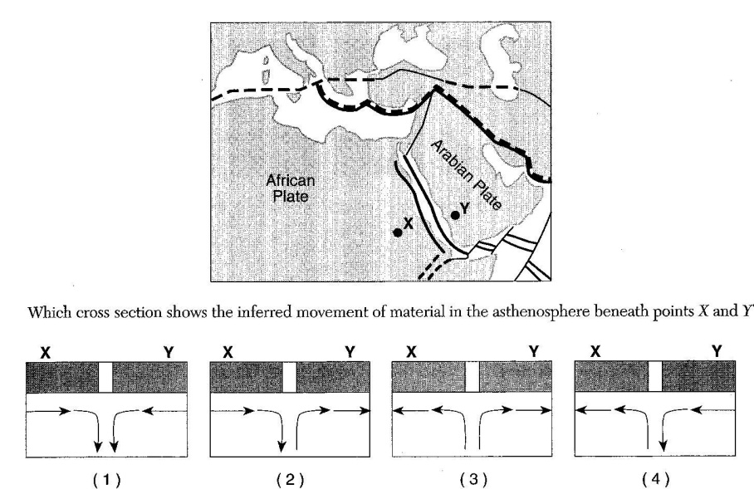
The map to the right shows a portion of Earth’s surface. Points X and Y are locations on the lithosphere.

2.______ Which cross section shows the inferred movement of material in the asthenosphere beneath points X and Y?

3.______ When two tectonics plates collide, oceanic crust usually subducts beneath continental crust because oceanic crust is composed of igneous rocks that has

(1) low density and is mafic (3) high density and is mafic
(2) low density and is felsic (4) high density and is felsic

4.______ Alternating parallel bands of normal and reversed magnetic polarity are found in the basaltic bedrock on either side of the

(1) Mid-Atlantic Ridge (3) San Andreas Fault
(2) Yellowstone Hot Spot (4) Peru-Chile Trench

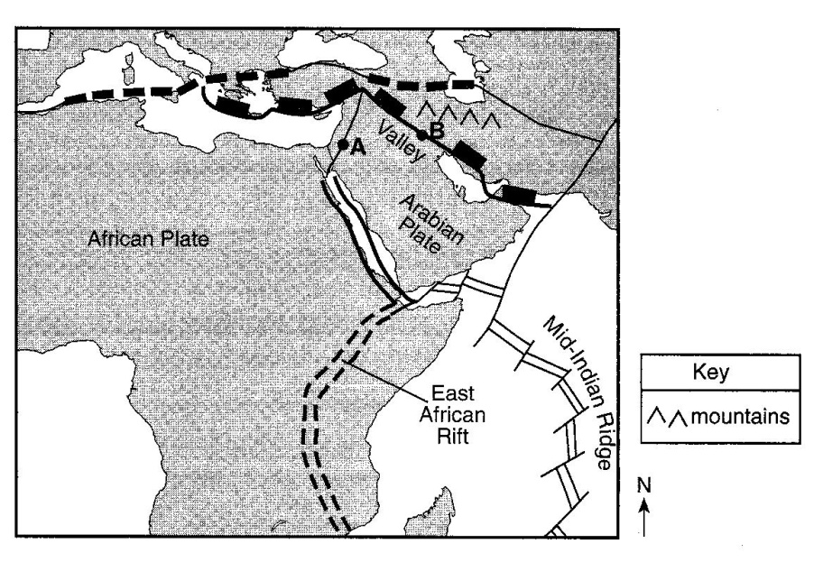
Base your answers to questions 5 through 7 on the map to the right, which is an enlargement of a portion of the Tectonic Plates map from the Earth Science Reference Tables. Points A and B are locations on different boundaries of the Arabian Plate.

5. Identify the type of plate boundary located at point A.

6. On the map shown, a valley is located south of point B and a mountain range north of point B. State the tectonic process that is creating these two land features.
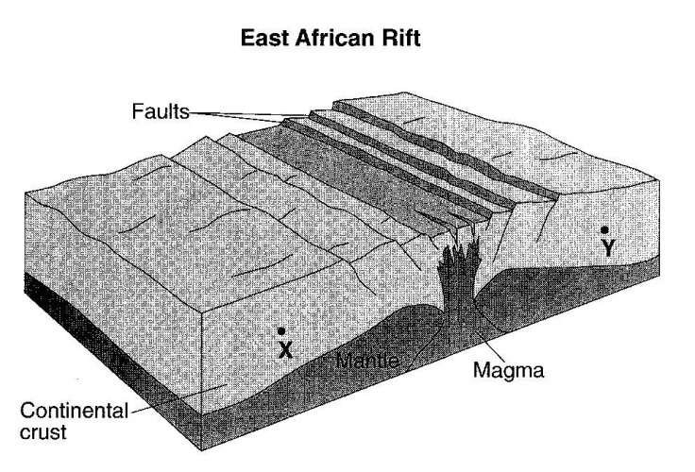

7. The block diagram to the right represents Earth’s surface and interior along the East African Rift. Draw two arrows, one through point X and one through point Y, to indicate the relative motion of each of these sections of the continental crust.

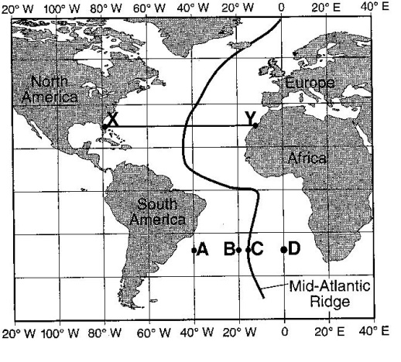
Base your answers to questions 8 through 10 on the map of the Mid-Atlantic Ridge shown to the right. Points A through D are locations on the ocean floor. Line XY connects locations in North America and Africa.

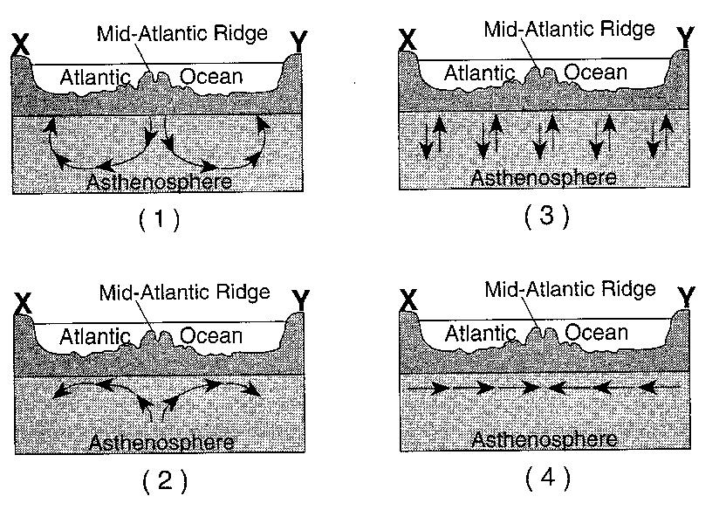
8._____ In which cross section below do the arrows best show the convection occurring within the asthenosphere beneath line XY?

9.______ Samples of ocean floor bedrock were collected at points A, B, C and D. Which sequence shows the correct order of the age of the bedrock from oldest to youngest?

(1) D>C>B>A (2) A>D>B>C (3) C>B>D>A (4) A>B>D>C

10.______ The boundary between which two tectonic plates is most similar geologically to the plate boundary at the Mid-Atlantic Ridge?

(1) Eurasian and Indian-Australian (3) Pacific and Nazca
(2) Cocos and Caribbean (4) Nazca and South American

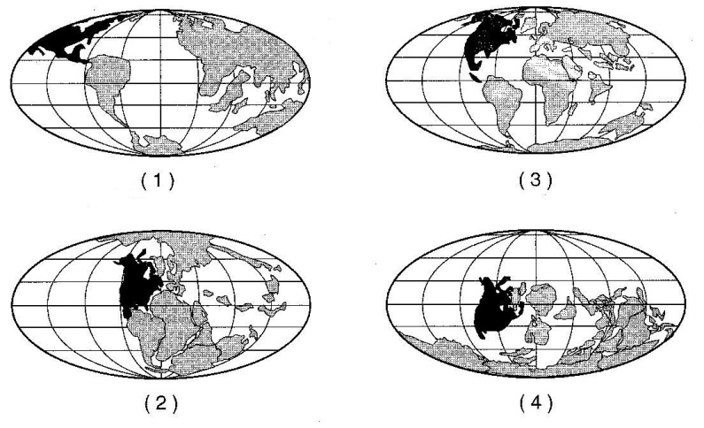

11.______ Which map to the right best indicates the probable locations of continents 100 million years from now if tectonic plate movement continues at its present rate and direction?

12.______ Which observation about the Mid-Atlantic Ridge region provides the best evidence that the seafloor has been spreading for millions of years?

(1) the bedrock of the ridge and nearby seafloor is igneous rock
(2) the ridge is the location of irregular volcanic eruptions
(3) several faults cut across the ridge and nearby seafloor
(4) seafloor bedrock is younger near the ridge and older farther away

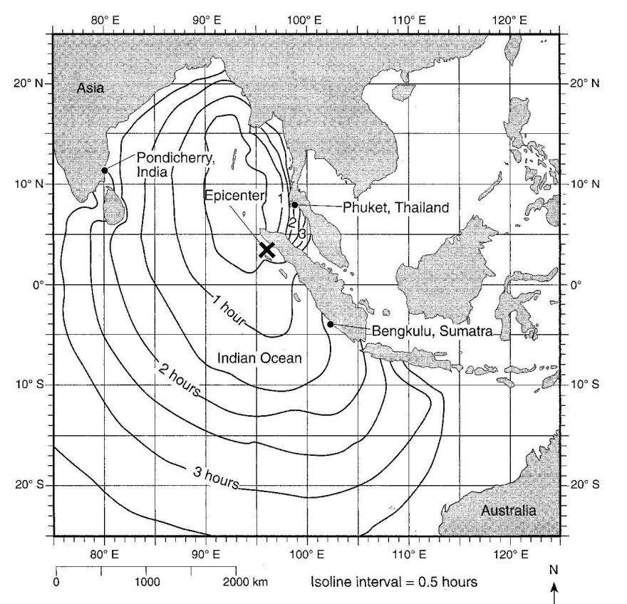
Use the map to the right to answer questions 13 through 15. This map shows the epicenter of an extremely strong earthquake that occurred on December 26, 2004. The epicenter of the earthquake is marked with an X. The isolines surrounding the epicenter show the approximate location of the first tsunami wave produced by this earthquake in half-hour intervals after the initial earthquake.

13. According to the map, how long after this earthquake did the first tsunami wave arrive at Bengkulu, Sumatra?

14. State the latitude and longitude of the epicenter of this earthquake. Include the units and compass directions in your answer.

15. Identify the overriding tectonic plate at the convergent plate boundary where this earthquake occurred.

16.______ Active volcanoes are most abundant along the

(1) edges of tectonic plates (3) 23.5ºN and 23.5ºS parallels of latitude
(2) eastern coastlines of continents (4) equatorial ocean floor

17.______ Which part of Earth’s interior is inferred to have convection currents that cause tectonic plates to move?

(1) rigid mantle (2) asthenosphere (3) outer core (4) inner core

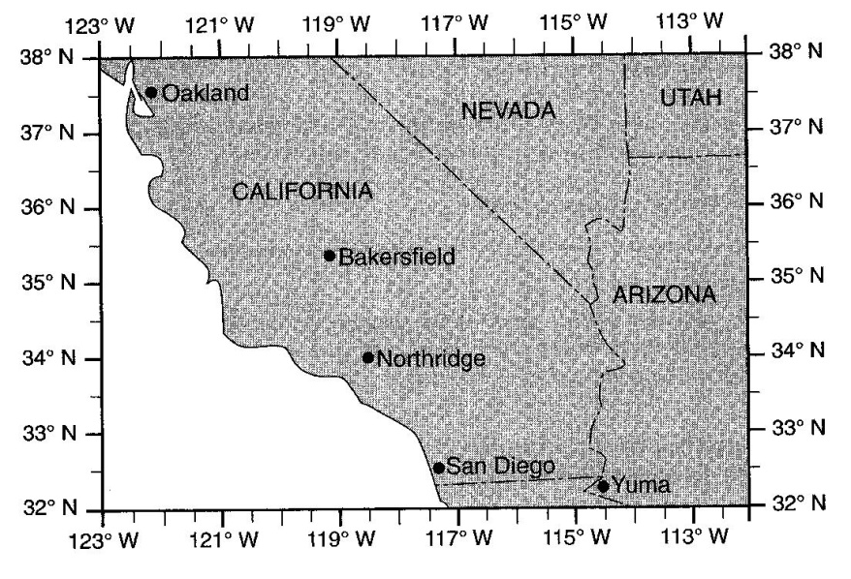
Base your answers to questions 18 through 21 on the map to the right, which shows a portion of the southwestern United States. On January 17, 1994, an earthquake occurred with an epicenter at Northridge, California.

18. State the latitude and longitude of Northridge, California. Include the correct units and compass directions in your answer.

19. Explain why earthquakes are common in this region of California.

20. Of the cities shown on the map, explain why Oakland was the last city to receive P-waves from this earthquake.

21. List two actions that a homeowner could take to prepare the home or family for the next earthquake.

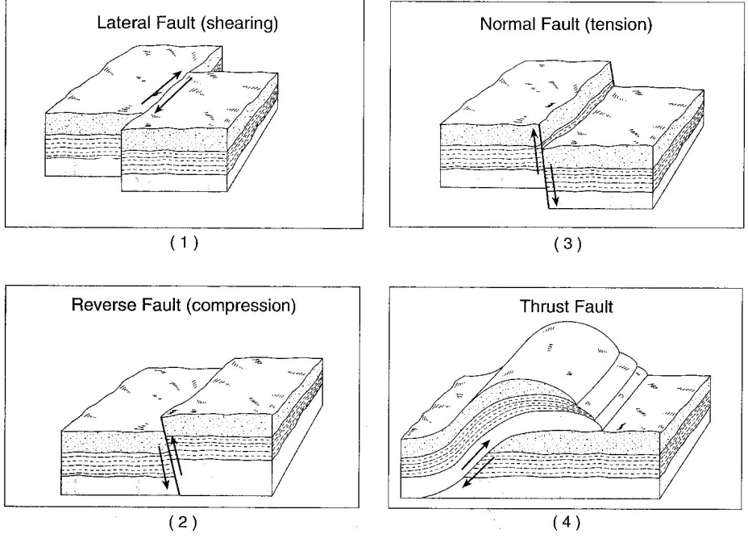
22.______ The diagram to the right shows four major types of fault motion occurring in Earth’s crust. Which type of fault motion best matches the general pattern of crustal movement at California’s San Andreas fault?

(1) A (2) B (3) C (4) D

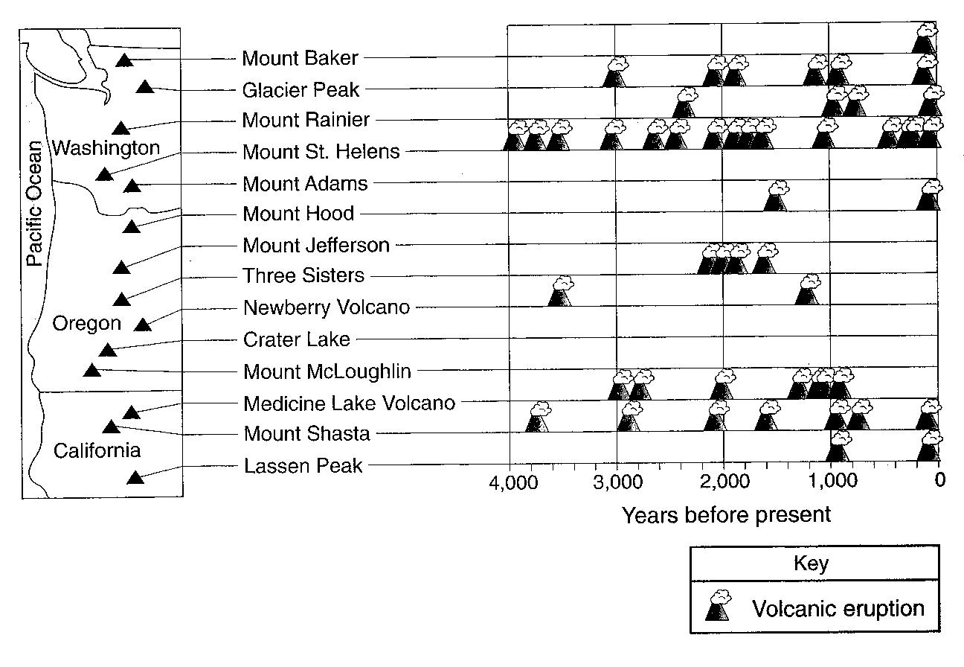
The map to the right shows the name and location of the volcanic peaks in the Cascade Mountain Range of the northwestern United States. The table shows the major eruptions of each peak over the past 4,000 years.

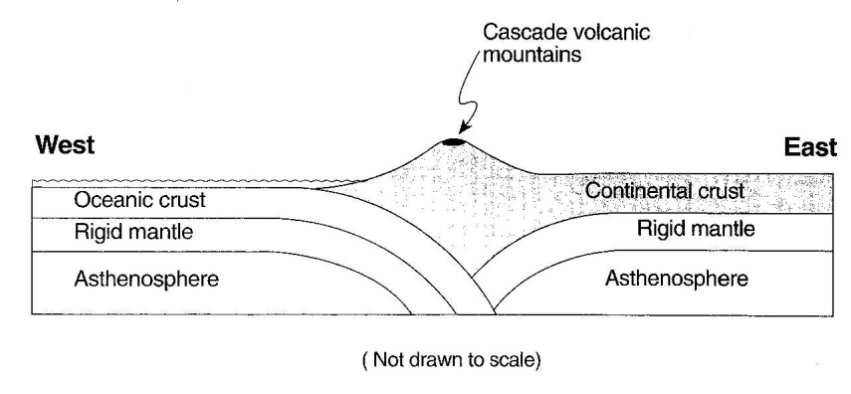
23. On the cross section below, place an arrow in the continental crust and an arrow in the oceanic crust to show the relative direction of plate movement.

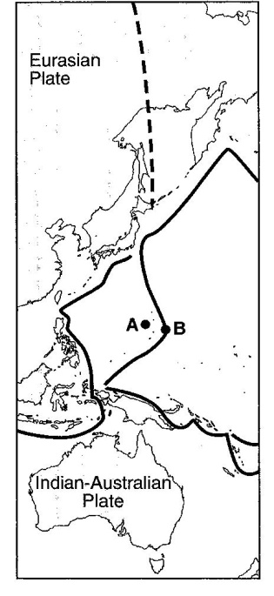
The map to the right shows some tectonic plates and the boundaries between them. Letters A and B are locations on Earth’s surface.

24. Identify the type of plate boundary feature found at location B.

..

