RADIOACTIVE DATING

NAME: ___________________________ DATE: ___________

1. _____ How old is a fossil that has radioactively decayed through 4 half-lives of carbon-14?

(1) 5,700 years (3) 22,800 years

(2) 17, 100 years (4) 28,500 years

Half –life of 4.6 X 109 years



2. _____ In the diagram above, how many boxes should be shaded to represent the additional decayed material formed during the second half-life?

(1) 12 (3) 3

(2) 6 (4) 0

3. _____ From the diagram above, which radioactive isotope has a half-life closest in duration to this radioactive sample?

(1) carbon-14 (3) uranium-238

(2) potassium-40 (4) rubidium-87



4. _____ In the diagram above, analysis of a basalt rock sample shows that 25% of its radioactive K-40 remained undecayed. How old is the basalt?

(1) 1.3 billion years (3) 3.9 billion years

(2) 2.6 billion years (4) 4.6 billion years



5. _____



6. _____ According to the graph, what is the half-life of this isotope?



(1) 100 years (3) 200 years

(2) 150 years (4) 300 years

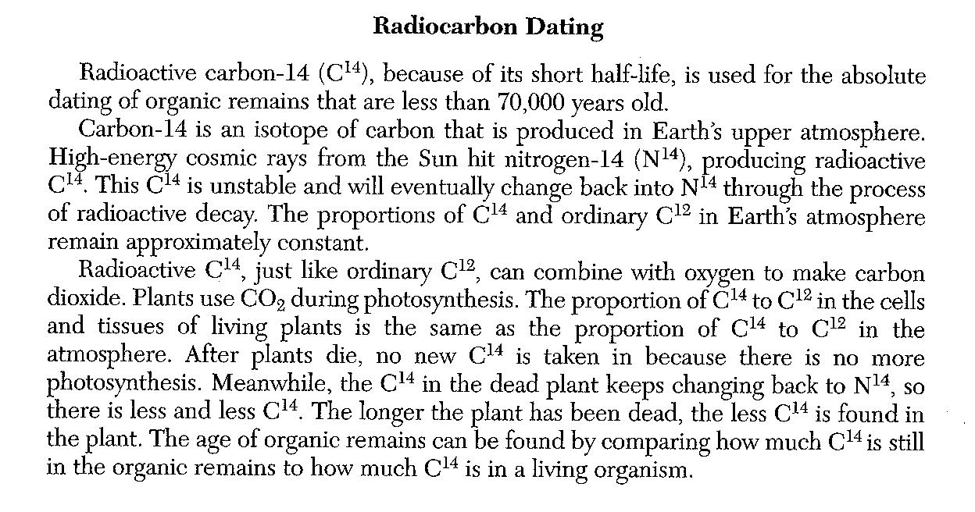

7._______________Radioactive decay was used to determine the geologic age of old wood preserved in a glacier. The amount of C14 in the old wood is half the normal amount of C14 currently found in the wood of living trees. What is the geologic age of the old wood?

8. State one difference between dating with the radioactive isotope C14 and dating with the radioactive isotope uranium-238 (U238)

Base your answers 9 and 10 on the diagram to the right, which represents a model of the radioactive decay of a particular element. The diagram shows the decay of a radioactive element into the stable decay element after one half-life period.

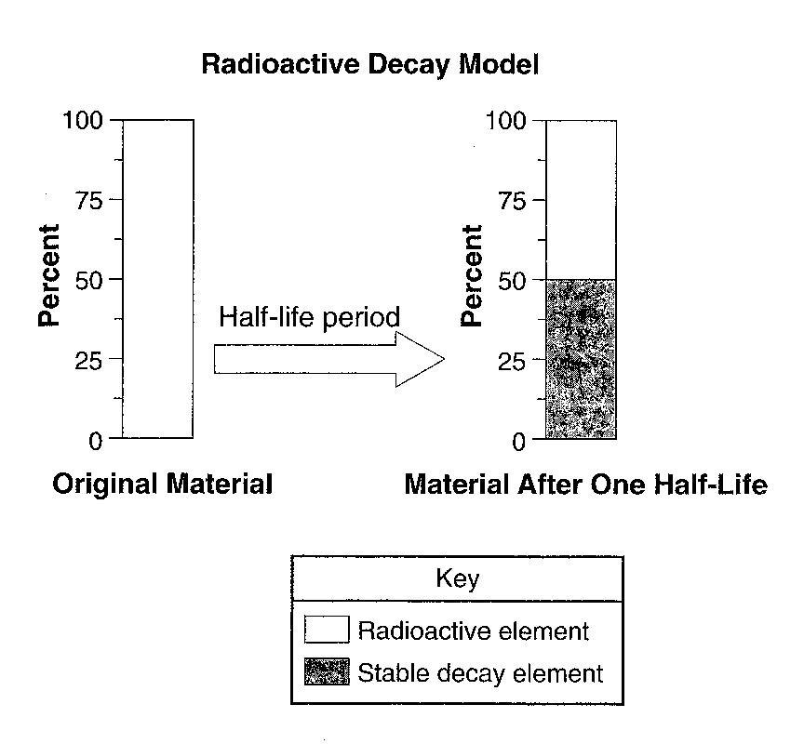

9. On the diagram to the right, shade in the amount of stable decay element present after the second half-life period.

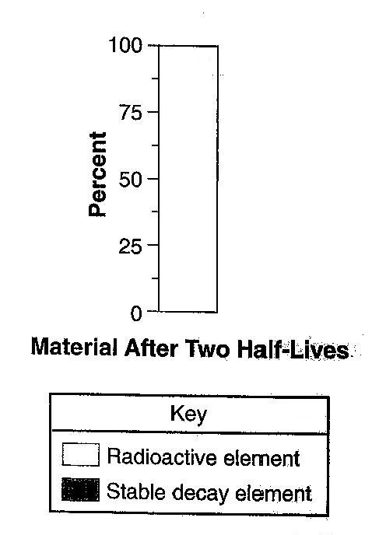

10. If the radioactive element in this model is Carbon-14, how much time will have passed after one half-life?

11.__________ A sample of wood that originally contained 100 grams of Carbon-14 now contains only 25 grams of Carbon-14. Approximately how many years ago was this sample part of a living tree?

1. 2,850 years (3) 11,400 years
2. 5,700 years (4) 17,100 years

12.__________ A sample of wood found in an ancient tomb contains 25% of its original carbon-14. The age of this wood sample is approximately?

1. 2,800 years (3) 11,400 years
2. 5,700 years (4) 17,100 years

The data table to the right shows the radioactive decay of carbon-14. The numbers of years required to complete four half-lives has been left blank.

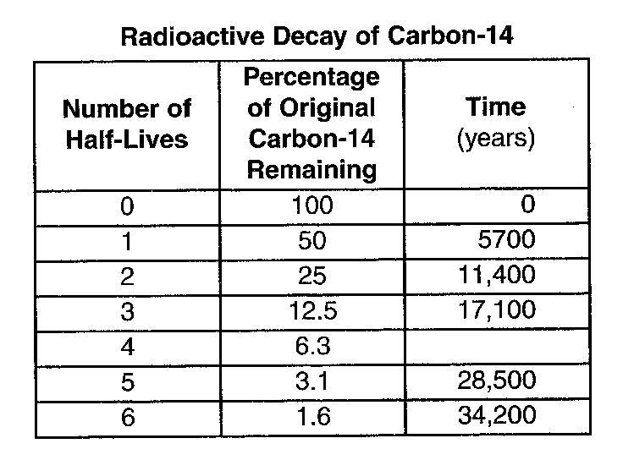

13. How long does it take for carbon-14 to complete four half-lives?

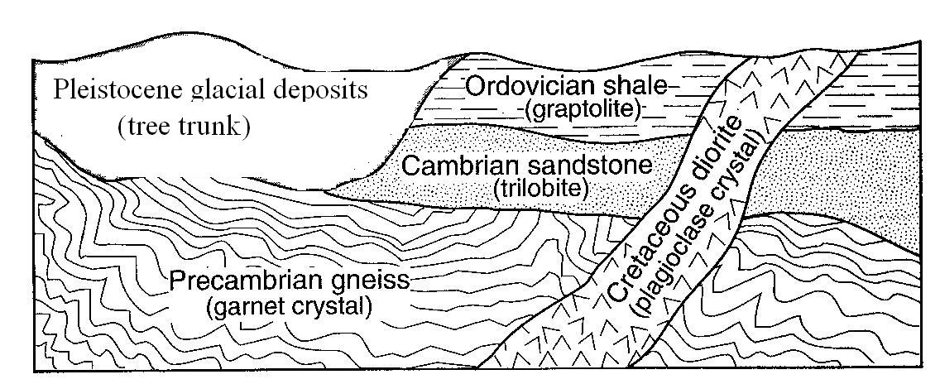

The cross section to the right shows part of Earth’s crust. The objects in parentheses indicate materials found within each rock unit or deposit.

14. Which object in parentheses could be accurately dated using carbon-14? **Explain your answer.**

15. Radioactive C14 was used to determine the geologic age of old wood preserved in a glacier. The amount of C14 in the old wood is half the normal amount of C14 currently found in the wood of living trees. What is the geologic age of the old wood?

16. State one difference between dating with the radioactive isotope C14 and dating with the radioactive isotope uranium-238 (U238)?

Base your answers to questions 17 and 18 on the graph to the right, which shows the generalized rate of decay of radioactive isotopes over 5 half-lives.

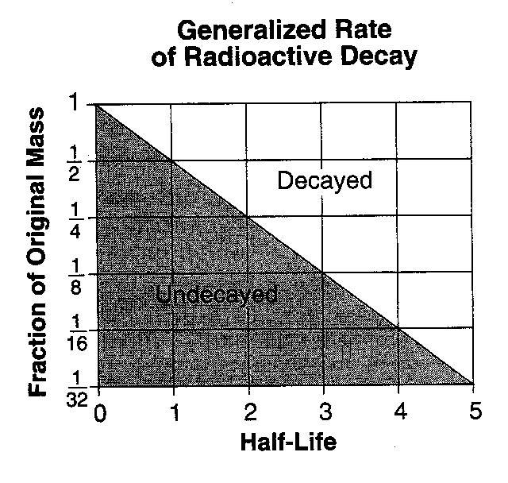

17.______ If the original mass of a radioactive isotope was 24 grams, how many grams would remain after 3 half-lives?

(1) 12 (2) 24 (3) 3 (4) 6

18.______ Which radioactive isotopes takes the greatest amount of time to undergo the change shown on the graph?

(1) carbon-14 (2) potassium-40 (3) uranium-238 (4) rubidium-87

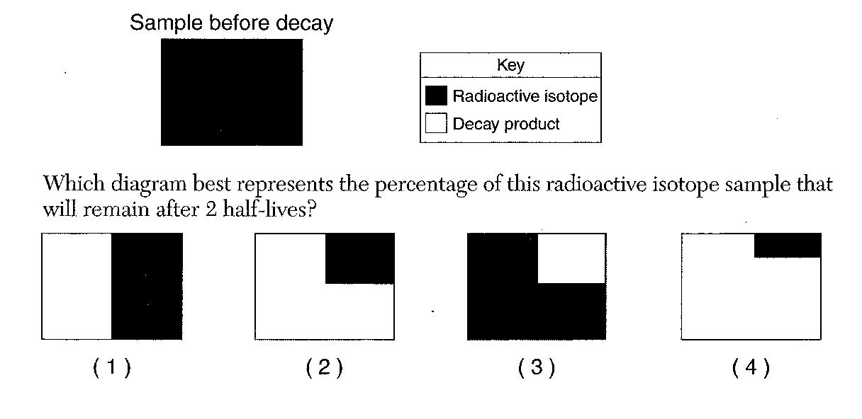

The diagram to the right represents a sample of a radioactive isotope.

19.______ Which diagram to the right best represents the percentage of this radioactive isotope sample that will remain after two half-lives.

20.______ An igneous rock containing 10 grams of radioactive potassium-40 and a total of 10 grams of its decay products. During which geologic time interval was this rock most likely formed?

(1) Middle Archean (2) Late Archean (3) Middle Proterozoic (4) Late Proterozoic