Recurring Regents Questions Worksheet

NAME: ___________________________

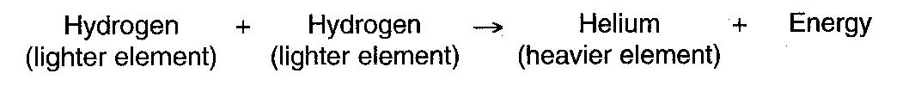
1.______ The reaction to the right represents an energy-producing process. The reactions represents how energy is produced

(1) in the sun by fusion (3) from the movement of crustal plates
(2) when water condenses in Earth’s atmosphere (4) during nuclear decay

2.______ Which ocean current carries cool water toward Earth’s equator?

(1) Alaska Current (3) Peru Current
(2) East Australia Current (4) North Atlantic Current

3.______ Which process produces the energy that allows the stars of the universe to radiate visible light?

(1) convection (2) nuclear fusion (3) insolation (4) radioactive decay

4. Explain why the constellation Orion is visible at night to an observer in New York State in December and January, but not in June and July.

5.______ Light and other forms of electromagnetic radiation are given off by stars using energy released during

(1) nuclear fusion (2) conduction (3) convection (4) radioactive decay

6.______ The path of a Foucault pendulum provides evidence that Earth

(1) rotates on its axis (3) is tilted on its axis
(2) revolves in its orbit (4) has an elliptical orbit

7.______ Which observation provides the best evidence that Earth revolves around the Sun?

(1) The constellation Orion is only visible in the night sky for part of the year.
(2) The North Star, Polaris, is located above the North Pole for the entire year.
(3) The Sun appears to move across Earth’s sky at a rate of 15º/hr.
(4) The Coriolis effect causes Northern Hemisphere winds to curve to the right.
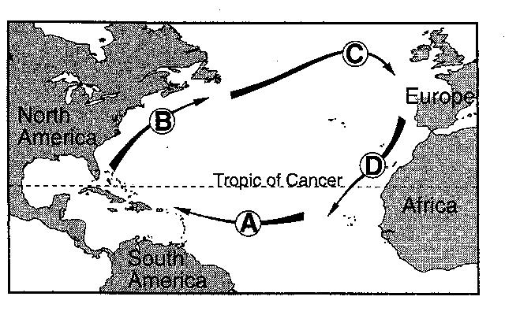

The arrows labeled A through D on the map to the right show the general paths of abandoned boats that have floated across the Atlantic Ocean.

8.______ Which sequence of ocean currents was responsible for the movement of these boats?

(1) South Equatorial > Gulf Stream > Labrador > Benguela
(2) South Equatorial > Australia > West Wind Drift > Peru
(3) North Equatorial > Koroshio > North Pacific > California
(4) North Equatorial > Gulf Stream > North Atlantic > Canaries

9.______ Which object forms by the contraction of a large sphere of gases causing the nuclear fusion of lighter elements into heavier elements?

(1) comet (2) planet (3) star (4) moon

10.______ What is the approximate rate of Earth’s revolution around the Sun?

(1) 1º per day (2) 1º per year (3) 15º per day (4) 15º per year

11.______ Which event is caused by Earth’s revolution?

(1) the apparent shift in the path of a Foucaul pendulum
(2) deflection of planetary winds to the right in the Northern Hemisphere
(3) the apparent rising and setting of the Sun
(4) different constellations observed in the night sky throughout the year

12.______ Which ocean current flows northeast along the eastern coast of North America?

(1) Gulf Stream (2) North Equatorial (3) California (4) Labrador

