Relative Humidity/Dew Point Calculation

NAME: ___________________________ DATE: ___________

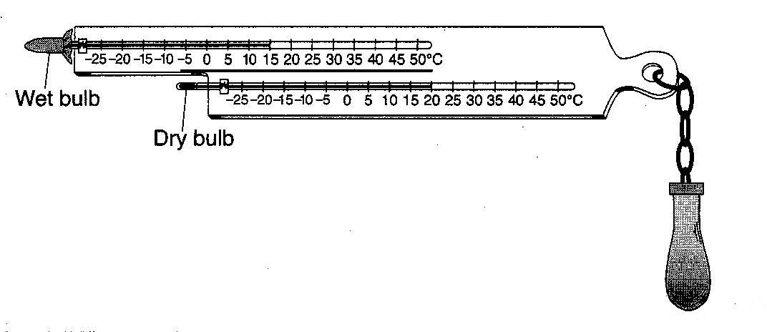
The diagram to the right shows a sling psychrometer.

1.__________Based on the dry-bulb and wet-bulb temperatures, what is the dew point?

- 5ºC (3) 14ºC
- 12ºC (4) 16ºC

2.__________What is the dewpoint temperature when the relative humidity is 30% and the air temperature is 20ºC?

- -28ºC (3) 6ºC
- 2ºC (4) 9ºC

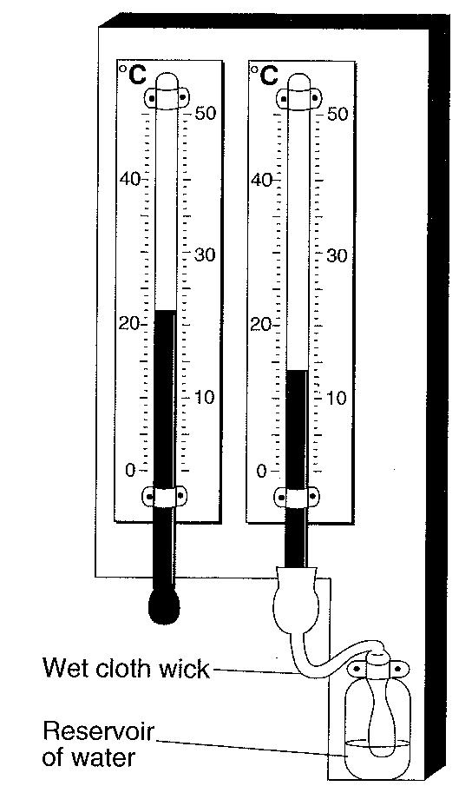
3.__________On a cold winter day, the air temperature is 2ºC and the wet-bulb temperature is -1ºC. What is the relative humidity at this location?

The weather instrument to the right is used to determine dewpoint and relative humidity.

4.__________Based on the temperatures shown, the approximate dewpoint and relative humidity are:

- -19ºC and 4% (3) 8ºC and 40%
- -5ºC and 25% (4) 12ºC and 53%

5._________What is the relative humidity if the dry-bulb temperature is 22ºC and the wet-bulb temperature is 17ºC?
(1) 5% (2) 14% (3) 60% (4) 68%

6.__________A student uses a sling psychrometer to measure the humidity of the air. If the relative humidity was 65% and the dry-bulb temperature was 10ºC, what was the wet-bulb temperature?
(1) 5ºC (2) 7ºC (3) 3ºC (4) 10ºC

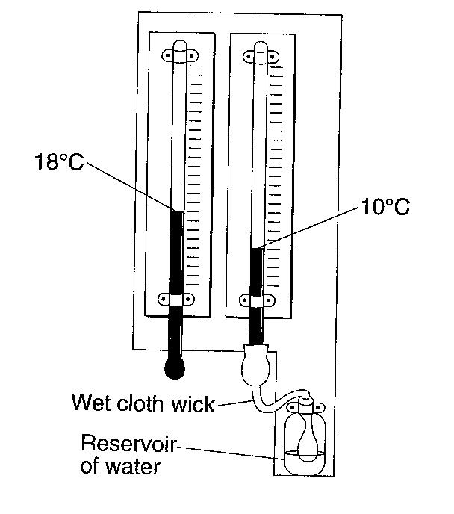
The weather instrument shown to the right can be used to determine dewpoint.

7.__________Based on the values shown, the dewpoint is
(1) -5ºC (3) 8ºC
(2) 2ºC (4) 33ºC

