SEASONS - 2

NAME: ___________________________ DATE: ___________

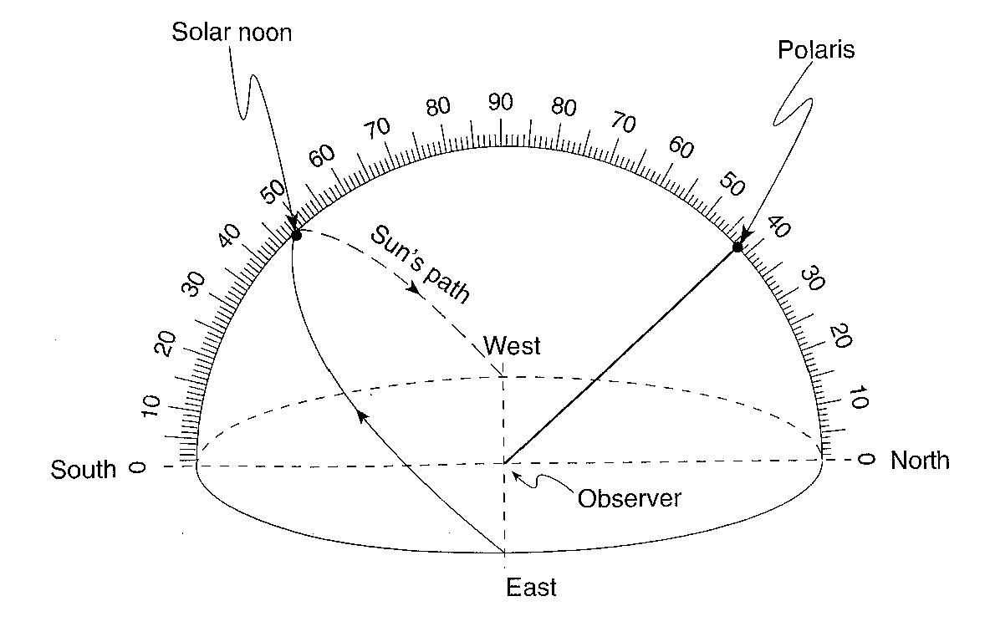
Base your answers to questions 1 through 3 on the diagram below, which represents a model of the sky (celestial sphere) for an observer in New York State. The curved line represents the Sun’s apparent path for part of one day. The altitude of Polaris is also indicated.

1. __________ According to this diagram, what is the Sun’s altitude at solar noon?
(1) 23.5º (3) 48º
(2) 42º (4) 90º

2. ___________Where is this observer most likely located?
(1) Massena (3) Slide Mountain
(2) Oswego (4) Mt. Marcy

3. ___________On which date could this observation of the Sun’s apparent path have been made?
(1) March 21 (3) October 21
(2) July 21 (4) December 21
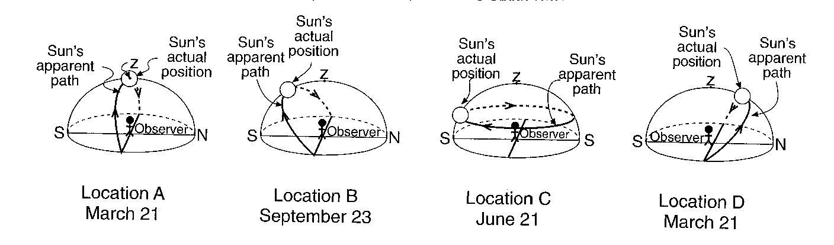
Base your answers to questions 4 through 6 on the diagram below, which shows a model of the apparent path and position of the Sun in relation to an observer at four different locations, A, B, C and D, on Earth’s surface on the dates indicated. The zenith (z) and the actual position of the Sun in the model at the time of the observation are shown. (The zenith is the point directly over the observer.)
4. __________ According to the Sun’s actual position shown in the diagrams, the most intense insolation is being received by the observer at location:
(1) A (3) C
(2) B (4) D

5. __________ Where on Earth’s surface is the observer at location C located?
(1) at the Equator (3) at the South Pole
(2) at the North Pole (4) in Oswego, New York

6. __________ From sunrise to sunset at location B, the length of the observer’s shadow will:
(1) increase, only (3) decrease, only
(2) increase, then decrease (4) decrease, then increase

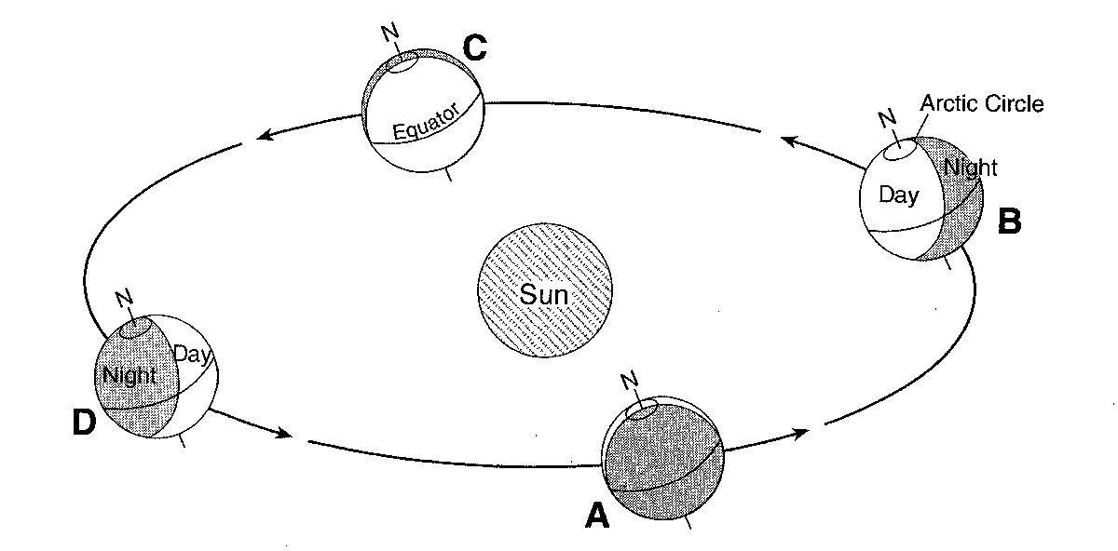
The diagram below shows Earth’s orbit around the Sun. Locations A, B, C and D represent Earth on the first day of the season.

7. _________Which location represents March 21?
(1) A (3) C
(2) B (4) D

8. __________Which location represents August 21?
(1) between C and D (3) between D and A
(2) between A and B (4) between B and C
Base your answers to questions 9 through 12 on the diagram below. The first diagram shows Earth’s location in its orbit on the first day of each of the four seasons, labeled A through D. The second diagram shows a north polar view of Earth on March 21. Point E represents a location on Earth’s surface. Longitude lines are shown at 15º intervals.

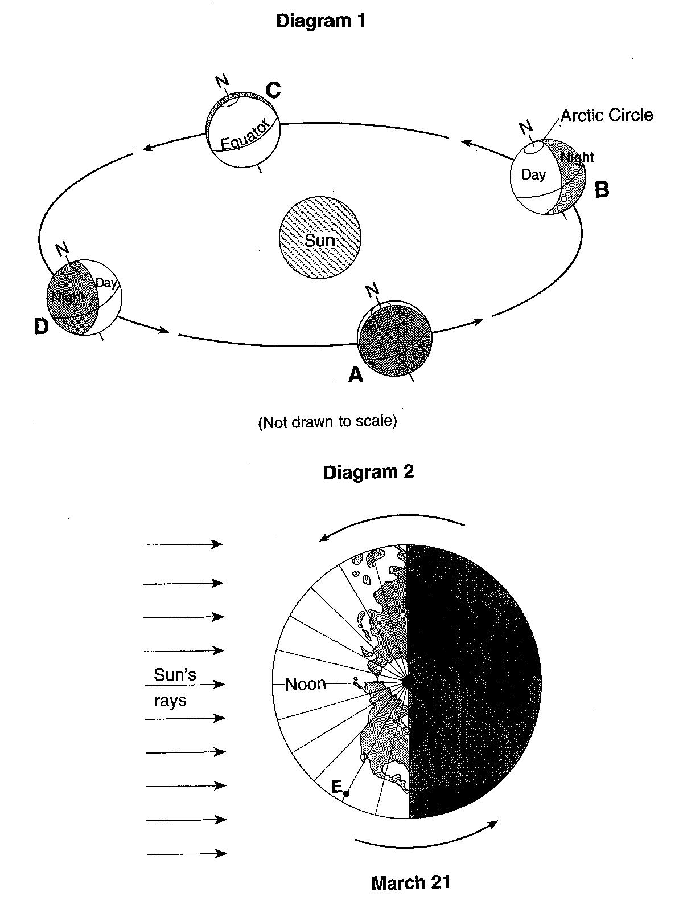
9. How does the altitude of the Sun at solar noon appear to change each day for an observer in New York State as Earth moves from position A to position B to position C?

10. Explain why the duration of insolation is 12 hours at both the Arctic Circle and the equator when Earth is at position C.

11. Describe one piece of evidence shown in the diagram which indicates that the Northern Hemisphere is experiencing winter at position D.

12. State the hour of the day at point E.

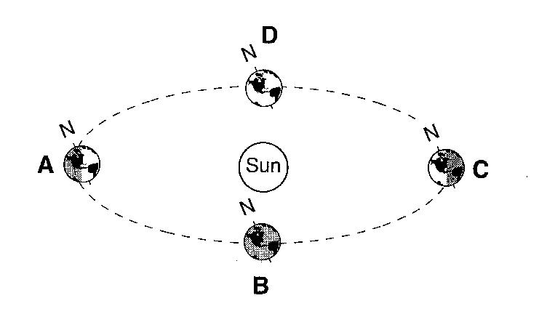
Base your answers to questions 13 and 14 on the diagram to the right, which represents Earth in its orbit around the Sun. The position of Earth on the first day of each season is labeled A, B, C and D.

13. _________Which position shows Earth when the northern hemisphere is experiencing its coldest season?
(1) A (3) C
(2) B (4) D

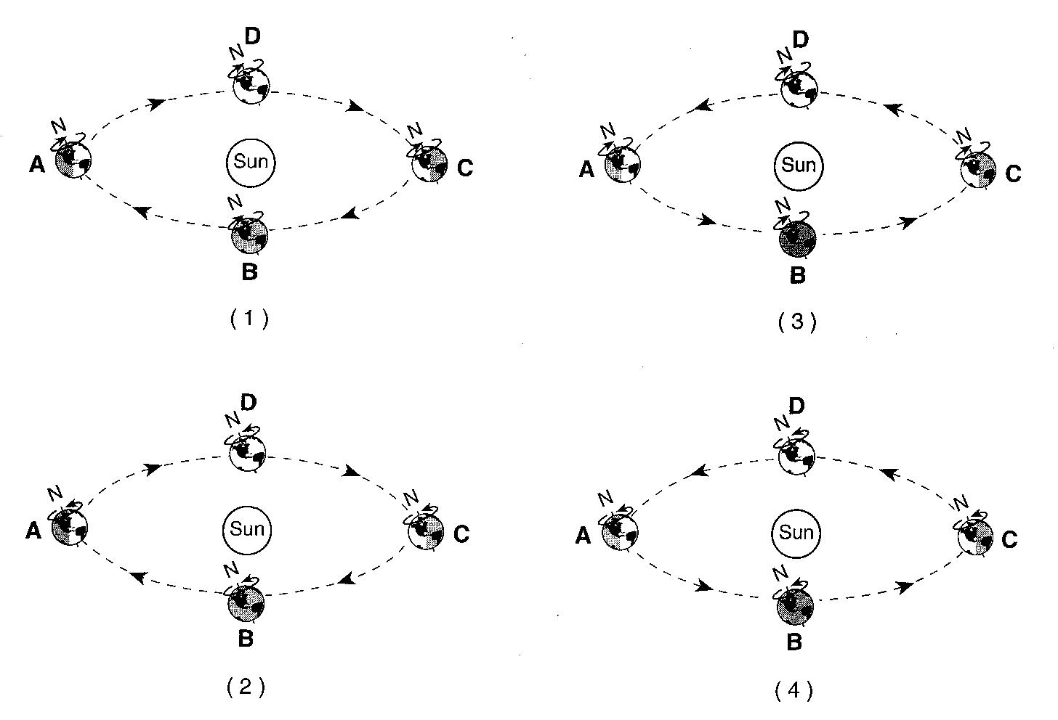
14. __________Which diagram correctly shows the direction of Earth’s revolution and rotation?
15.______ At which location are the Sun’s noontime rays perpendicular to Earth’s surface at the Tropic of Cancer?
(1) A (2) B (3) C (4) D
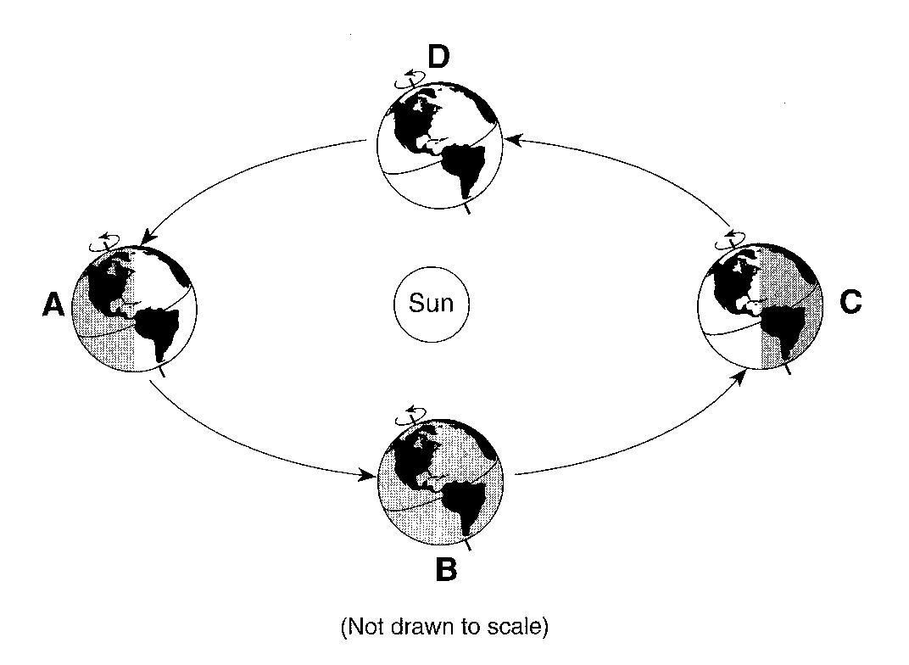
Base your answers to questions 16 through 18 on the diagram below, which shows a model of Earth’s orbit around the sun. Letters A, B, C and D represent Earth’s position at the beginning of each season.

16.__________Which position of Earth represents the first day of summer in the Northern Hemisphere?
(1) A (3) C
(2) B (4) D
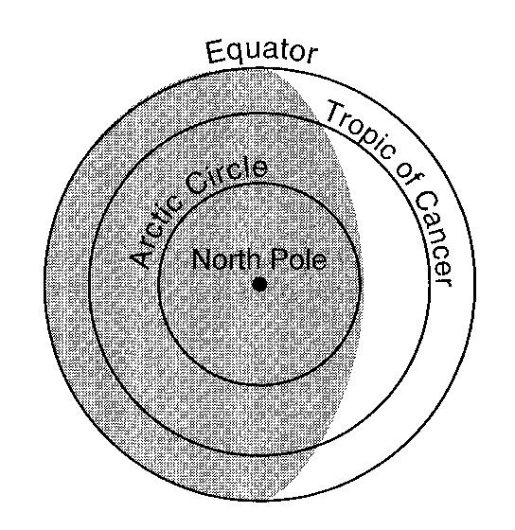

The diagram to the left shows how Earth is illuminated (lighted) by the Sun as viewed from above the North Pole.

17._________ In which orbital position would Earth be illuminated as shown?
(1) A (3) C
(2) B (4) D

18._________How many degrees will the Sun’s vertical rays shift on Earth’s surface as Earth travels from position C to position D?
(1) 15º (3) 47º
(2) 23.5º (4) 365º

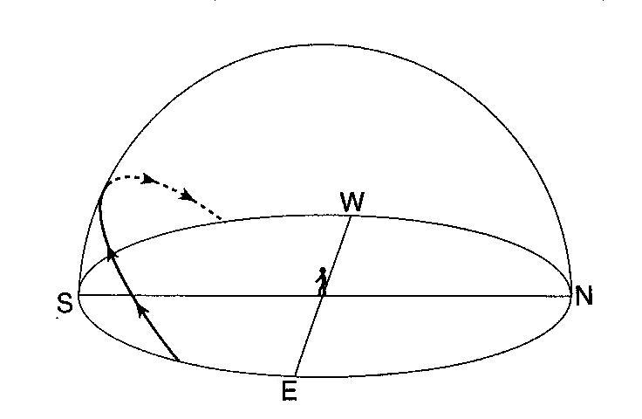
The model to the right shows the Sun’s apparent path across the sky for an observer in New York State.

19.__________On which day of the year was this path observed?

- March 21 (3) September 21
- June 21 (4) December 21

20.__________At which latitude is the Sun directly overhead on certain days of the year?

- 23.5ºN (3) 66.5ºN
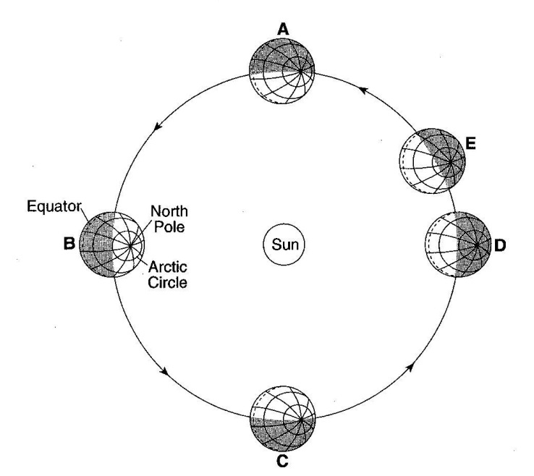
- 42ºN (4) 90ºN

Base your answers to questions 21 and 22 on the diagram to the right, which shows the parts of Earth experiencing daylight and darkness as Earth orbits the Sun. Letters A, B, C, D and E are positions in Earth’s orbit as viewed from above the Northern Hemisphere.

21.________ Approximately how many days does it take Earth to move from position A to position C in its orbit?

22.______________ Which season is the Northern Hemisphere experiencing when Earth is at position E?
Base your answers to questions 23 through 25 on the diagram below, which shows the altitude and apparent positions of the noontime Sun, as seen from various latitudes on Earth on a particular day of the year. Letters A through D represent locations on Earth’s surface.
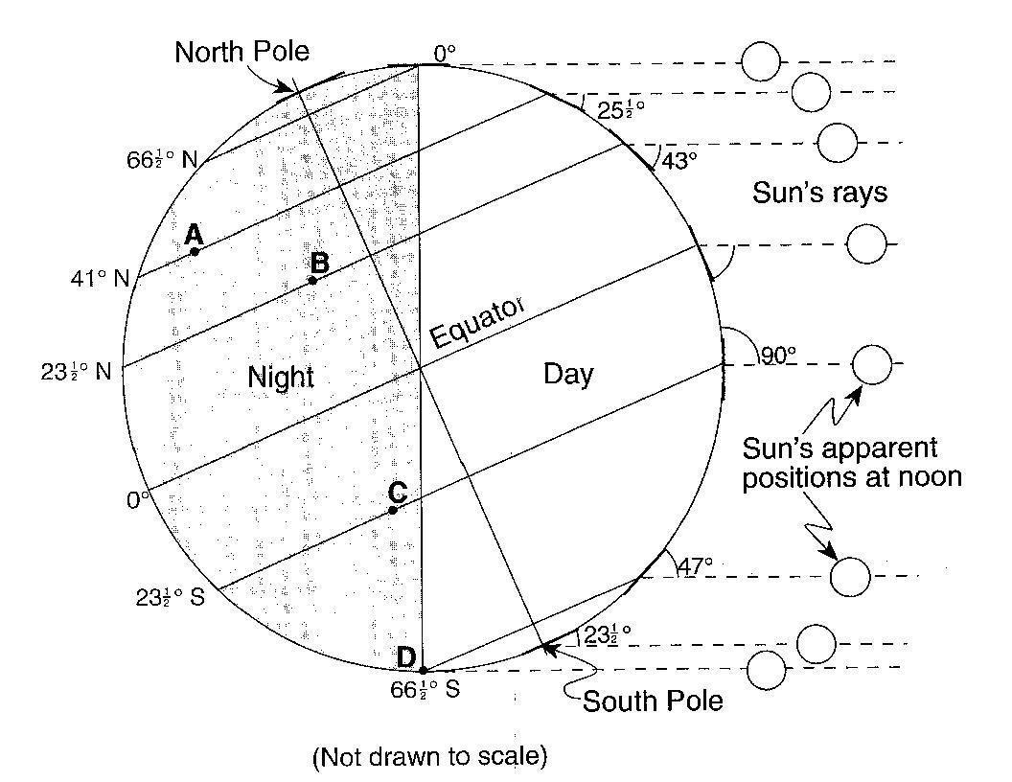

23.__________ Which lettered location will experience the shortest period of daylight during one Earth rotation on this day?

- A (3) C
- B (4) D

24.__________ What is the altitude of the noontime Sun at the Equator on this date?

- 23.5º (3) 66.5º
- 43º (4) 90º

25.__________ Which season will begin at 41º N latitude, three months after the date represented by this diagram?

- summer (3) winter
- fall (4) spring

26.__________On June 21, where will the Sun appear to rise for an observer located in New York State?

- due west (3) north of due east
- due east (4) south of due east

Base your answers to questions 27 through 29 on the diagram provided below, which represents the Sun’s rays striking Earth at a position in its orbit around the Sun.
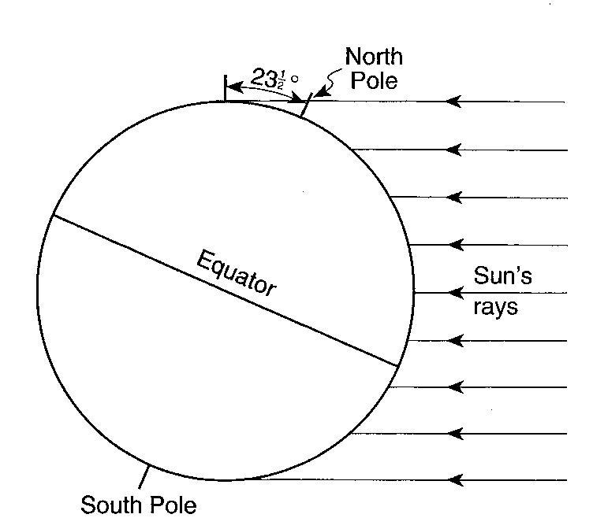

27. On the diagram to the right, neatly and accurately shade the area of Earth that is in darkness.

28. On the diagram to the right, draw the line of latitude that is receiving the Sun’s direct, perpendicular rays on this date.

29. What month of the year is represented by this diagram?

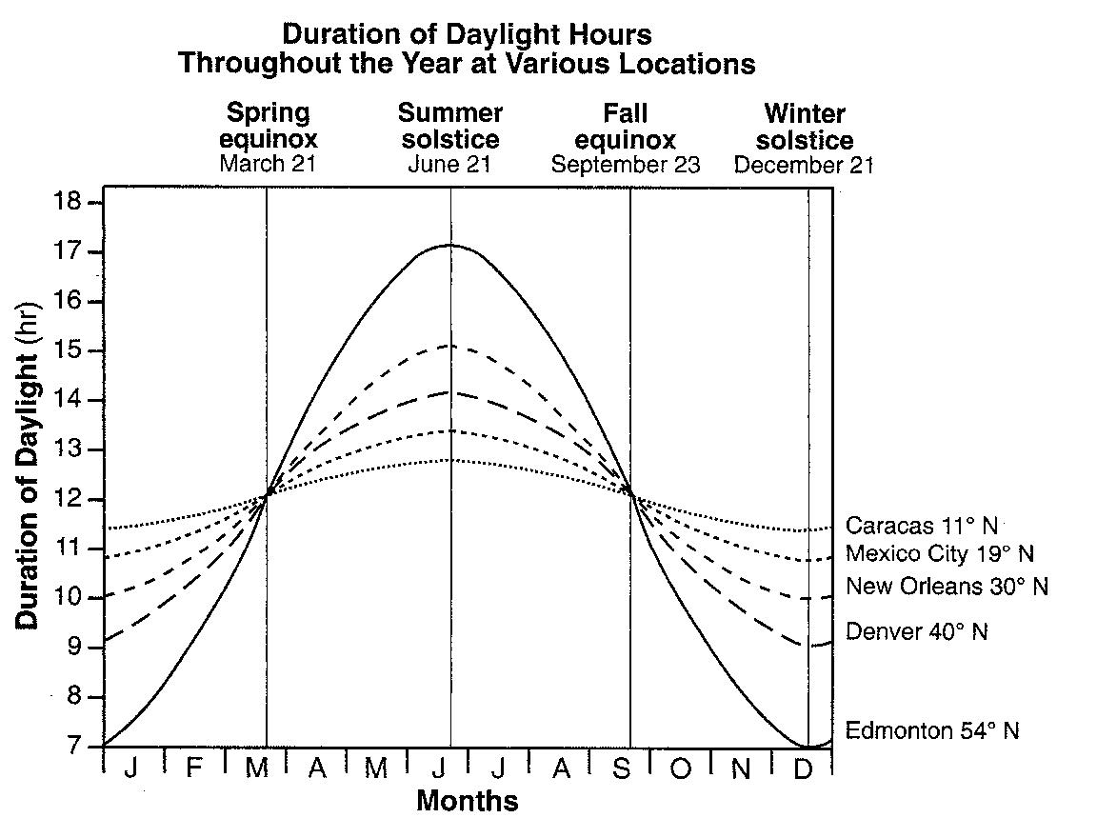
The graph to the right shows the duration of daylight hours throughout the year for five cities located in the northern hemisphere.

30.______ Which city experiences the greatest variation in daylight hours during one year?

(1) Caracas (3) New Orleans
(2) Mexico City (4) Edmonton

31.______ What is the primary reason each city’s duration of daylight changes throughout the year?

(1) Earth’s axis is tilted 23.5º to the plane of its orbit.
(2) Earth’s rotation rate is 15º per day.
(3) The cities are located at different longitudes.
(4) The cities are located at different elevations.

32.______ Which statement best describes the position of the Sun at sunrise and sunset as seen by an observer in New York State on June 21?

(1) The Sun rises north of due east and sets north of due west.
(2) The Sun rises south of due east and sets south of due west.
(3) The Sun rises north of due east and sets south of due west.
(4) The Sun rises south of due east and sets north of due west.

33.______ How many times will the Sun’s perpendicular rays cross Earth’s Equator between March 1 of one year and March 1 of the next year?

(1) 1 (2) 2 (3) 3 (4) 4

