Seismic Waves Worksheet

NAME: ________________________________________

1. _____ A seismic station 4000 kilometers from the epicenter of an earthquakes records the arrival time of the first P-wave at 10:00:00. At what time did the first S-wave arrive at this station?

(1) 9:55:00 (3) 10:07:05

(2) 10:05:40 (4) 10:12:40

2. _____ A P-wave takes 8 minutes and 20 seconds to travel from the epicenter of an earthquake to a seismic station. Approximately how long will an S-wave take to travel from the epicenter of the same earthquake to this seismic station?

(1) 6 min 40 sec (3) 15 min 00 sec

(2) 9 min 40 sec (4) 19 min 00 sec

3. _____ A seismic station is recording the seismic waves produced by an earthquake that occurred 4200 kilometers away. Approximately how long after the arrival of the first P-wave will the first S-wave arrive?

(1) 1 min 05 sec (3) 7 min 20 sec

(2) 5 min 50 sec (4) 13 min 10 sec

4. _____ An earthquake’s first P-wave arrives at a seismic station at 12:00:00. This P-wave has traveled 6000 kilometers from the epicenter. At what time will the first S-wave from the same earthquake arrive at the seismic station?

(1) 11:52:20 (3) 12:09:20

(2) 12:07:40 (4) 12:17:00

5. _____ A P-wave arrived at a seismic station at 08:45:40. The seismic station is 6,200 km away from the earthquake epicenter. At what time did the earthquake occur?

(1) 08:36:00 (3) 08:28:20

(2) 08:55:20 (4) 08:35:00

6. _____ An earthquake P-wave arrived at a seismic station in Albany, NY at 10:07 pm. If the earthquake occurred at exactly 10:00 pm, approximately how far from the earthquake epicenter was Albany, NY?

(1) 1,900 km (3) 4,000 km

(2) 3,200 km (4) 5,200 km

7. _____ P-waves and S-waves from the same earthquake arrived at 3 different seismic stations.

The difference in arrival times of the first P-waves and first S-waves at Station A was 9 minutes. The difference in arrival times of the first P-waves and first S-waves at Station B was 7 minutes. The difference in arrival times of the first P-waves and first S-waves at Station C was 5 minutes.

Which statement correctly describes the distance between the earthquake epicenter and the seismic stations?

(1) A is closest to the epicenter, and C is farthest from the epicenter.

(2) B is closest to the epicenter, and C is farthest from the epicenter.

(3) C is closest to the epicenter, and A is farthest from the epicenter.

(4) A is closest to the epicenter, and B is farthest from the epicenter.

8. _____ The first S-wave from an earthquake arrived at a seismic station 2 min 40 sec after the first P-wave arrived. What is the approximate distance from the seismic station to the earthquake epicenter?

(1) 3,200 km (3) 1,600 km

(2) 2,400 km (4) 1,000 km

9. _____ The seismogram recorded at Station A would show the

(1) arrival of P-waves only

(2) earliest arrival of P-waves

(3) greatest difference in the arrival times of P-waves and S-waves

(4) arrival of S-waves before the arrival of P-waves

10. Identify the *two* planets that would allow an S-wave from a crustal quake to be transmitted through the core to the opposite side of the planet.

11. The distance from Albany, New York to the epicenter of an earthquake is 5600 km. Approximately how much longer did it take for the first S-wave to arrive at Albany than the first P-wave?

(1) 4 minutes and 20 seconds (3) 9 minutes and 0 seconds

(2) 7 minutes and 10 seconds (4) 16 minutes and 10 seconds

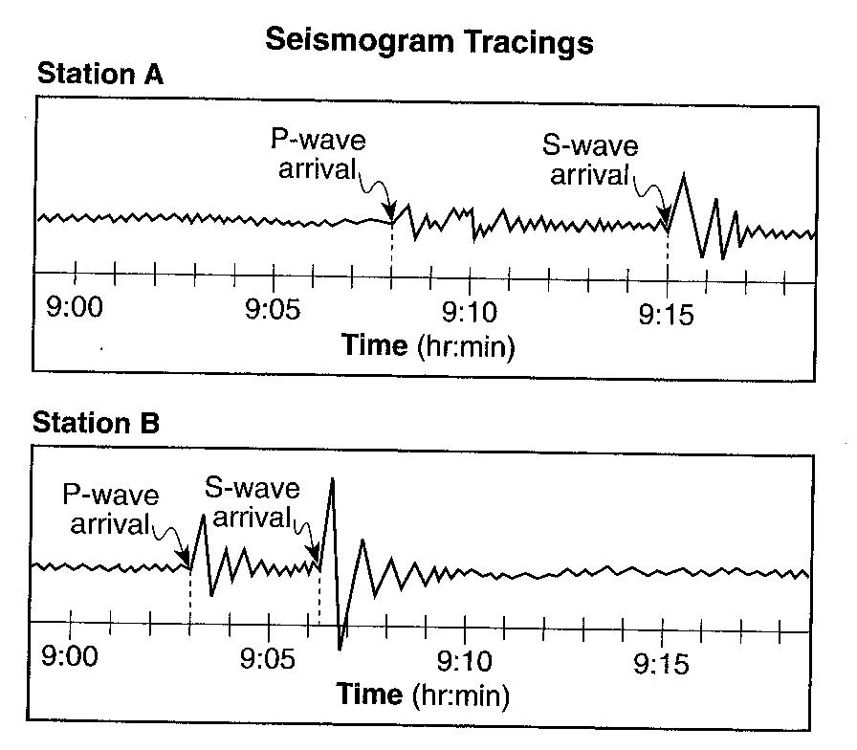

Base your answers to questions 12 and 13 on the diagram to the right, which shows two seismogram tracings, at stations A and B, for the same earthquake. The arrival times of the p-waves and S-waves are indicated on each tracing.

12. Explain how the seismic tracings recorded at station A and station B indicate that station A is father from the earthquake than station B.

13. Seismic station A is located 5,400 kilometers from the epicenter of the earthquake. How much time would it take for the first S-wave produced by this earthquake to reach seismic station A?

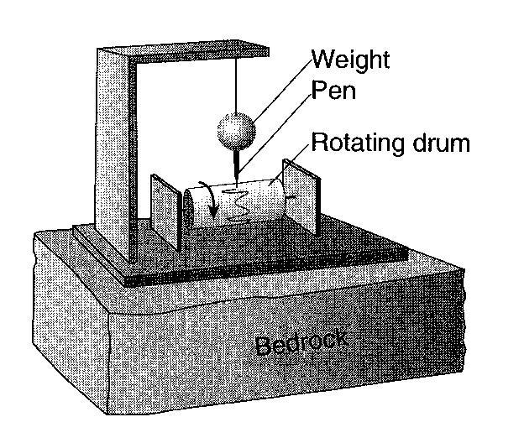Base your answers to questions 14 through 16 on the diagram to the right, which shows a seismograph that recorded seismic waves from an earthquake located 4000 kilometers from this seismic station.

14.____________ Which type of seismic wave was recorded first on the rotating drum?

15. State one possible cause of the earthquake that resulted in the movement of the bedrock detected by this seismograph.

16.____________________ How long does the first S-wave take to travel from the earthquake epicenter to this seismograph?

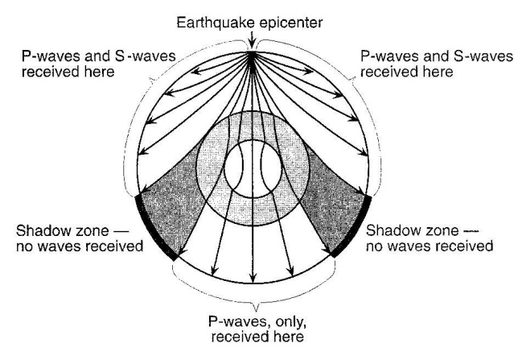

Base your answer to question 17 on the cross section to the right, which shows the path of seismic waves traveling from an earthquake epicenter through the different layers of Earth’s interior.

17.______ No P-waves or S-waves are received in the shadow zone because

(1) P-waves are absorbed and S-waves are refracted by Earth’s outer core

(2) P-waves are refracted and S-waves are absorbed by Earth’s outer core

(3) both the P-waves and S-waves are refracted by Earth’s outer core

(4) both the P-waves and S-waves are absorbed by Earth’s outer core

18. The distance between the New Madrid fault system and Albany, New York is 1800 kilometers. What was the time difference between the arrival of the first P-wave and the arrival of the first S-wave at Albany when an earthquake occurred.

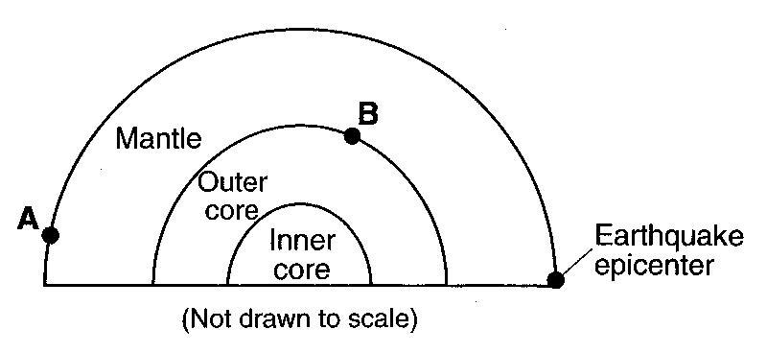

19. Looking at the cross section to the right, explain why seismic station A receives P-waves, but not S-waves from this earthquake.