STATION MODELS

NAME: ___________________________ DATE: ___________

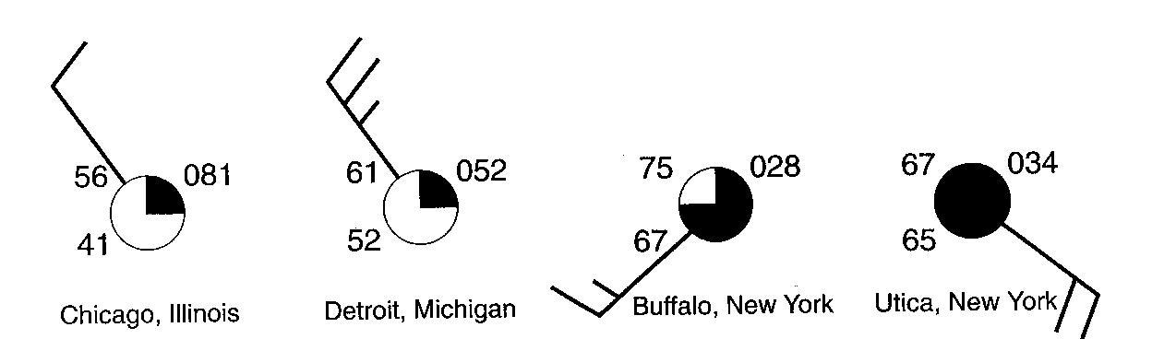
Base you answers to questions 1 through 3 on the station models to the right, which show various weather conditions recorded at the same time on the same day at four different cities.

1.______ Which wind speed was recorded at Detroit?
(1) 15 knots (2) 25 knots (3) 35 knots (4) 45 knots

2.______ Which city had the lowest relative humidity?

(1) Chicago (2) Detroit (3) Buffalo (4) Utica

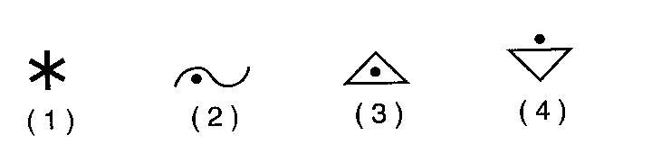
3.______ Which weather symbol below best represents the type of precipitation that was most likely occurring in Utica?

4. On the weather map symbol to the right, using the proper format, record the six weather conditions shown below.
Wind: from the northwest
Wind speed: 10 knots
Barometric pressure: 1022.0 mb
Cloud cover: 50%
Visibility: 5 mi
Precipitation (in the past 6 hours): .45 in

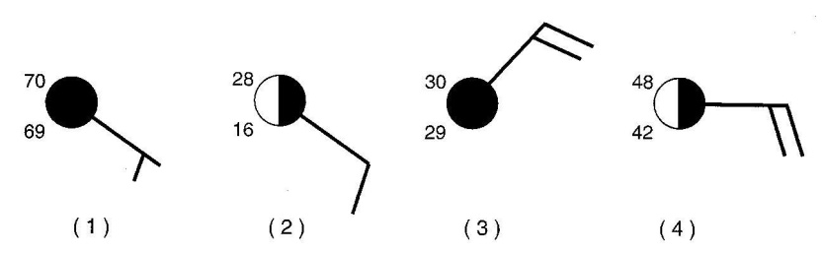
5.______ On which station model to the right would the present weather symbol * most likely be found?

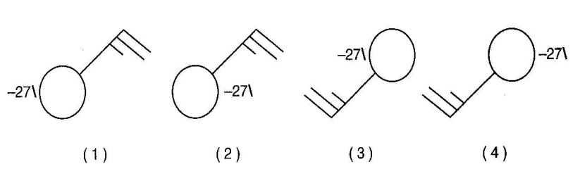
6.______ Which station model correctly represents the weather conditions in an area that is experiencing winds from the northeast at 25 knots and has had a steady drop in barometric pressure of 2.7 millibars during
the last three hours?

