Water Cycle Worksheet

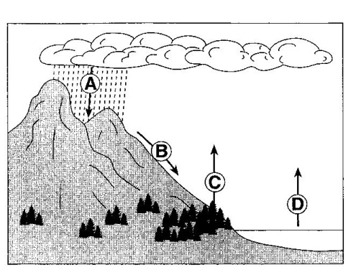
NAME: ___________________________

The arrows in the diagram to the right represent the movement of water in the water cycle.

1.______ Which arrow repersents the process of transpiration?

(1) A (2) B (3) C (4) D

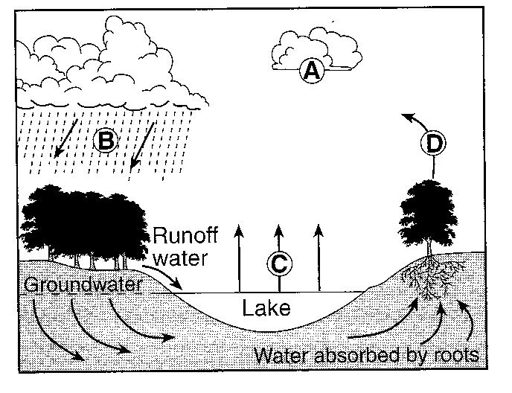
The letters A through D on the cross section to the right represent four of the processes that are part of the water cycle.

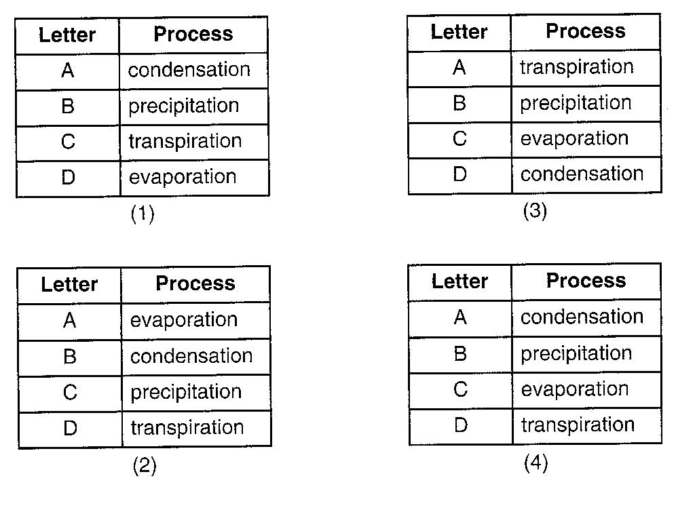
2.______ Which table below correctly matches each letter with the process that it represents?

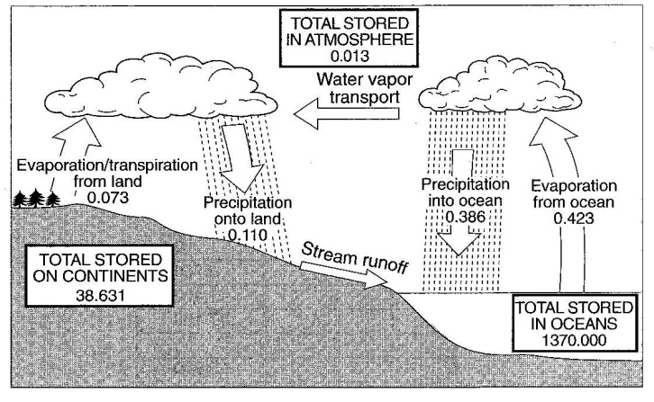
3. Calculate the total amount of water stored in the atmosphere, the oceans, and on the continents at any one time.

4. Explain why the yearly total precipitation over the oceans is greater than the yearly total precipitation over the continents.

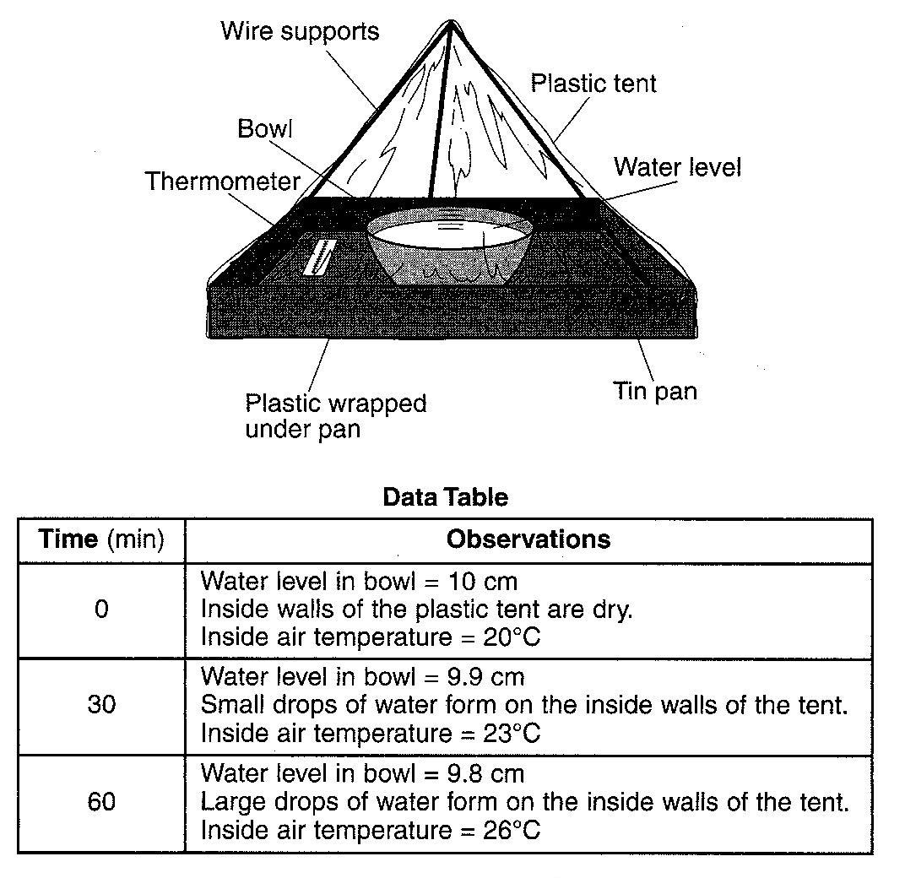
Base your answers to questions 5 through 8 on the model and data table shown to the right. A student constructed a model to demonstrate how water is recycled by natural processes on Earth. The model consisted of a clear plastic tent over a pan containing a bowl of water. The model was sealed so no water could enter or leave the tent. The data table shows the observations recorded when the model was placed in direct sunlight for 60 minutes.

5. Identify the process that caused the water level in the bowl to decrease.

6. How much heat energy, in calories per gram, is released as water droplets are formed on the inside walls of the tent?

7. If the model is changed and the bowl of water is replaced with a green plant, by which process would the plant supply water vapor to the air inside the tent?

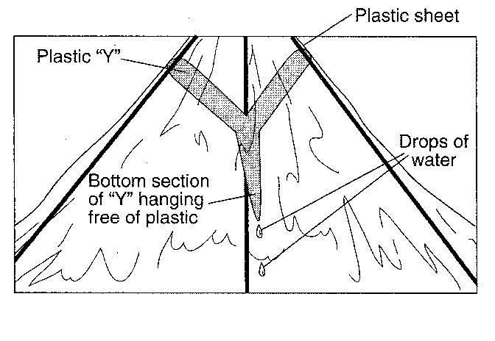

8. A student glues a Y-shaped piece of plastic, as shown to the right, near the top of the inside of the tent and repeats the demonstration. Drops of water are seen dripping from the bottom of the Y after 60 minutes. Which process of the water cycle is being represented by the dripping water?

9.

