Weather Worksheet

NAME: ___________________________

Base your answers to questions 1 through 5 on the weather map below. The map shows a low pressure system and some atmospheric conditions at weather stations A, B and C.
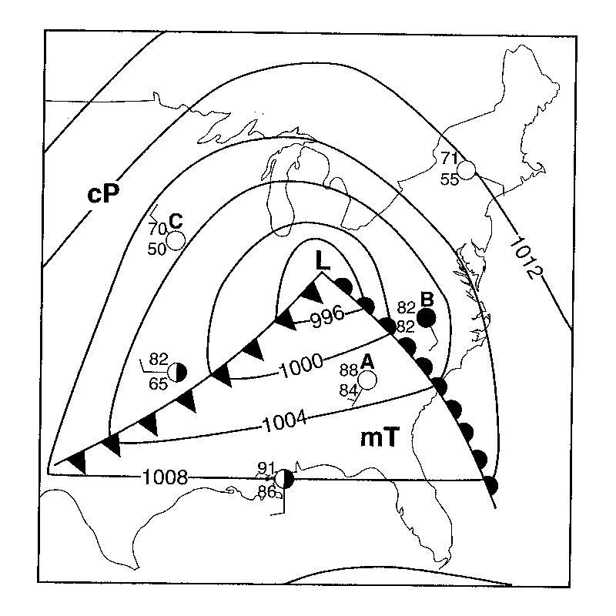
1._________Which type of weather is usually associated with a cP air mass, as shown near weather station C?

(1) moist and cool (3) dry and cool
(2) moist and warm (4) dry and warm

2._________If this weather system follows a normal storm tack, the low-pressure center (L) will generally move toward the

(1) northeast (3) southeast
(2) northwest (4) southwest

3. Which city in the map above has the best chance for precipitation and why?

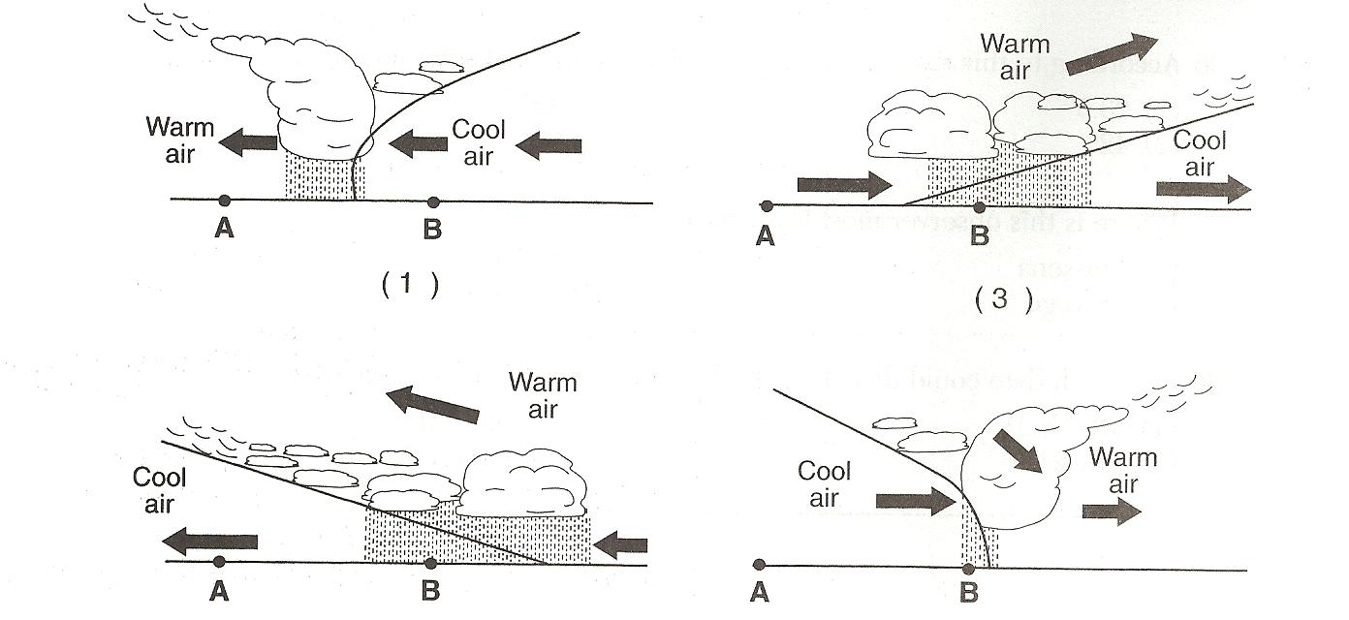
4. _________Which cross section below best represents the air masses, air movement, clouds, and precipitation occurring behind and ahead of the warm front located between stations A and B?

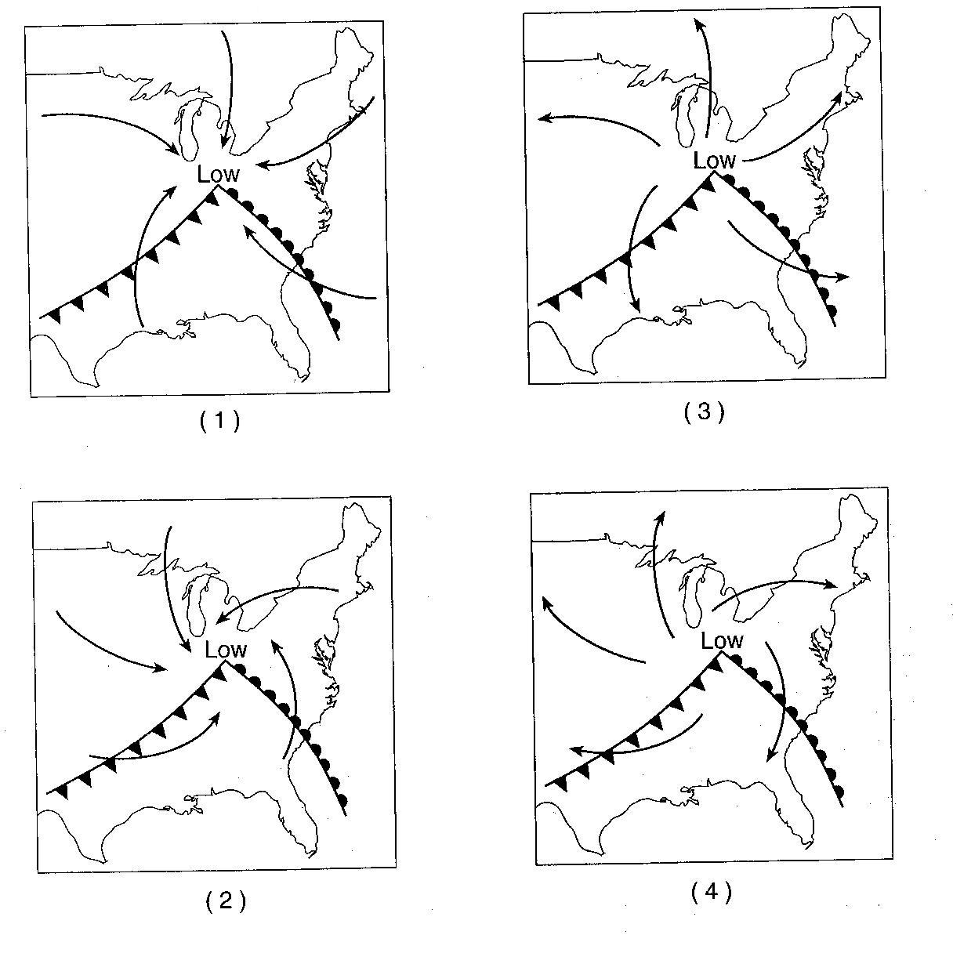
5.__________The arrows on which map to the right best represent the surface winds associated with this low-pressure system?

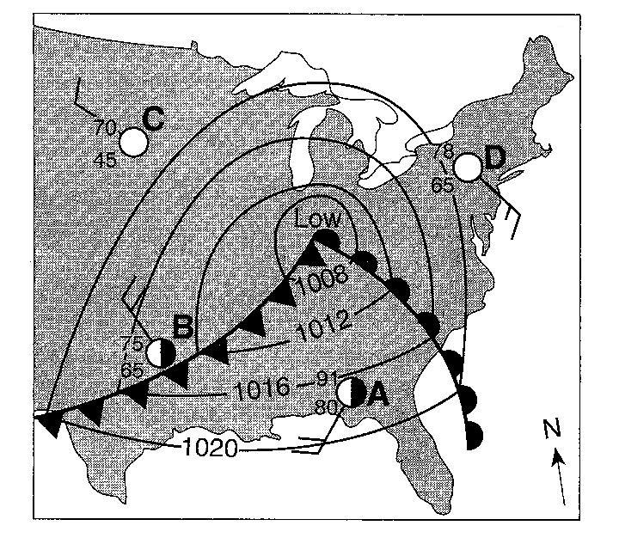

Base your answers to questions 6 through 8 on the map to the right, which shows a low-pressure system over the eastern United States. Letters A through D represent weather stations.

6.______ Which weather instrument was used to measure wind speed at station D?

(1) barometer (3) psychrometer
(2) thermometer (4) anemometer

7._______ Surface winds within this low-pressure system most likely are flowing

(1) toward the center in a clockwise pattern
(2) toward the center in a counterclockwise pattern
(3) away from the center in a clockwise pattern
(4) away from the center in a counterclockwise pattern
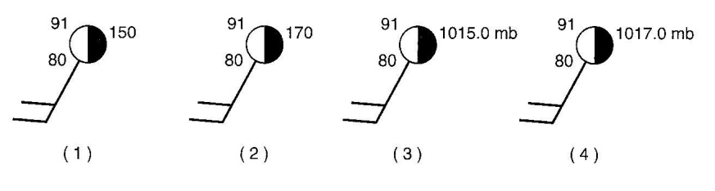
8.______ Which station model to the right correctly represents the barometric pressure at station A?

Base your answers to questions 9 through 12 on the weather map below, which shows a low-pressure system located over the central United States. points A, B , and C represent locations on Earth’s surface. The isobars on the map show air pressure in millibars.
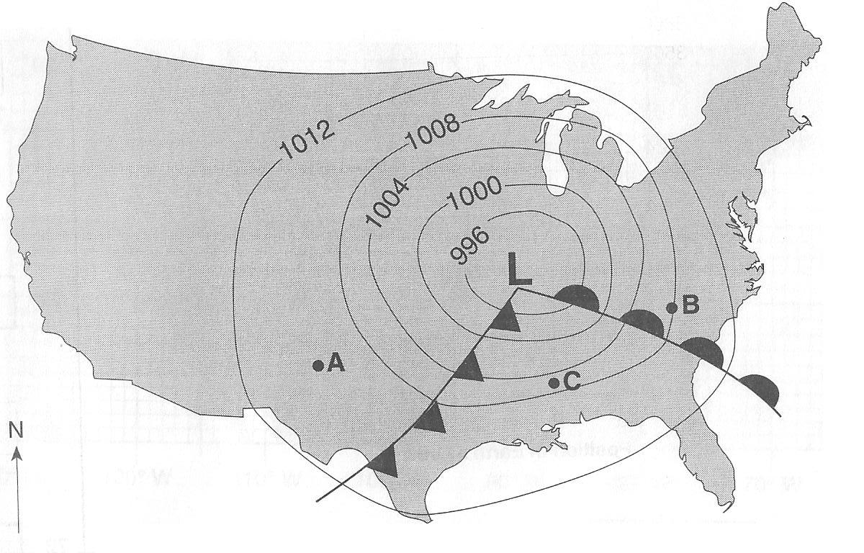
9. On the map above, draw an arrow, beginning at the L, to show the direction the low-pressure system will most likely move in the next two days.

10. What evidence shown on the map indicates that point B is most likely experiencing precipitation?

11.____________ What is the two-letter symbol used on a weather map to indicate the warm, moist air mass that is over point C?

12. What evidence shown on the weather map indicates that point C is experiencing greater wind speeds than point A?

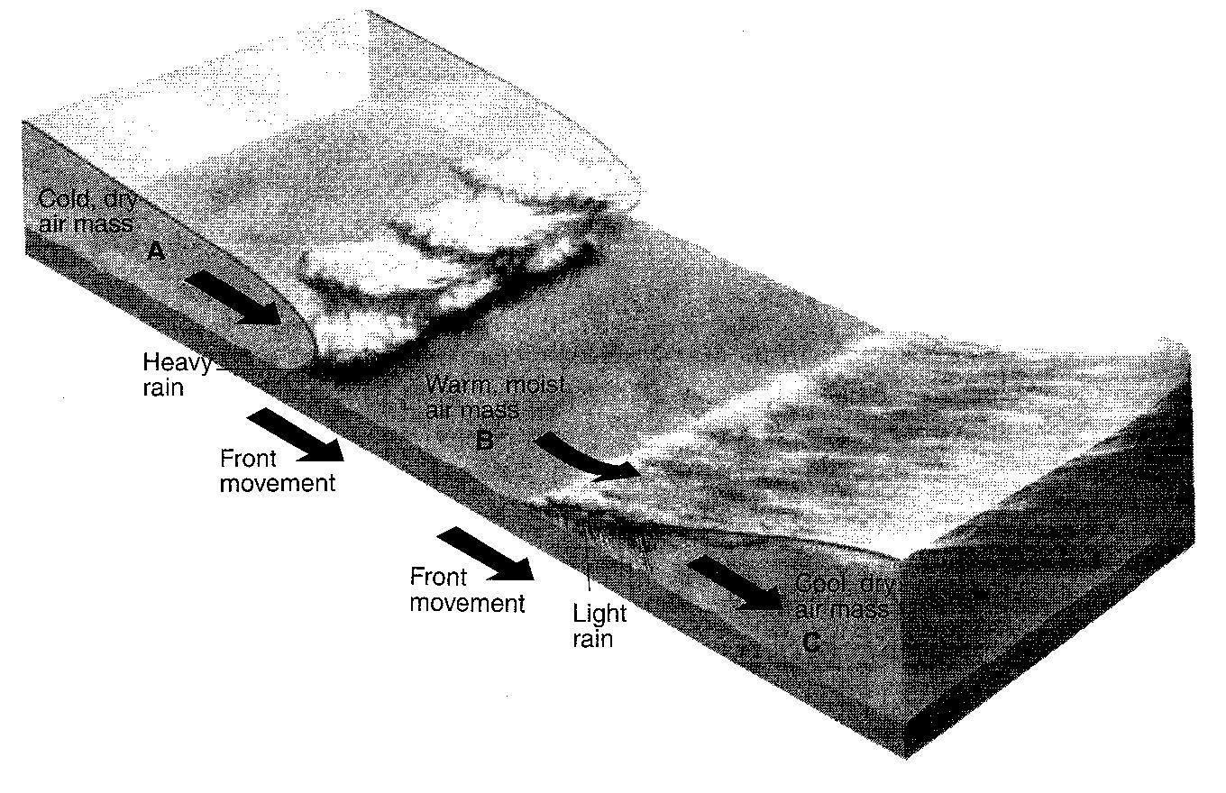
Base your answers to questions 13 through 15 on the diagram to the right, which shows air masses, clouds, and rain associated with two fronts that are influencing weather conditions in New York State. Letters A, B, and C represent three air masses. The arrows show the direction of air and front movements.

13. Identify the most likely geographic source region for air mass B.

14. Identify the type of front shown between air mass B and air mass C.

15. Identify one process that causes clouds to form in the air rising along the frontal surface between air mass A and air mass B.

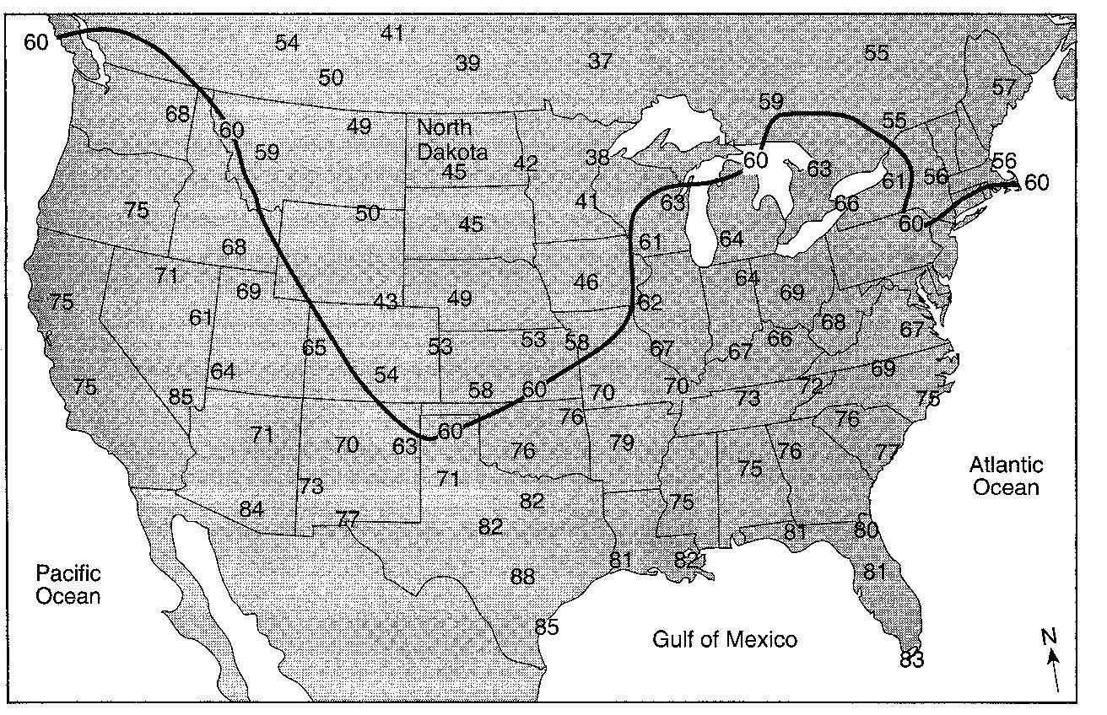
16. On the map to the right, draw the 70oF isotherm. Extend the isotherm to the edges of the continent.

17. Identify the two-letter weather map symbol for the dry, cold air mass over North Dakota.

18.______ A barometric pressure of 1021.0 millibars is equal to how many inches of mercury?

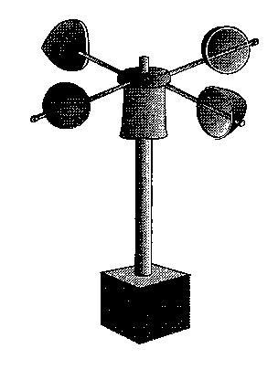
(1) 29.88 (2) 30.15 (3) 30.25 (4) 30.50

19.______ An instrument used to measure a weather variable is shown to the right. Which weather variable is measured by this instrument?

(1) wind direction (3) wind speed
(2) air pressure (4) amount of rainfall

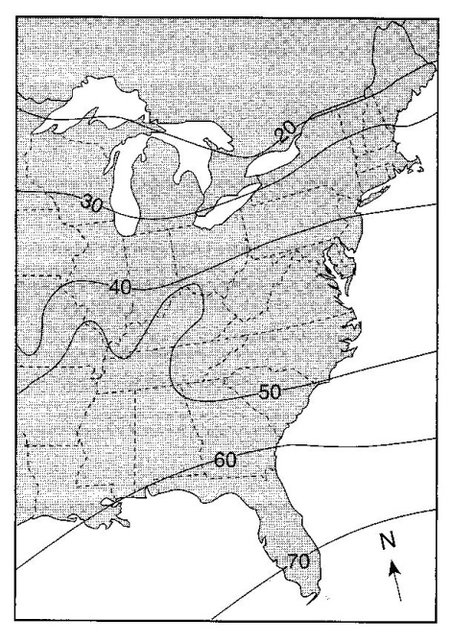

The map to the left shows a weather variable recorded at noon on a certain day. Isolines show values from 20 to 70.

20._____ Which weather variable is most likely represented by the isolines on this map?

(1) snowfall in inches
(2) wind speed in knots
(3) barometric pressure in millibars
(4) air temperature in degrees Fahrenheit

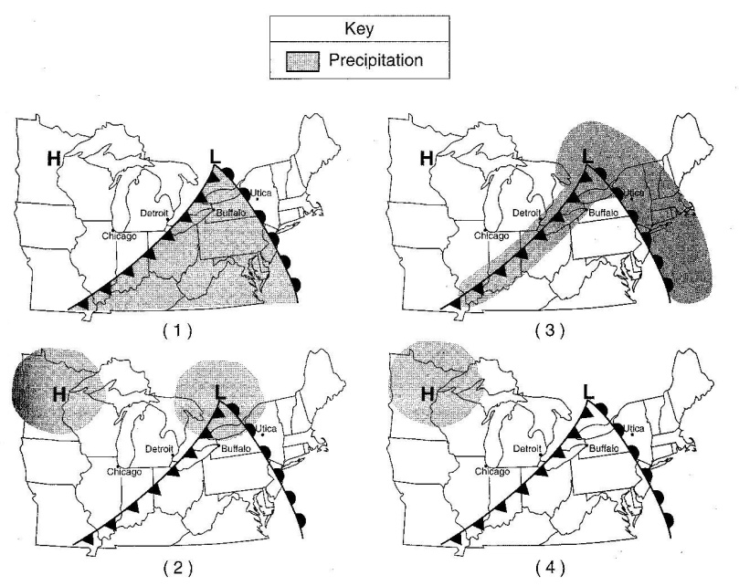

21.______ Which weather map to the right shows the most probable areas of precipitation associated with these weather systems?

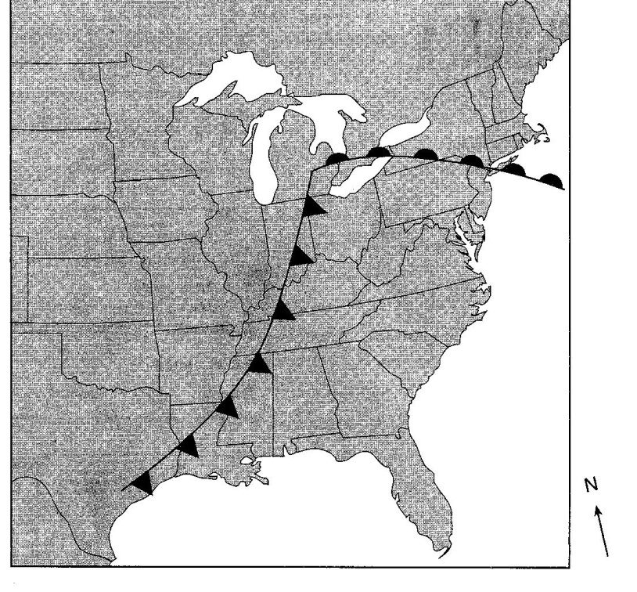
Base your answers to questions 22 through 26 on the weather map to the right, which shows two fronts associated with a low-pressure system.

22. On the weather map to the right, write the letter L at the location of the center of the low-pressure system.

23. On the weather map to the right, write the air-mass symbols to indicate the most likely locations of the continental polar air mass and maritime tropical air mass that have formed this low-pressure system.

24. On the weather map to the right, place an X where precipitation is most likely occurring.

25. Which type of weather front has entered New York State?

26. Warm, moist air is rising along the two frontal surfaces. Describe how the water vapor in this rising air forms clouds. Include dewpoint and condensation in your answer.
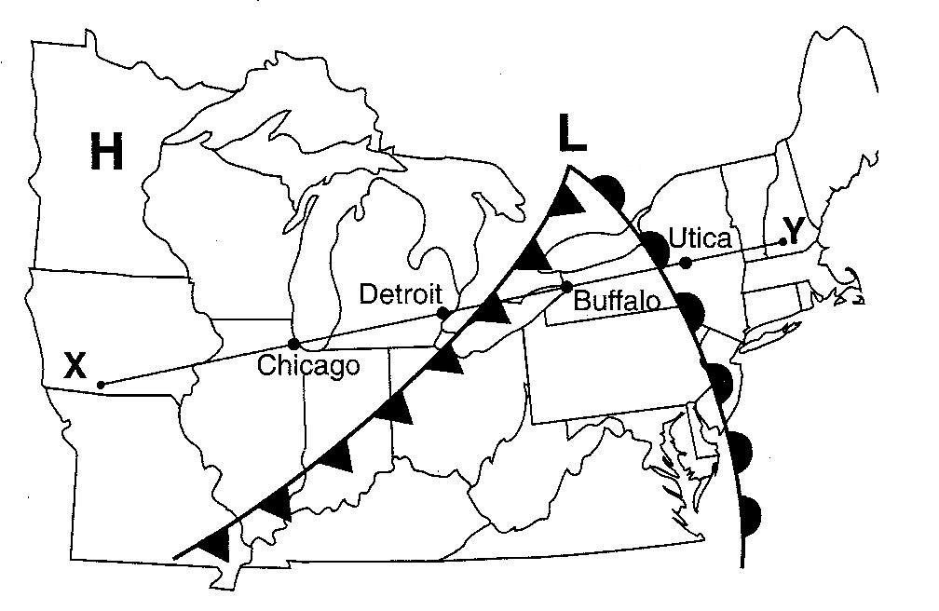
27.______ On the map to the right, which type of front is located between Buffalo and Detroit?

(1) stationary (3) occluded
(2) warm (4) cold

28.______ Which cross section below best represents the fronts and air movements in the lower atmosphere along line XY on the map to the right?

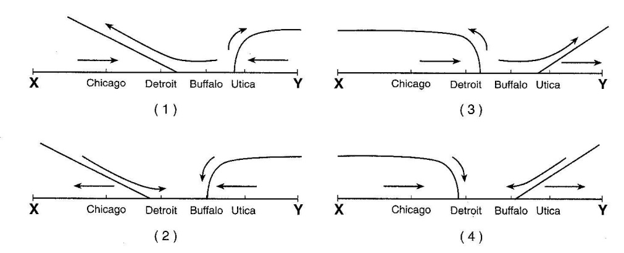

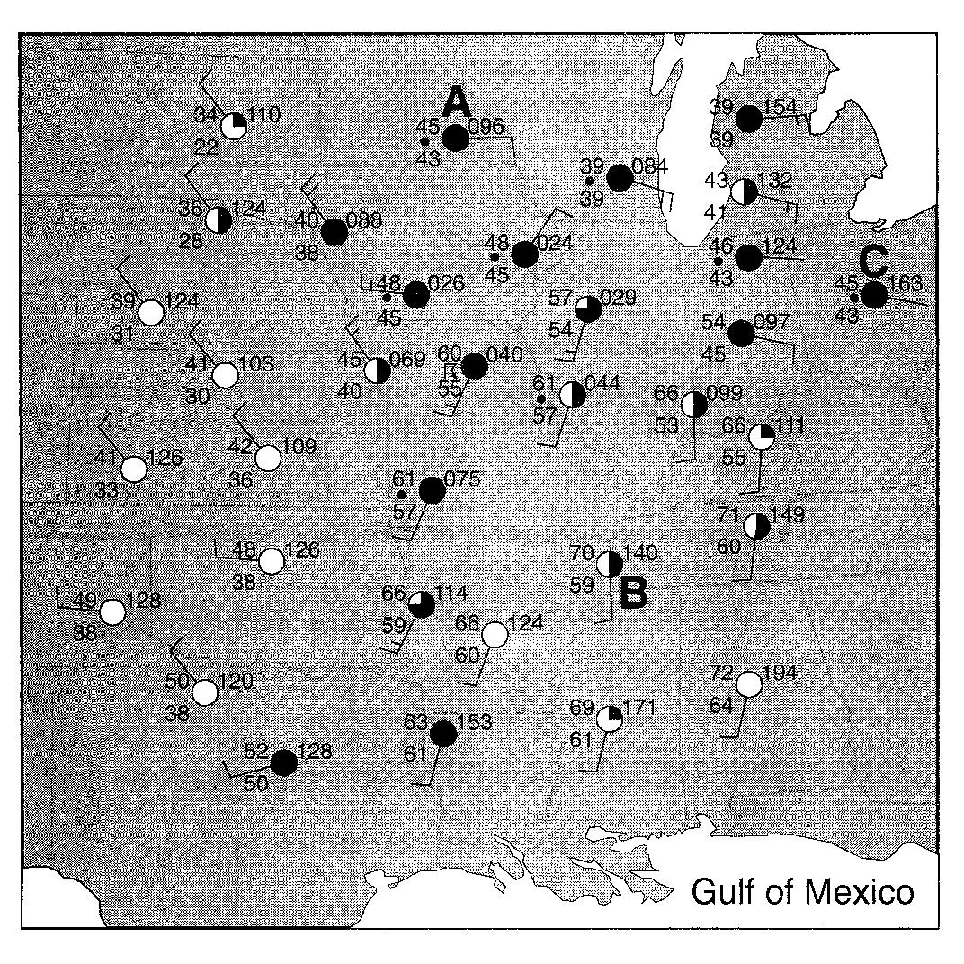
Base your answers to questions 29 through 31 on the map to the right, which shows weather station models and some weather variables for a portion of the United States. Selected weather stations are labeled A, B, and C.

29. State the air pressure, in millibars, at weather station A.

30. The city represented by weather station B is currently being affected by an air mass that originated over the Gulf of Mexico. What is the two-letter air-mass symbol used to represent this air mass?

31. Which weather condition is indicated by the present weather symbol at station C?

32.______ Air masses are identified on the basis of temperature and

(1) type of precipitation (2) wind velocity (3) moisture content (4) atmospheric transparency

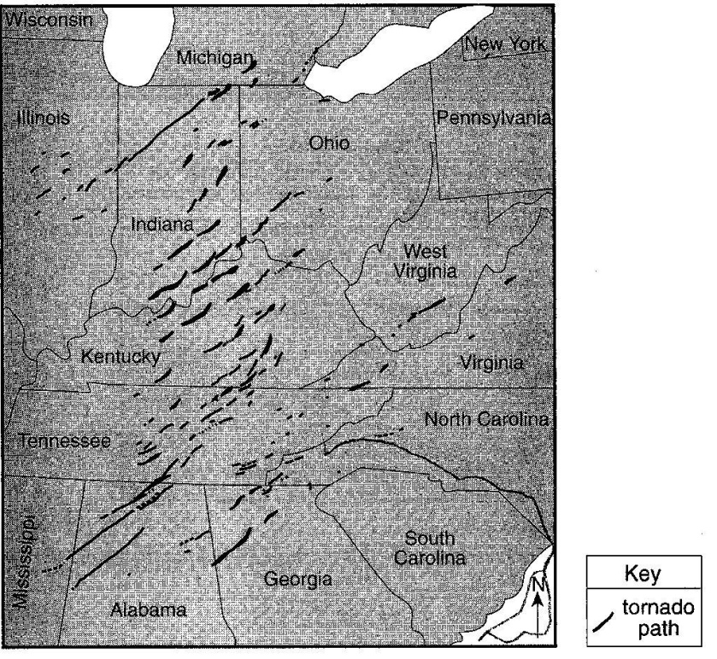
Base your answers to questions 33 through 36 on the map to the right, which shows a portion of the United States where 148 tornados occurred during a 24-hour period in April 1974. The paths of the tornados are shown.

33. Most of these tornados occurred with thunderstorms along cold fronts. Identify the water cycle process that forms clouds along cold fronts.

34. Describe the air movement most likely found within these tornados.

35. Explain why all the tornados moved toward the northeast.

36. A school receives a tornado warning. Describe one emergency procedures that a teacher and students in a classroom should immediately take to protect themselves from injury.

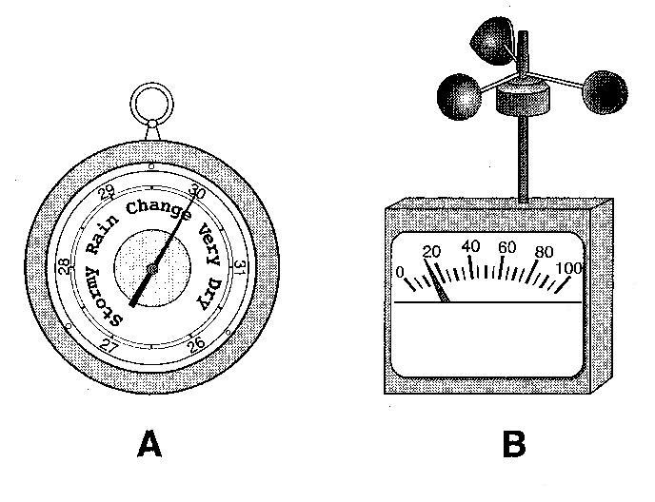

The diagram to the right shows weather instruments A and B.

37.______ Which table below correctly indicates the name of the weather instrument and the weather variable that it measures?

