DA MOON

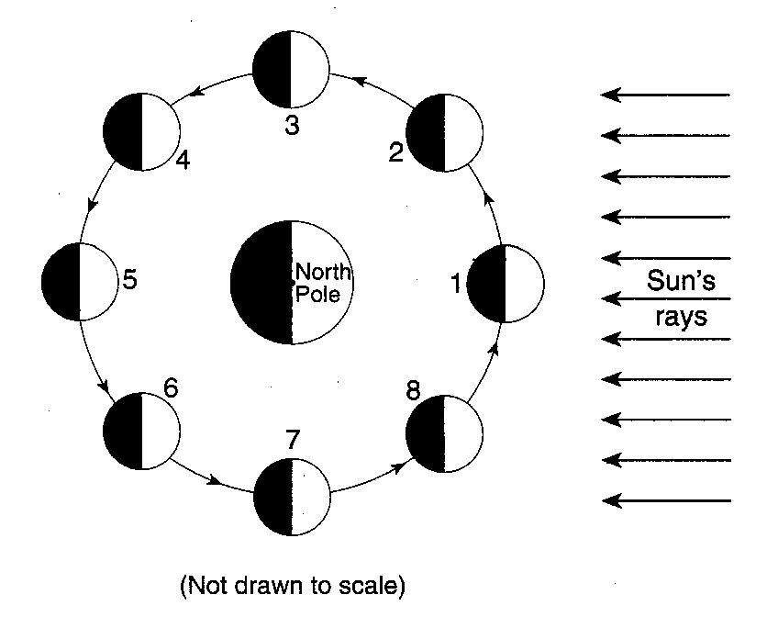
NAME: ___________________________ DATE: ___________

The diagram to the right shows the Moon as it revolves around Earth. The numbered locations represent different positions of the Moon in its orbit

1.__________Which Moon phase to the right would be seen by an observer in New York State when the Moon is in position 2?

The photographs below show the surface of the Moon as seen from Earth over an 80-minute period during a single night. 2._________Which motion is responsible for the changing appearance of the Moon?
(1) The Moon moves into the shadow of Earth.
(2) The Moon moves into the shadow of the Sun.
(3) The Sun moves into the shadow of Earth.
(4) The Sun moves into the shadow of the Moon.
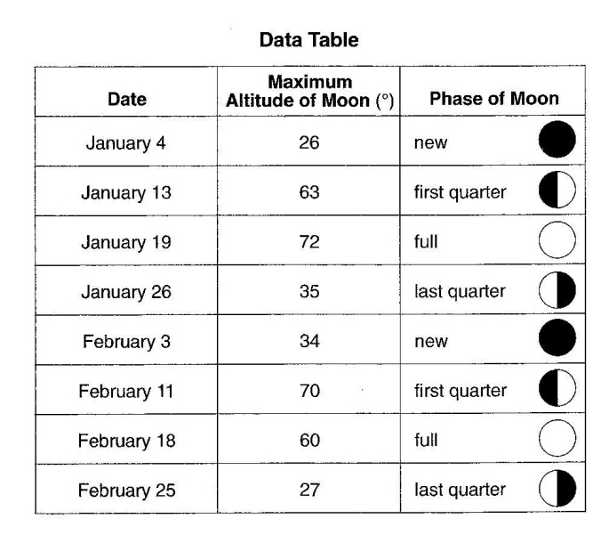
Base your answers to questions 3 through 6 on the data table to the right and graph below. The data table shows the maximum altitude and phase of the Moon observed above the southern horizon on certain dates during January and February at a New York State location. The line on the graph below shows the altitude of the noontime Sun observed during the same time period at the same New York State location.

3. On the graph below, plot with an X the maximum altitude of the Moon for each date shown on the data table.
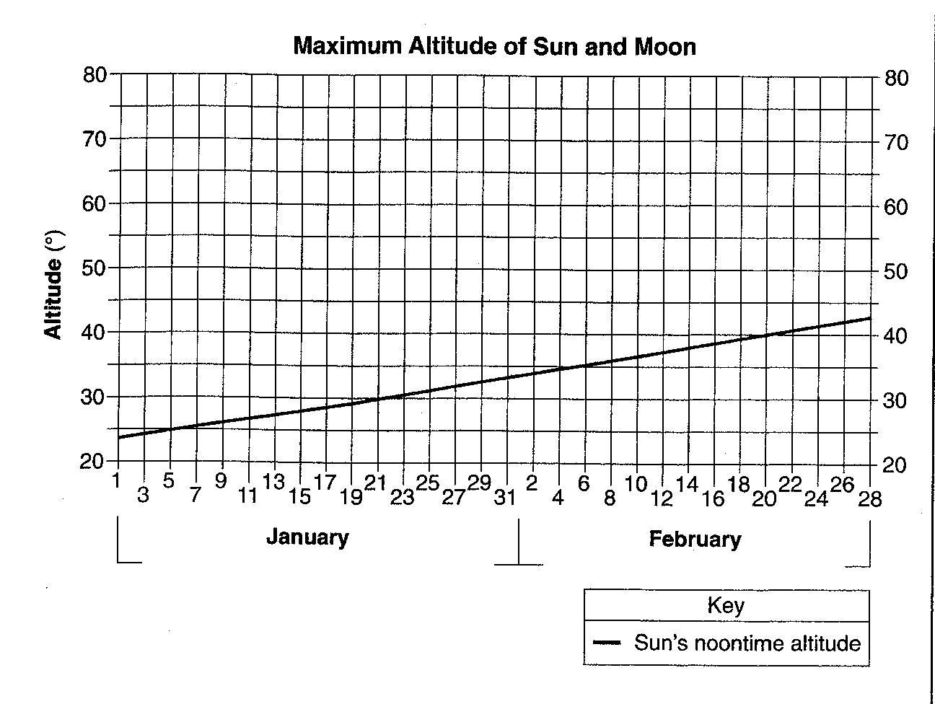
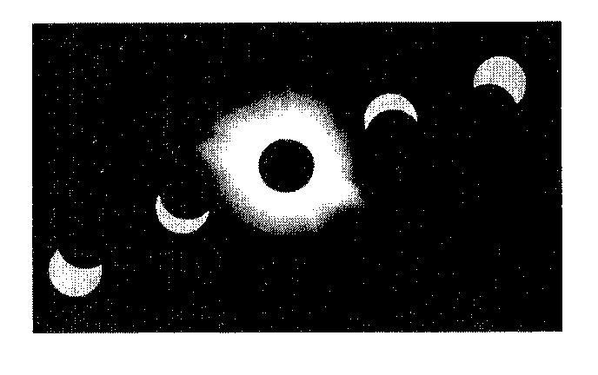
The multiple-exposure photograph to the right, taken on February 3, shows a total solar eclipse in the middle of the photograph. The maximum altitude of the Sun on this date was 34º above the southern horizon at this New York State location.

4. Based on the data and/or the graph on the previous page, explain why this total eclipse occurred on February 3.

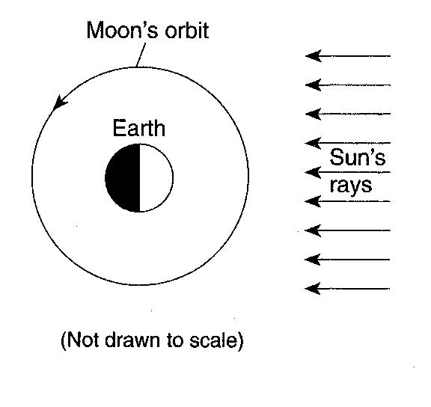

5. The diagram to the right shows the Moon’s orbit around Earth. Place an X on the orbit to represent the Moon’s position on February 18.

6. Assuming that February had 28 day, on which date in March did the next full Moon occur?
March _______________

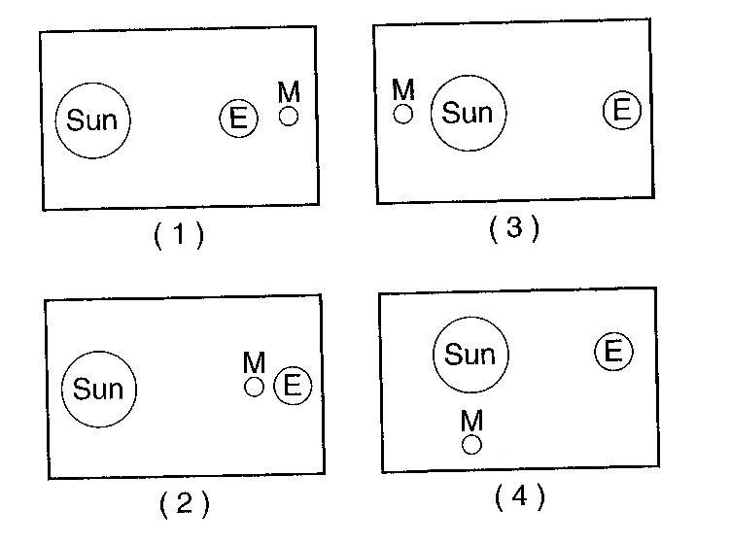
7.__________Which diagram to the right best represents the positions of Earth (E), the Sun and the Moon (M) that could create a solar eclipse?

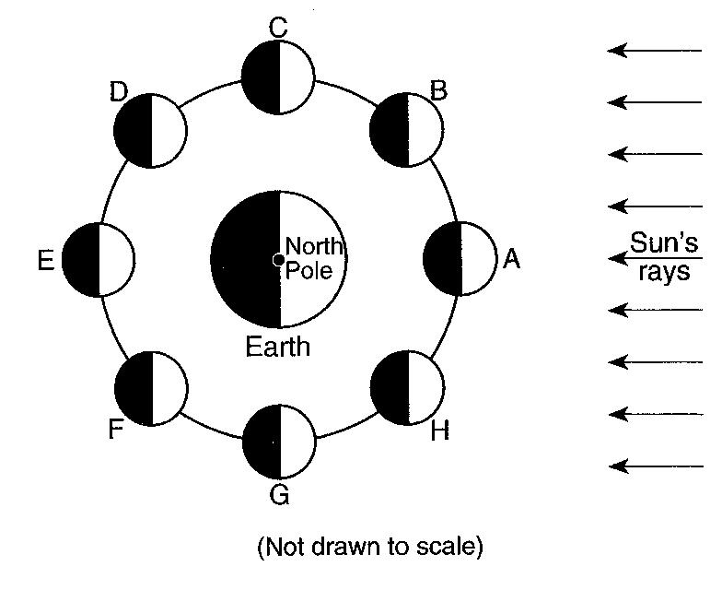
Base your answers to questions 8 through 10 on the diagram to the right, which shows the Moon at positions A through H in its orbit around Earth.

8.___________Which letters represent the two positions of the Moon when the least difference between the levels of high and low ocean tides occur on Earth?

9.__________How many days does it take for the Moon to complete one cycle of phases as viewed from Earth?

10.__________At which Moon position could a lunar eclipse occur?

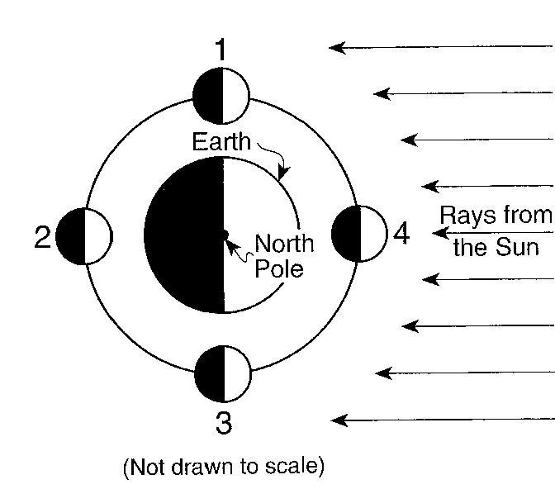
The diagram below shows the Moon at four positions in its orbit around Earth.

11.__________An observer on Earth could see a solar eclipse when the Moon is at position
(1) 1 (3) 3
(2) 2 (4) 4

12.__________An observer on Earth would see the greatest difference between high and low tide when the Moon is at positions
(1) 1 or 2 (3) 2 or 4
(2) 1 or 3 (4) 3 or 4
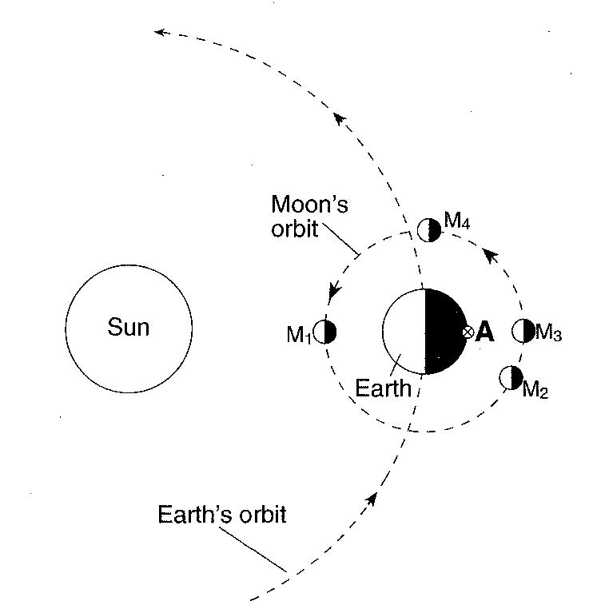
Base your answers to questions 13 through 15 on the diagram to the right, which shows Earth in orbit around the Sun, and the Moon in orbit around Earth. M₁, M₂, M₃, and M₄ indicate positions of the Moon in its orbit. Letter A indicates a location on Earth’s surface.

13.__________ At which Moon position could a solar eclipse be seen from Earth?

- M₁ (3) M₃
- M₂ (4) M₄

14.__________An observer at location A noticed that the apparent size of the Moon varied slightly from month to month when the Moon was in position M₄ in its orbit. Which statement best explains this variation in the apparent size of the Moon?
(1) The Moon expands in summer and contracts in winter.
(2) The Moon shows complete cycles of phases throughout the year.
(3) The Moon’s period of rotation is equal to its period of revolution.
(4) The Moon’s distance from Earth varies in a cyclic manner.

15.__________An observer at location A on Earth views the Moon when it is at position M₃. Which phase of the Moon will the observer see?

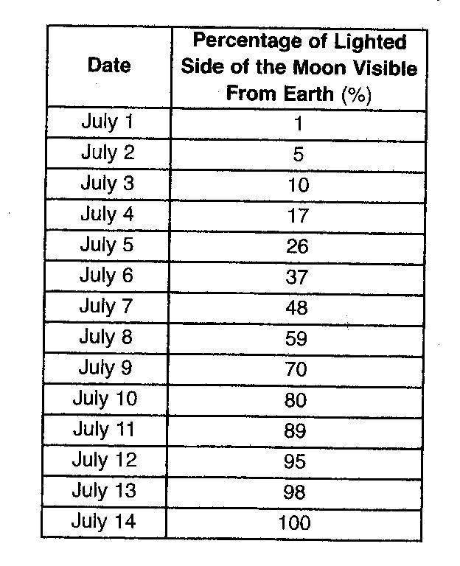
Base your answers to questions 16 through 19 on the data table below, which shows the percentage of the lighted side of the moon visible from Earth for the first fourteen days of July 2003.

16. On what July date listed in the table did the Moon appear as shown below?
July ______________

17. What motion of the Moon causes the percentage of the lighted side of the Moon visible from Earth to change from July 1 to July 14?

18. A full Moon phase was observed on July 14. On what day in August was the next full Moon phase observed?
August _____________________
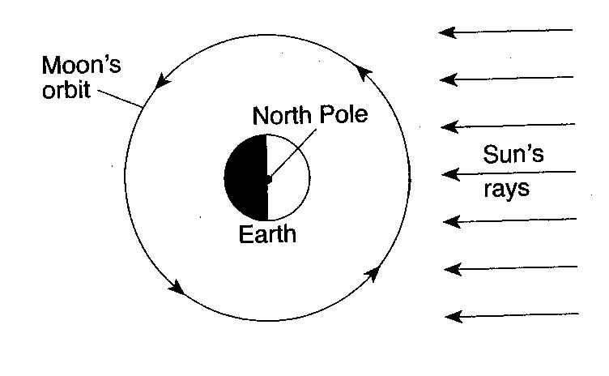
19. The diagram to the right shows the orbit of the Moon around Earth. Place an X on the orbit to show where the Moon was in its orbit on July 14, 2003.

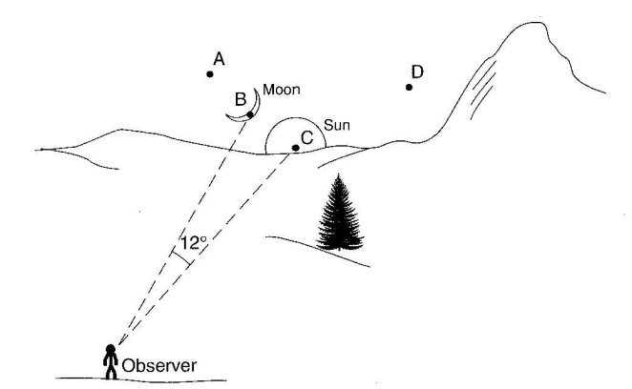
The diagram to the right shows the position of the Sun and the Moon at sunset during an evening in New York State. Points A, B, C and D represent positions along the western horizon.

20.__________At sunset on the following evening, the Moon will be located at position
(1) A (3) C
(2) B (4) D
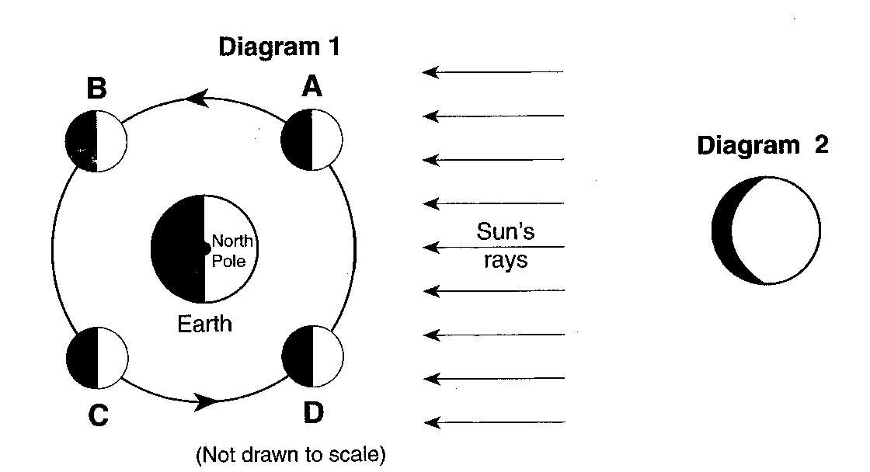
Diagram 1 to the right shows the Moon in its orbit at four positions labeled A, B, C and D. Diagram 2 shows a phase of the Moon as viewed from New York State

21.__________At which labeled Moon position would the phase of the Moon shown in Diagram 2 be observed from New York State?
(1) A (2) B (3) C (4) D

22._________Which arrangement of the Sun, the Moon and Earth results in the highest high tides and the lowest low tides on Earth. (Diagrams are not drawn to scale.)
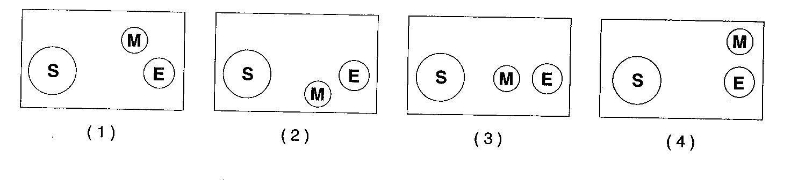
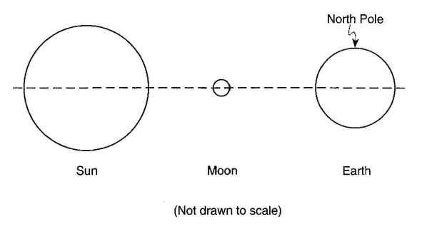
29. The diagram to the right shows the Sun, the Moon and Earth in line with one another in space. On the diagram, draw two dots on the surface of Earth to indicate locations where the highest ocean tides are most likely occurring.

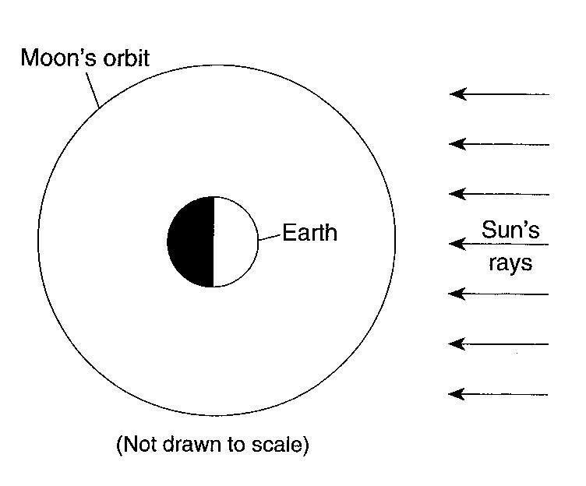

30. On the diagram to the right, place an X on the Moon’s orbit to show the Moon’s position during a solar eclipse.

31. The Moon has many more impact craters on its surface than Earth has on its surface. State two reasons that Earth has so few visible impact craters.

32. In the space provided below, draw the relative positions of Earth, the Moon, and the Sun, as viewed from space, so that a full-moon phase would be visible to an observer on Earth. Label Earth, the Moon, and the Sun in your drawing.

Base your answers to questions 33 – 34 on the reading passage below and your knowledge of Earth Science.
The Blue Moon

A “Blue Moon” is the name given to the second full moon in a calendar month. Because there are roughly 29.5 days between full moons, it is unusual for two full moons to “fit” into a 30 or 31 day month (and impossible to fit into a 28 or 29 day month, so February can never have a Blue Moon). The saying, “Once in a Blue Moon” means a rare occurrence and predates the current astronomical use of the term, which is quite recent. In fact, Blue Moons are not all that rare. On average, there will be one Blue Moon every 2.5 years. After 1999, the next Blue Moons will be in November 2001, July 2002, and June 2007. The last one before 1999 was in July 1996.
The term Blue Moon is believed to have originated in 1883 after the eruption of Krakatoa. The volcano put so much dust in the atmosphere that the Moon actually looked blue in color. This was so unusual that the term “Blue Moon” was coined.
“The Blue Moon”
David R. Williams

33. Explain why a Blue Moon never occurs during the month of February.

34. What is the greatest number of full-moon phases, visible from Earth, that are possible in a span of 1 year.

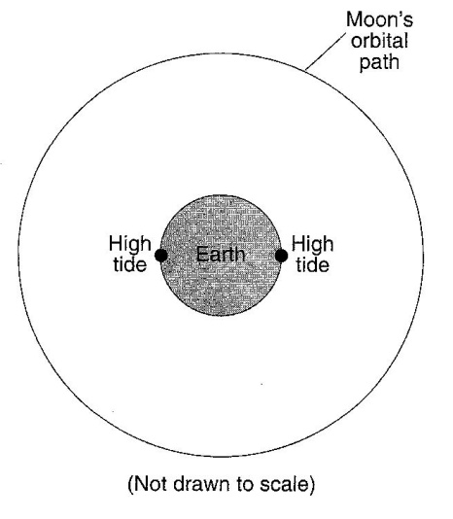

35. The diagram to the right shows the Moon’s orbital path and Earth as viewed from space. The points on Earth indicate two locations where high ocean tides are occurring. Place an X on the Moon’s orbital path to show where the Moon could be located when these high tides are produced.

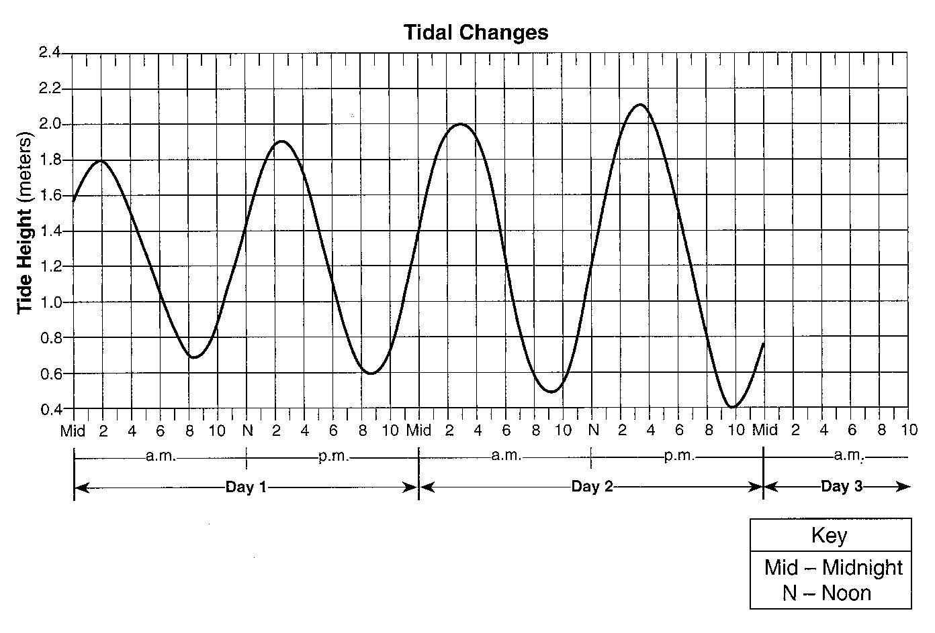
Base your answers to questions 35 and 36 on the graph to the right, which shows two days of tidal data from a coastal location in the northeastern United States.

35.______ If the pattern shown continues, the most likely height and time for the first high tide on day 3 would be

(1) 2.2 meters at 4 a.m.
(2) 2.3 meters at 4 a.m.
(3) 2.2 meters at 5 a.m.
(4) 2.3 meters at 5 a.m.

36.______ The change in the tides as shown on the graph is primarily the result of

(1) Earth’s rotation and the Moon’s revolution (3) the Moon’s rotation and Earth’s revolution
(2) Earth’s rotation and revolution (4) the Moon’s rotation and revolution

