TOPO MAPPING LAB
This lab can be used to construct a topo map by having students walk a trail and mark off elevations at given points on a map. I laid out all of the points to exaggerate the slope, hopefully you can do the same at your school. I used Google maps to get the top down view of my school for the topo map.
Date Sheet 1
Name:
Mapping Lab

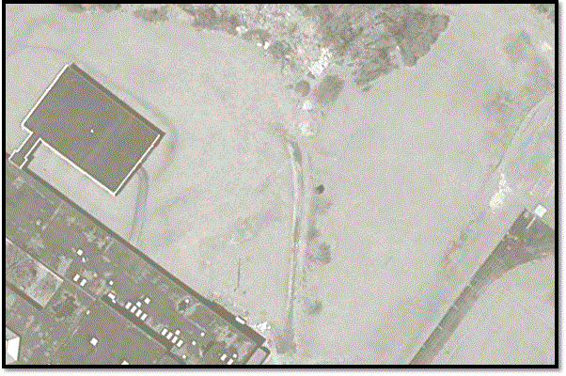
Objectives: Students should concentrate on:
Contour lines, slope, gradient, map scale, map legend, profile construction.

Students will construct a topographic map using by walking a series of trails and recording elevations and counting paces. In addition students will create a map legend and place symbols on the map in correct locations. The students will then calculate slope and create a map legend. Using their map students will create a topographic profile.
Procedure:
Using the map above pace off the trail listed: BA, CA, DA, EA, FA.
- While pacing the trail, stop at the marked blazes and record the elevation at each location and how many steps you are from the trailhead on Data Sheet 1.
  - You must keep a total count of steps from each trail (B,C,D,E,F) from the start to the tree which marks point A.
- While stopped at each marked blaze, record the slope in that exact spot as F=Flat, M= Moderate, S=Steep on Data Shett 1.
- Using your best guess based on paces you have taken and Figure 1, mark the blazes on Figure 1 above.
- Make contour lines on Figure 1 using a contour interval of 10ft. Start with 460 (near the tree which is spot A).
- On figure 1 insert a Map Scale (a graphic scale), the contour interval and a map legend. The legend should include: the Gravel Road, the Track & the Path…the mark your map with the correct symbols (that you invented).
- Complete the Problems and Questions listed on the second page of this lab. Complete the Lab Self Assessment ( the last page…don’t forget your name.)

Problems:
- Calculate the gradient for line C1-C4: (round to the tenth and include correct units):
Trail/Location  Blaze # | Describe the hill as F=Flat, M= Moderate, S=Steep | Elevation (ft.) | Steps from trailhead (stp.)
CA 1 |  | 440 | 0
CA 2 |  | 450
CA 3 |  | 460
DA 1 |  | 430 | 0
DA 2 |  | 440
DA 3 |  | 450
DA 4 |  | 460
EA 1 |  | 410 | 0
EA 2 |  | 420
EA 3 |  | 430
EA 4 |  | 440
EA 5 |  | 450
EA 6 |  | 460
FA 1 |  | 400 | 0
FA 2 |  | 410 | 0
FA 3 |  | 420
FA 4 |  | 430
FA 5 |  | 440
FA 6 |  | 450
FA 7 |  | 460

- Calculate the gradient for line F1-F10: (round to the tenth and include correct units):

Questions:
- What was the flattest trail? What did the lines look like there in terms of spacing?

- What was the steepest trail? What did the lines look like there in terms of spacing?

Labels for points on the trails. You will most likely have to change these to fit your school.
C1 | Elevation is  460ft.
C2 | Elevation is  450 ft.
C3 | Elevation is  460 ft.
C4 | Elevation is  430 ft.
D1 | Elevation is  460 ft.
D2 | Elevation is  450 ft.
D3 | Elevation is  440 ft.
D4 | Elevation is  430 ft.
D5 | Elevation is  420 ft.
E1 | Elevation is  460 ft.
E2 | Elevation is  450 ft.

E3 | Elevation is  440 ft.
E4 | Elevation is  430 ft.
E5 | Elevation is  420 ft.
F1 | Elevation is  460 ft.
F2 | Elevation is  450 ft.
F3 | Elevation is  440 ft.
F4 | Elevation is  430 ft.
F5 | Elevation is  420 ft.
F6 | Elevation is  410 ft.
F7 | Elevation is  400 ft.
F8 | Elevation is  390 ft.

F9 | Elevation is  380 ft.
F10 | Elevation is  3700 ft.

