Topographic Features of the Taku Glacier Region

Name: ________________________________________

Background: The map in this lab is one of the Juneau Icefields in Alaska. It is showing the Taku, Norris, and Hole-in-the Wall Glaciers as well as land contours, glacial contours, and the positions of the edge of each glacier at different times since 1890. Glaciers gain and lose snow and ice each year. The amount of snow and ice added to a glacier is called accumulation and causes the glacier to advance. The amount lost due to melting is called ablation that causes the glacier to retreat up the hill. This relationship is called the glacial budget.

- On the map lightly shade the areas of land and water using the following key:

Highlands = green Lowlands = brown Water = blue Glaciers = white

- What is the approximate latitude and longitude of the Taku Glacier at the location marked 1980? Don’t forget to include directions.
Latitude _____________________ Longitude _____________________

- Measure East-West distance across the entire map in miles. _________________
- Measure the North-South distance of the entire map in miles. ________________
- What is the width of the Taku Glacier at the terminus (end)? _________________
- What is the width of the Taku Glacier at the 1000 ft contour? ________________
- What is the length of the Taku Glacier shown on the map? (measure along the center of the glacier) ____________________
- What is the width of the Norris Glacier at its 1000 ft contour? ________________
- What is the contour interval of the map on land? __________________________
- What is the highest elevation on the map? _______________________________
- What is the contour interval on the glacier? ______________________________
- Calculate the gradient of the Taku Glacier from 1000 ft contour to the terminus at Take River (elevation 0)? Show work. __________________

- Draw a topographic profile across the Taku Glacier from the 2000 ft contour west of Hill 4125 (near Norris Glacier) through peak 2360 ending on the 1000 ft contour on the east bank of the Taku River.

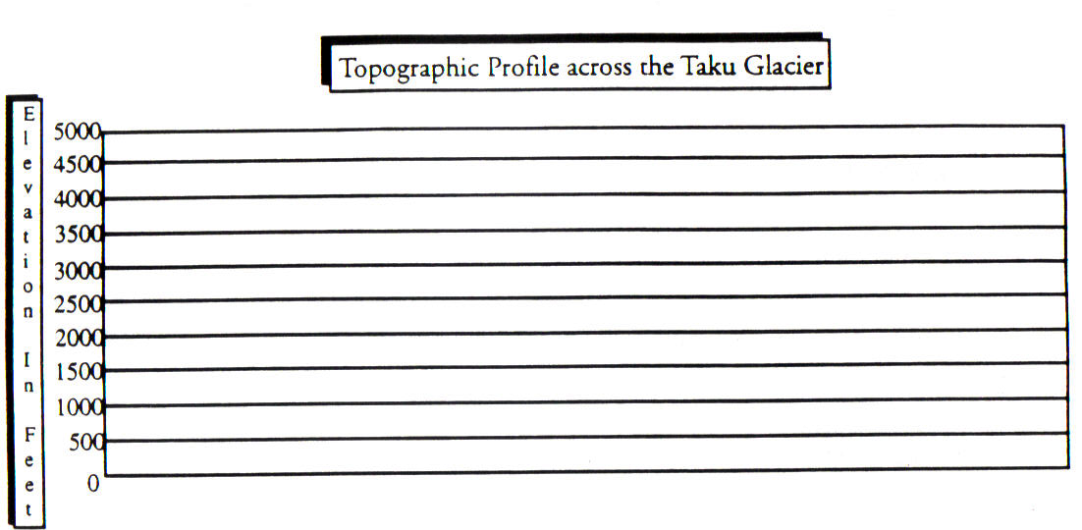

Part II
- What is the term used when a glacier adds snow and ice that winter? (Hint read the background section) __________________
- This will cause the glacier to __________________
- The dark lines on the glaciers indicate the position of the terminus (glacier front) in the years indicated. Which glaciers appear to be advancing and which are retreating?
Advancing: _____________________________Retreating: _________________
- What will happen to Taku Glacier as the Earth warms due to Global Warming? (please correct terminology listed in the background) ________________
- What part of the glacier travels the fastest? _______________________
- Describe the arrangement of the sediments deposited directly by glaciers
_______________________
- State one possible explanation for the north-south orientation of the Finger Lakes. (Hint look at pages 2-3 in your ESRT)
____________________________________________________________________
- When glaciers carve out a valley, they form a(n) ________ shaped valley.
- Deposits of very large boulders at random are called _______________________.

Map of Taku Glacier



