Name:__________________________________ Date:________
Earth Science- Ms. Susan Period:______

Topographic Maps Test
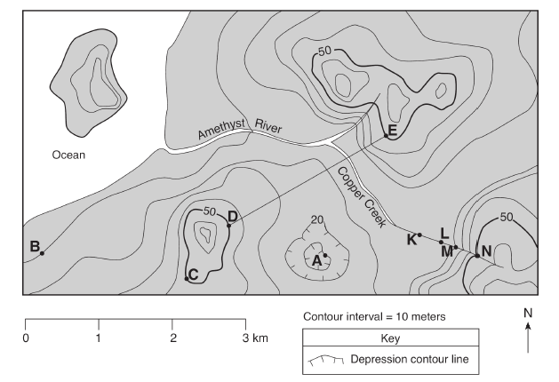

Using the map above:
1) What is the elevation of: (Label your answer with the appropriate units)
Point B: ________ Point E: ________ Point N: ________ Point A:______ __

2) Show all work for the following problems. Label with appropriate units.
Calculate the gradient of C to B. | Calculate the gradient of N to B.
3) In what direction is Amethyst River flowing? __________________________
How do you know? _____________________________________________________________________

4) Draw a topographic profile of D to E. 5) Draw a topographic profile of B to C.
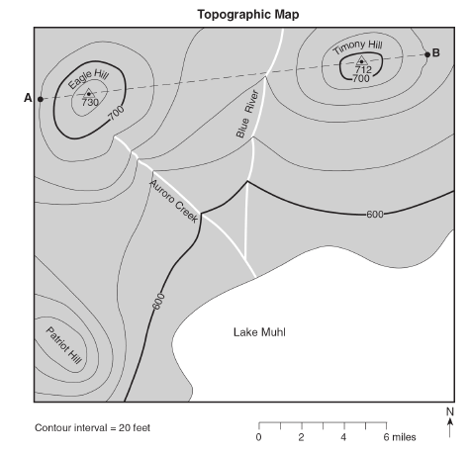Using the map to the left:

6) What is the elevation of: (Label your answer with the appropriate units)
Point A: ________
Point B: ________

7) What is the highest possible elevation of Patriot Hill? (Label your answer with the appropriate units)
________
8) In what direction does Blue River flow?
____________________
9) In what direction does Auroro Creek flow?
_____________________

10) Draw a topographic profile of AB. Begin your scale at 600. Include the elevations of the hills on the graph.
11) Using the map to the right, explain what evidence there is that tells you the southern side of Holland Hill is very steep.

________________________________________
12) What is the elevation of: (Label with units)
Point A: ________ Point Z: ________

13) Calculate the gradient from Z to Y. Show all work.
(Label with units)

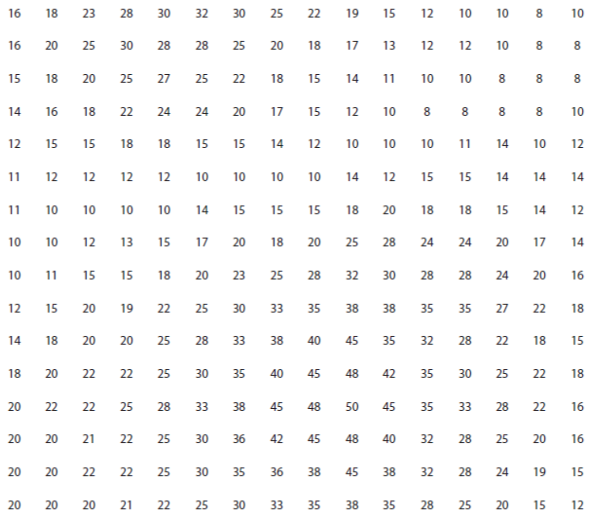14) Draw in the contour lines beginning with 10m. The contour interval is 5 m.

15)

15) Draw in the contour lines beginning with 20m. The contour interval is 20m.
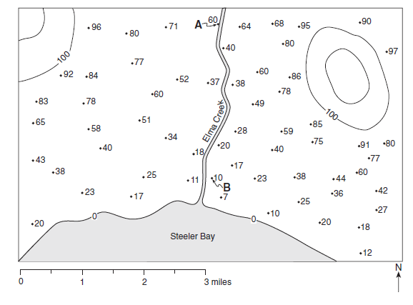
16) Define the following vocabulary words in your own words. If you do not use full sentences, you will not receive full credit.
a) Topographic Map:

b) Contour Line:

c) Elevation:

d) Topographic Profile:

e) Gradient:

f) Contour Interval:

