How to Use Latitude & Longitude
When you are using Latitude & Longitude, it is similar to using _____________ paper.
- LATITUDE:
  - Latitude lines run from ______ (the least) degrees latitude to _____ (the most) degrees latitude.
  - The starting line of latitude or ZERO degrees is the __________________.
  - 90º North and 90º South are known as _________________ & _________________.
  - Draw and label those 3 important Latitude lines.
- Writing Latitude
- The two directions that Latitude measures is either ____________ or ___________.
- Just like climbing up (____________) or down (______________) on a ladder!
- Latitude measurements are written _____________.
- If your latitude is 57ºS, then you are in the __________ (direction) hemisphere or _________ the equator.
- Polaris & Latitude
- Using the circle above, DRAW in the star Polaris where it should be located.
- Polaris can only be seen in the ____________ (direction) hemisphere.
- You can find your latitude, by measuring how high Polaris is in the __________ (direction) sky.
the altitude of polaris is equal to __________________________!
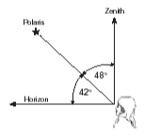
- If you measure Polaris to be 42º above the horizon then your latitude is ____ and the direction is ________.
C
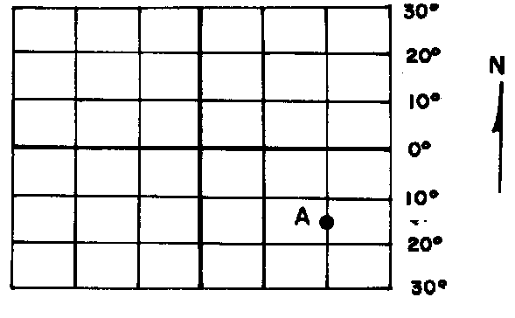

- Trace & Label the Equator.
B
- Label the Latitude compass directions next to each degree.
- What is the degree of latitude & direction for the following points?
A - ____________ C - ____________
D
B - ____________ D - ____________

- LONGITUDE:
  - Longitude lines run from ______ (the least) degrees longitude to _____ (the most) degrees longitude.
- The starting line of longitude or ZERO degrees is the _______________________.
- The highest line of longitude or 180º is the _______________________________.
- Lines of longitude ALL meet at the __________________ & ____________________.
- Draw what lines of longitude look like.
- Writing Longitude
- The two directions that Longitude measures is either ____________ or ___________.
- This is like moving _________ or _________ across a map.
- If your longitude is 165ºW, then you are in the ___________ (direction) hemisphere or ____________ of the Prime Meridian.
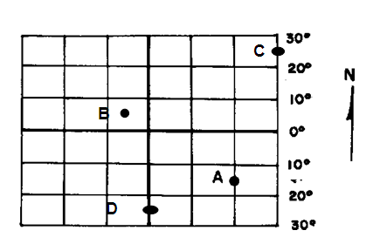
- Trace & Label the Prime Meridian.
- Label the Longitude compass directions next to each degree.
- What is the degree of longitude and direction for each of the following points?
A - __________ C - __________
B - __________ D - __________
Now put it all together!
Point C:
Latitude Longitude
_________ _________
Point A:
Latitude Longitude
_________ _________
Point D:
Latitude Longitude
_________ _________
Point B:
Latitude Longitude
_________ _________
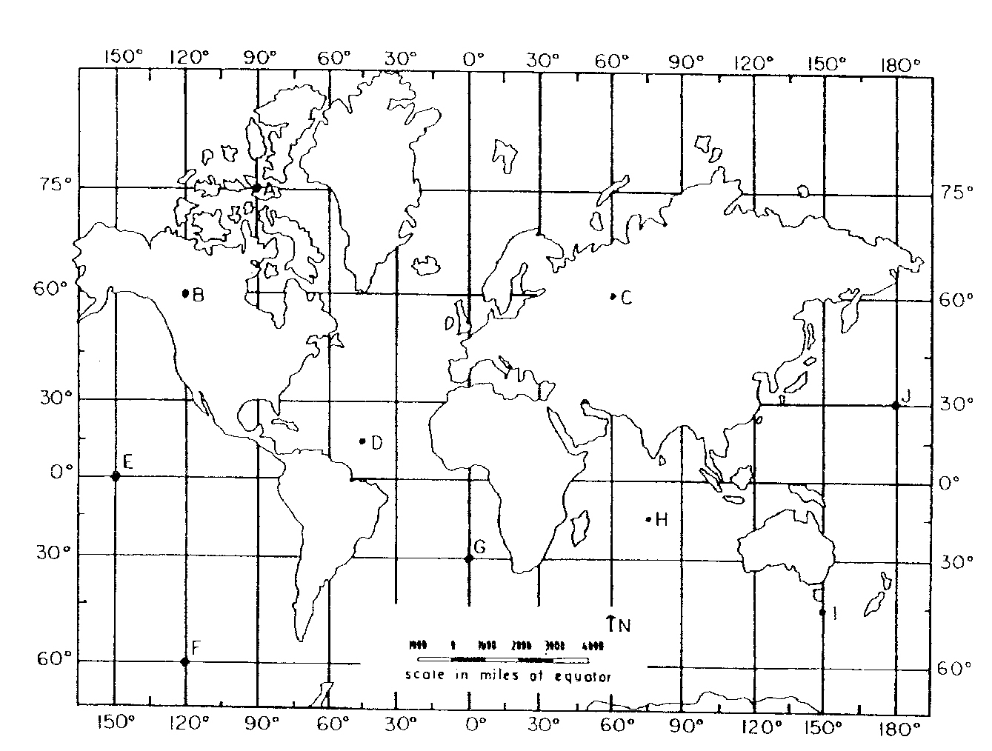
Directions:
- Start by labeling your compass directions next to your degrees of Latitude.
- Label your compass directions next to your degrees of Longitude.
- Complete the table below for locations A – I.
- You DO NOT use minutes on this map, only on the NYS Map in the ESRT!!

Example: 45ºN, 10ºE

Location | Latitude  (degrees, direction) | Longitude  (degrees, direction)
A
B
C
D
E
F
G
H
I

