Name__________________________________________________ Date__________________ Period____________
WEATHER INSTRUMENTS
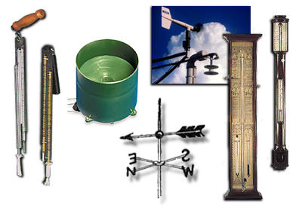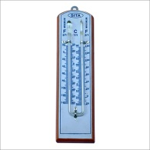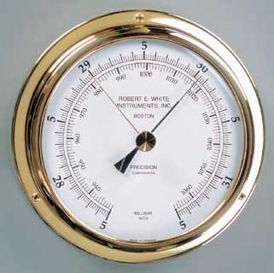
Sling Psychrometer Rain Gauge Anemometer Maximum/Minimum Thermometer
Wind Vane Barometer
Match each word with the picture of the appropriate weather instrument from the list and words above.
After matching the picture with the name of the weather instrument above then tell what each instrument measures and in what units the readings are expressed.
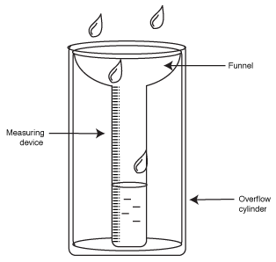 A._____________________________ B. ____________________________
Measures ___________________________________ Measures _____________________________
Units _______________________________________ Units__________________________________
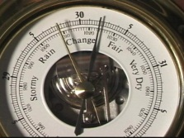 C. _____________________________ 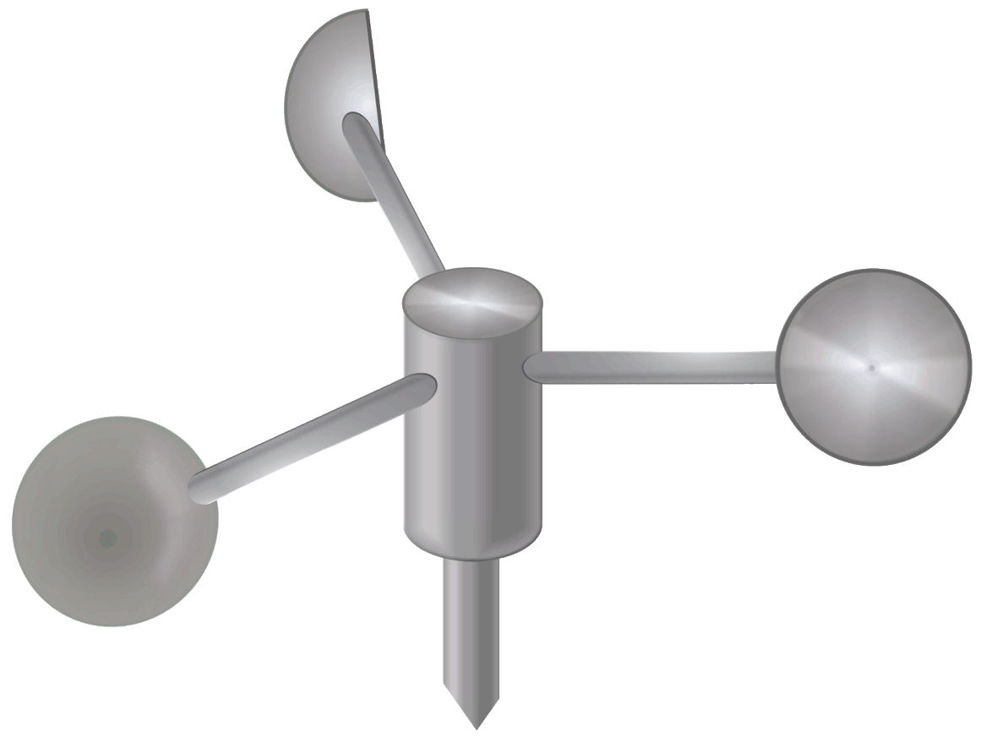 D. _______________________________
Measures ___________________________________ Measures _____________________________
Units _______________________________________ Units___ ______________________________
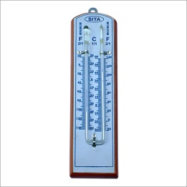 E._____________________________ 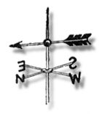 F._____________________________
Measures ___________________________________ Measures _____________________________
Units _______________________________________ Units___ ______________________________
Which of the instruments would best measure/determine each of the following conditions?
a. amount of precipitation in the past 24 hours _____________________________
b. a snowstorm is approaching __________________________________________
c. a gentle breeze ________________________________________
Which instrument would give each of the following readings?
a. 14 mph ________________________________________ b. 53% _________________________________
c. a northeast wind ________________________________
d. the highest and lowest temperature reached in the past 24 hours________________________________
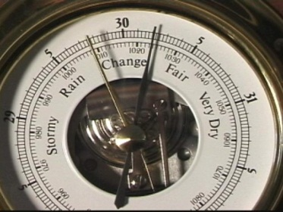
Barometer Readings (inches) Weather Forecast
30.1 - 30.2 rising fair: rain within 48 hours
30.1- 30.2 steady fair; little change
30.1 - 30.2 falling slowly rain within 24 hours
30.1 - 30.2 falling rapidly rain within 12 hours
30.0 – or below, rising slowly clearing
30.0 – or below, falling slowly rain for 24-48 hours
30.0 – or below, falling rapidly rain with winds
29.8 or below, falling rapidly storm with strong winds
According to weather forecasts, tell what kind of weather might develop under each of the following conditions using the data above.
1. barometer reading of 29.90” rising slowly _________________________________________________________.
2. barometer reading of 30.20” rising rapidly ________________________________________________________.
3. barometer reading of 29.80” falling rapidly ________________________________________________________.
4. barometer reading of 30.10” steady ______________________________________________________________.
5. barometer reading of 30.10” steady ______________________________________________________________.
6. barometer reading of 28.80” falling rapidly ________________________________________________________.
7. What type of weather will generally follow a rising barometer reading? ________________________________.

