Cornelius, Tina

Tina.cornelius@clark.kyschools.us

2014 Campbell Junior High

Earth’s History

Embedded Assessment 4

27 _______________________________________________________________________________________

__________________________________________________________________________________________

__________________________________________________________________________________________

__________________________________________________________________________________________

__________________________________________________________________________________________

__________________________________________________________________________________________

__________________________________________________________________________________________

__________________________________________________________________________________________

__________________________________________________________________________________________

__________________________________________________________________________________________

__________________________________________________________________________________________

Name _____________________________________________ Class period______ Date_________

History of Earth Answer Sheet

1. b2004. b200 7. b20010. b20013. b20016. b20019. b20022. b200

2. b2005. b200 8. b200 11. b20014. b20017. b20020. b20023. b200

3. b2006. b200 9. b200 12. b20015. b20018. b20021. b20024. b200

25. b200

Extended Responses

26._______________________________________________________________________________________

__________________________________________________________________________________________

__________________________________________________________________________________________

__________________________________________________________________________________________

__________________________________________________________________________________________

__________________________________________________________________________________________

__________________________________________________________________________________________

__________________________________________________________________________________________

__________________________________________________________________________________________

__________________________________________________________________________________________

__________________________________________________________________________________________

**Teacher Use ONLY**

______ ______ ______ ______ ______ ______ ______ ______

**History of Earth Test**

**Do NOT write on this test!!!!!**

**Multiple Choice questions= 3.5 pts each**

**I can determine the relative age of fossils/rock layers.**

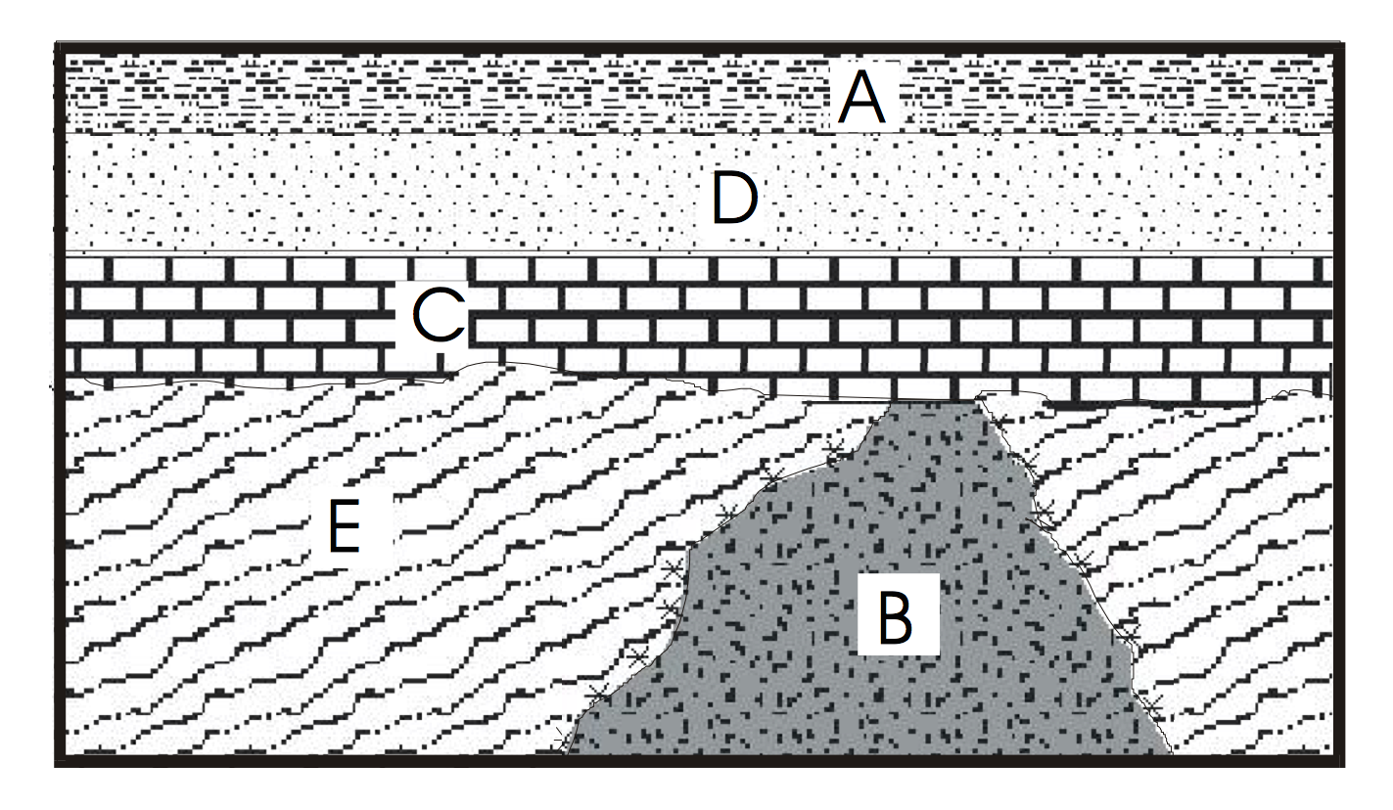

1. List the geologic events from oldest to youngest.

A B C D

a) A, D, C, E, B

b) B, E, C, D, A

c) E, B, C, D, A

d) E, C, B, D, A

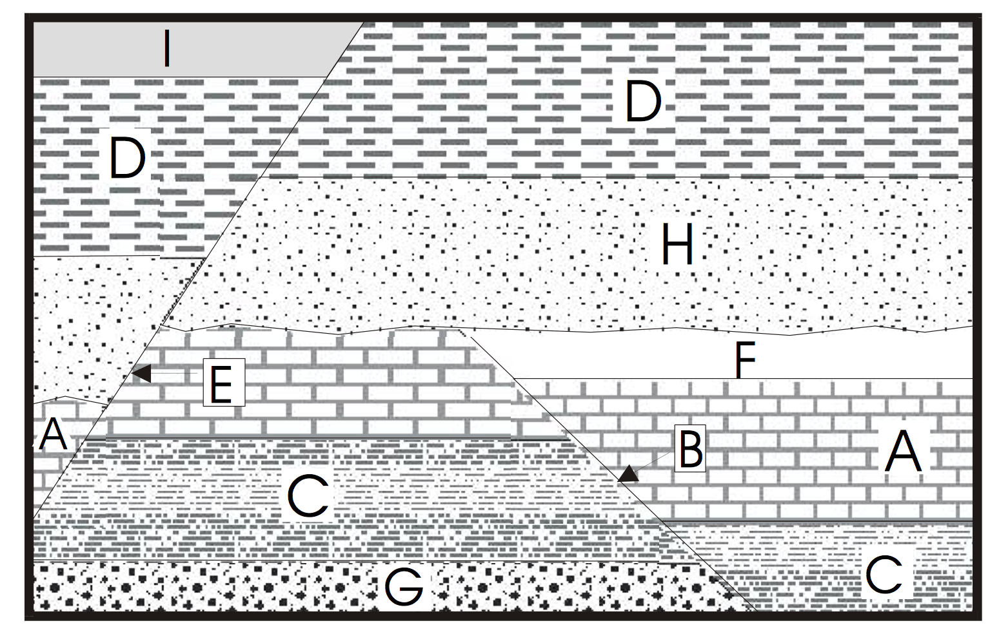

2. List the geologic events from oldest to youngest.

a) G, C, A, F, B, H, D, I, E

b) G, C, S, F, B, H, D, I, E

c) G, C, A, B, F, H, D, I, E

d) I, D, H, E, F, A, C, G, B

3. List the fossils from oldest to youngest.

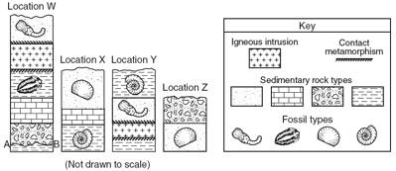

a) B, A, D, C

b) A, B, C, D

c) C, D, A, B

d) D, C, B, A

**I can calculate absolute age using radiometric dating.**

4. How many half lives does it take for a sample of any isotope to decay to 12.5% of the original sample?

a) 1 half lives

b) 2 half lives

c) 3 half lives

d) 4 half lives

Use the radioactive decay chart below to help answer the following questions.

|  |  |
| --- | --- |
| **Element** | **Half-life** |
| Bismuth-212 | 60.5 minutes |
| Carbon-14 | 5730 years |
| Chlorine-36 | 400,000 years |
| Cobalt-60 | 5.26 years |
| Iodine-131 | 8.07 days |

5. Jalam has a 325-gram sample of Iodine-131. What will the mass of the sample be after 24.21 days?

a) 650 grams

b) 162.5 grams

c) 81.25 grams

d) 40.625 grams

6. Melanie has a sample of 24 grams of Chlorine-36 that is confirmed to be 800,000 years old. What was the mass of the **original sample**?

a) 96 grams

b) 48 grams

c) 12 grams

d) 6 grams

7. If Wynne started with 48 grams of an original substance, how much would she have left after 2 halflifes?

a) 3

b) 6

c) 12

d) 24

8. What is the half-life of a radioactive isotope if a 500. Gram sample decays to 62.5 g in 24.3 hours?

a) 8.1

b) 16.2

c) 24. 3

d) 32.4

**I can describe major events in the history of the universe.**

9. What types of events mark the end of a period?

a) Global Climate Change

b) Mass Extinction

c) Appearance of a New Classification of Organisms

d) All of the above

10. Which answer best describes the event known as the Big Bang?

a) A massive explosion that caused the stars

to line up into the constellations.

b) Earth was formed through a massive explosion.

c) All of the matter/energy was condensed into a small area and started to expand.

d) All of the matter/energy was spread out throughout the universe and then condensed into a small area.

11. Which date is the best estimate to the age of the Earth?

a) 14 million years

b) 4.6 million years

c) 14 billion years

d) 4.6 billion years

**I can describe the Precambrian Era.**

12. Most of the life forms during the Precambrian era were _____________________.

a) Unicellular

b) Multicellular

c) Mammals

d) Reptiles

13. How many years did the Precambrian Era last?

a) About 4 billion years

b) About 200 million years

c) About 65 million years

d) About 4 million years

**I can describe the Paleozoic Era.**

14. During the Paleozoic Era, the continents were together in a supercontinent known as _________________.

a) Pangaea

b) Gondwana

c) Pangaea Ultima

d) Anteurasiafricalia

15. The Paleozoic Era lasted from ___________ mya to ______________ mya.

a) 65 to 0

b) 250 to 65

c) 550 to 250

d) 860 to 550

16. The Paleozoic Era has been nickname the “Age of the ____________”

a) Mammals

b) Dinosaurs

c) Bacteria

d) Fishes

**I can describe the Mesozoic Era.**

17. All of the following organisms were living during the Mesozoic Era **except**:

a) Dinosaurs

b) Reptiles

c) Humans

d) Flowering Plants

18. At the beginning of the Mesozoic period, Pangea breaks apart and what other major event occurred?

a) first reptiles

b) mass extinction

c) first life

d) first flowering plants appear

**I can describe the Cenozoic Era.**

19. The Cenozoic Era is also known as the “Age of the _____________”

a) Mammals

b) Dinosaurs

c) Bacteria

d) Fishes

20. Which of the following geologic events did **NOT** take place during the Cenozoic Era?

a) Formation of the Grand Canyon

b) Ice age

c) Formation of a super continent

d) Appearance of mammals

21. Which of the following epochs/periods is **NOT** from the Cenozoic Era?

a) Paleogene

b) Jurassic

c) Neogene

d) Quaternary

**I can determine the relative age of fossils/rock layers.**



22. List the rock layers from OLDEST to YOUNGEST:

a) A, B, C

b) C, A, B

c) B, C, A

d) B, A, C

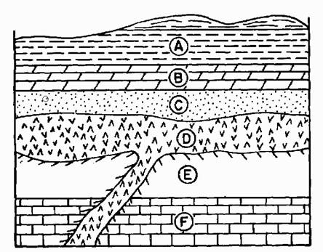

23. List the rock layers from OLDEST to YOUNGEST:

a) D, F, E, C, B, A

b) F, E, D, C, B, A

c) A, B, C, D,E, F

d) F, D, E, C, B, A

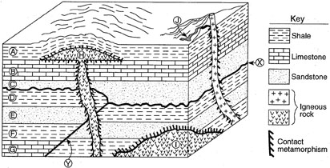

24. What is the **oldest** layer in the diagram above:

a) G

b) Y

c) I

d) H

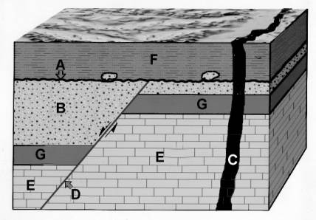

25. What is the **YOUNGEST** unit?

a) A

b) C

c) D

d) F

**I can describe how index fossils are used in relative dating.**

**Extended Response 6 pts (2 pts each part)**

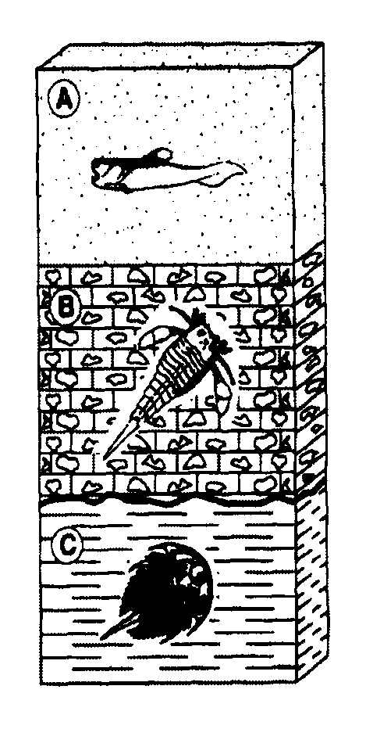

Use **Complete sentences** to answer the following:

26 a Using the diagram above, which of the following fossils (A, B or C ) is the oldest?

b. How do you know?

C. State the law that describes how you determine the age of the fossils and rock layers.

**Extended Response 6 pts**

27. A. Define index fossil.

B. In the illustration to the right, which fossil would be considered an index fossil? Explain why.

*HINT: There may be more than one answer for this part of the extended response.*

C. List the fossils in order from oldest to youngest.

Rock Sample A Rock Sample B

Sas

